BLM 2.GR.1 Practice: Get Ready
1. a) highest: December; lowest: July and August
b) the bank rate increased from July to December.
2. a) fall b) 29 students
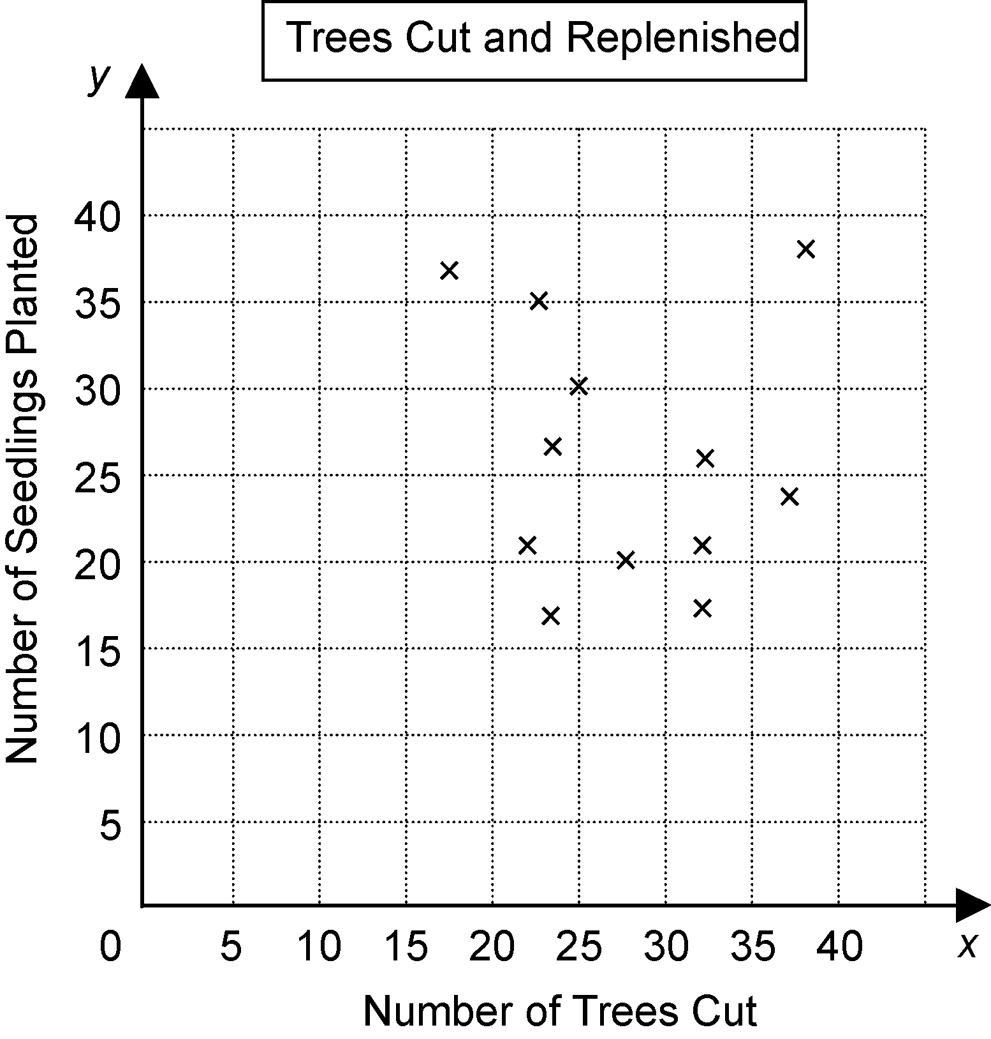
3. a)

b) No; there does not appear to be any relationship between the number of trees
cut and the number of seedlings planted.
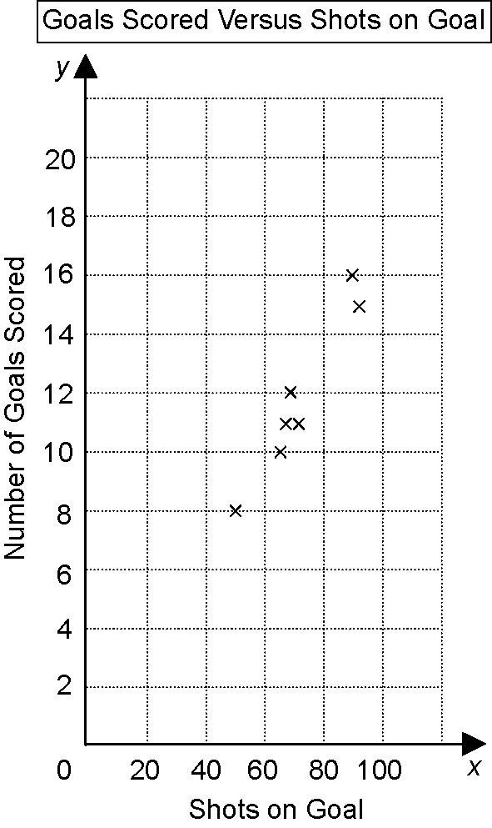
4. a)

b) about 5 goals
5. a) 9 km/h b) $3/kg c) 55 words/min
6. a) 250 m/min
b) $2.90/kg
c) 0.8 pages/min

BLM 2.1.1 Practice: Hypotheses and Sources of Data
1. Answers will vary.
a) The masses of tomatoes grown in sunny conditions are not greater than the masses of tomatoes grown in shady conditions.
b) Most students would not prefer to wear a school uniform.
c) As the amount of training increases, the behaviour of pet dogs does not improve.
d) As the weather gets warmer, the number of people who go ice-skating remains the same or increases.
e) People who use Brand X toothpaste will not have fewer cavities.
f) Listening to music with a fast beat will not increase the listener’s heart rate.
2. Answers will vary.
a) People who play more sports have a higher level of fitness.
b) Higher movie prices result in lower box office sales.
c) When the temperature is above 35°C or below −5°C, fewer people go outdoors.
d) People who live close to school walk to school.
3. Answers will vary.
a) People who play more sports do not have a higher level of fitness.
b) Higher movie prices do not result in lower box office sales.
c) When the temperature is above 35°C or below −5°C, the number of people who go outdoors does not change or increases.
d) People who live close to school do not walk to school.
4. a) Primary; Janet collected the data herself by calling the stores.
b) Secondary; the data were collected by the Bank of Canada.
c) Primary; Carly measured the temperatures herself and recorded the results.
5. a) secondary
b) primary
c) primary
6. a) primary
b) secondary
c) primary
7. Answers will vary. Most of the students in my class are involved in a club or sports team. I would test my hypothesis by asking the students in my class if they were involved in a club or sports team.

BLM 2.2.1 Practice: Sampling Principles
1. a) all high schools in urban areas in the province or country of interest
b) all vets who care for cats
c) all grade 9 science students at that school
d) all people
2. a) sample; it is too costly and too time-consuming to ask everyone in the province
b) sample; testing the light bulbs destroys them
c) census; it would not take too much time to survey all the students in the class
d) sample; it is too costly and too time-consuming to measure all adults
3. I would ask the office for a copy of each of the class lists. I would arrange the class lists in order. Then, I would randomly select a class and randomly select a student from that class. I would survey every tenth student before and after the selected student.
4. a) all the students at the school
b) None of the sampling methods described is being used. This will not be a random sample.
c) It is likely that only students with strong opinions about the policy will respond to the survey.
5. a) all grade 9 students at Frieda’s school
b) Frieda should select a random sample. One way to do this is to assign a consecutive number to each grade 9 student. Then, Frieda can use random numbers to help her select the students to survey.
6. a) stratified random sample; no
b) random sample; no
BLM 2.3.1 Practice: Use Scatter Plots to Analyse Data
1. a) independent: speed; dependent: distance travelled
b) independent: quality of study; dependent: exam mark
c) independent: time of year; dependent: cost of vacation
d) independent: number of sweaters; dependent: amount of wool needed
2. a) independent: capacity of gas tank; dependent: distance travelled
b) as the capacity of the gas tank increases, so does the distance travelled

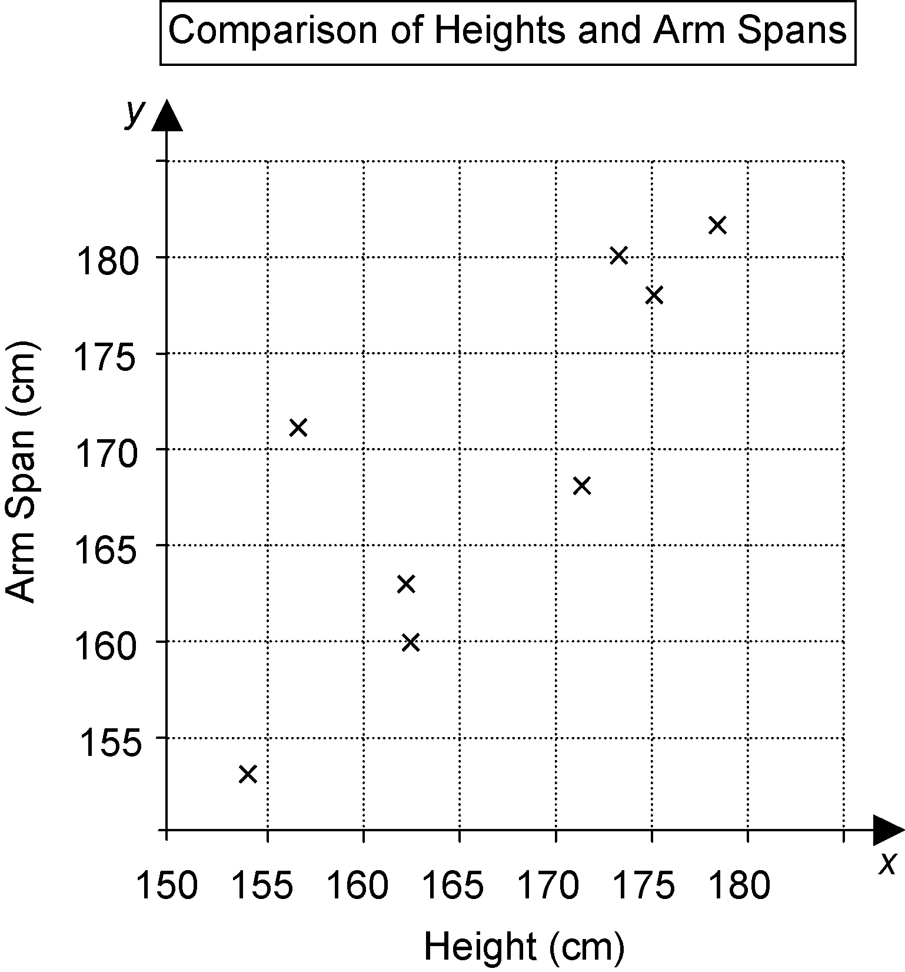
3. a)

b) A taller person tends to have a longer arm span and a shorter person tends to have a shorter arm span.
c) There is one outlier. The height 157 cm and arm span 171 does not fit the pattern of the other data. In most cases, height and arm span are almost equal.
4. a) independent: age; dependent: value
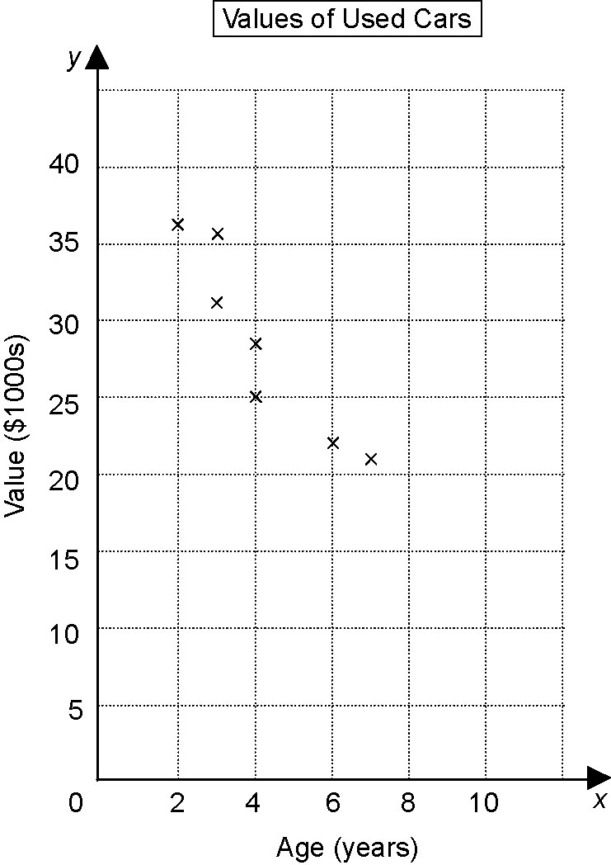
b)

c) As a car gets older, its value tends to decrease.
d) Jane paid too much. When I plot the point (7, 28) on the scatter plot, I can see it is an outlier.
The value of another 7-year-old car is only
$21 000 and a 4-year-old car has a value of $29 000.

BLM 2.4.1 Practice: Trends, Interpolation, and Extrapolation
1. a) increased; each bar is higher than the bar to the left.
b) The number of Canadians with asthma has increased each period from 1994 to 2001.
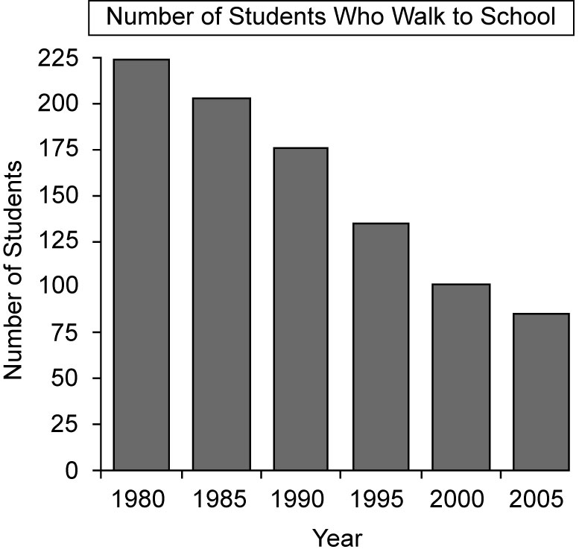
2. a)

b) The number of students who regularly walk to this elementary school has decreased steadily from 1980 to 2005.
c) If the trend continues, about 30 students will regularly walk to school in 2015.
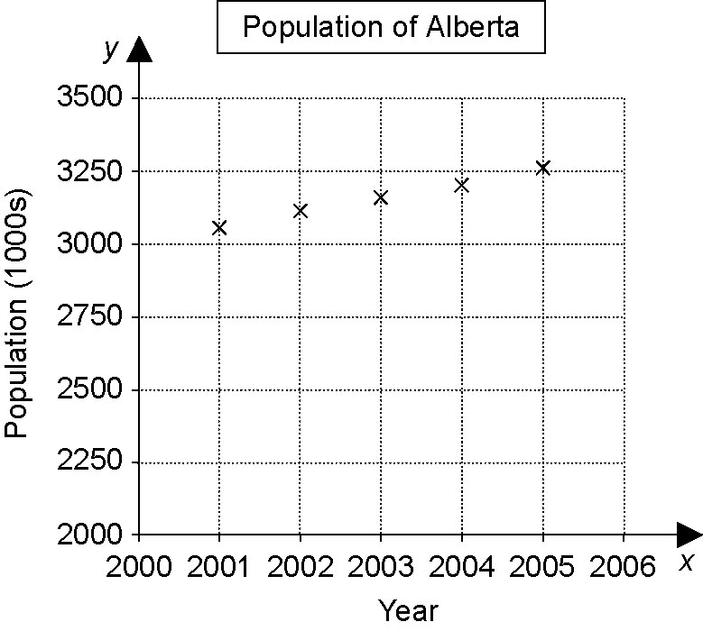
3. a)

b) The population of Alberta has shown a steady increase from 2001 to 2005.
c) If the trend continues, the population of Alberta will be about 3 500 000 in 2010.
BLM 2.5.1 Practice: Linear and Non-Linear Relations
1. a) non-linear
b) linear
c) linear
d) non-linear

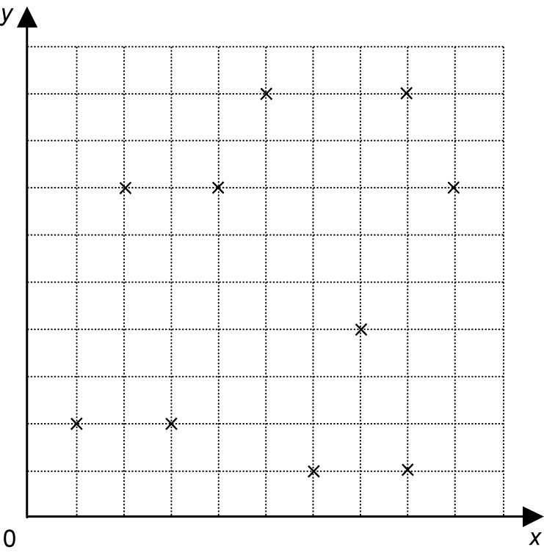
2. a)

non-linear
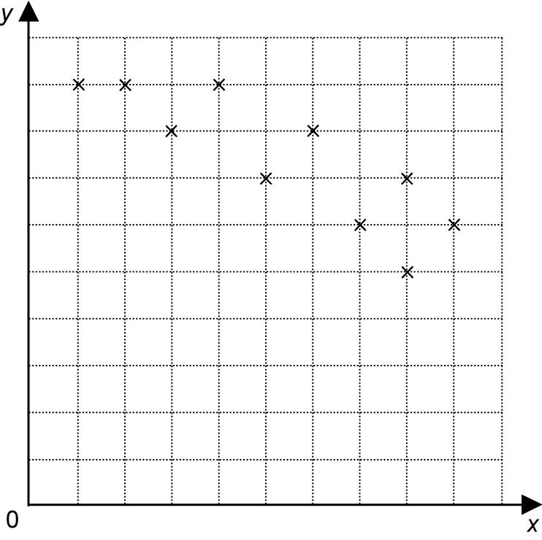
b)

linear
3. a) no; there are not enough points
b) yes; points are about equally distributed above and below the line
c) yes; points are about equally distributed above and below the line
d) no; points in the middle are all above the line
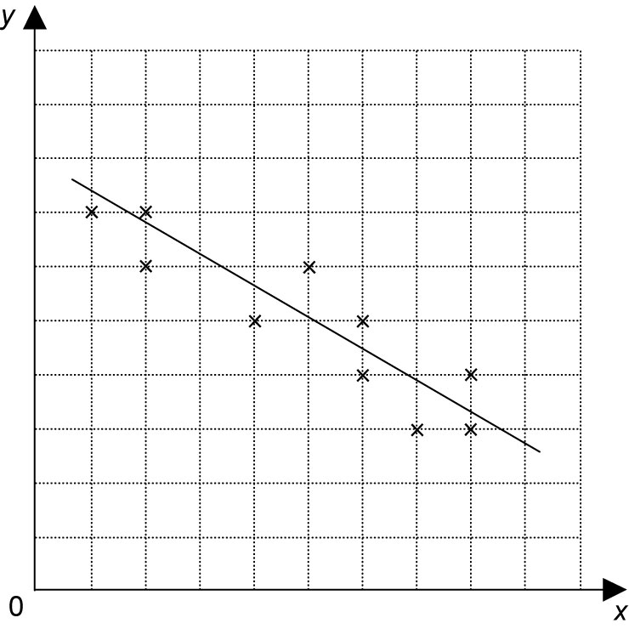
4.

BLM 2.6.1 Practice: Distance-Time Graphs
1. A
2. a) Someone is moving quickly at a steady pace.
b) Someone is moving at a moderate, steady pace.
c) Someone is standing still.
d) Someone is moving backward or walking home at a moderate, steady pace.
3. a) Walk at a moderate speed. About halfway, slow down and walk very slowly for a short time. Run the remainder of the distance.
b) Walk home at a steady pace. Partway home, stop to talk to a friend.
c) Walk slowly for a short distance, then run briefly. Stop for a rest, then walk quickly the rest of the way.
d) Walk slowly to school. Stop partway to talk, then run back home.
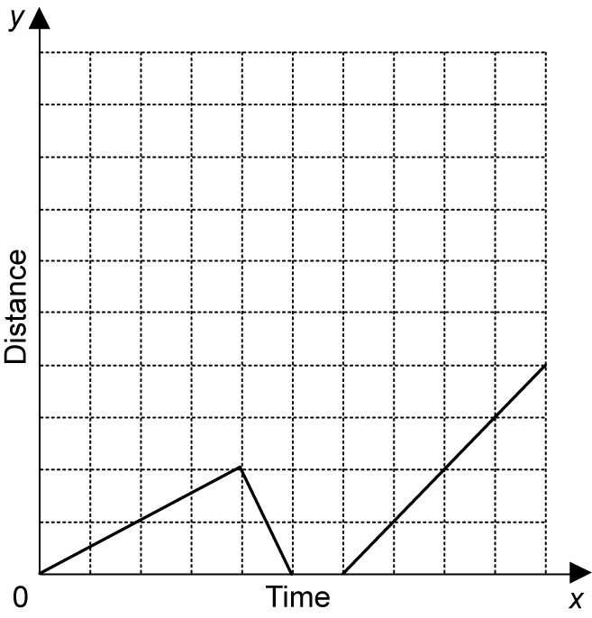
4.

BLM 2.CR.1 Chapter 2 Review
1. a) When the cost of electricity rises, the consumption of electricity decreases.
When the cost of electricity rises, the consumption of electricity does not decrease.
b) There is no relationship between the number of pets in a household and household income.
There is a relationship between the number of pets in a household and household income.
2. a) secondary
b) primary
c) primary
d) secondary
3. a) all the students at the school
b) I would assign each home class in each grade a number. I would randomly select one class from each grade. Within each selected class,
I would assign each student a number then I would use random numbers to select 5 students from each class.
4. a) all the students who play in any of the school bands
b) To select a random sample, I could assign all the students in a band a number. I would use the random number generator on my calculator to select students to survey.
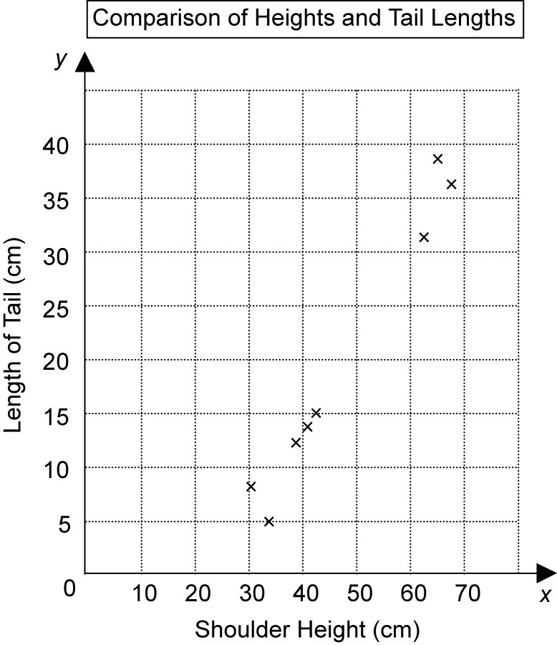
5. a)

b) From the data, it appears that taller dogs have longer tails and shorter dogs have shorter tails.
c) There are no outliers in the data. I would not discard outliers because some breeds of dogs have short tails and some have very long tails.
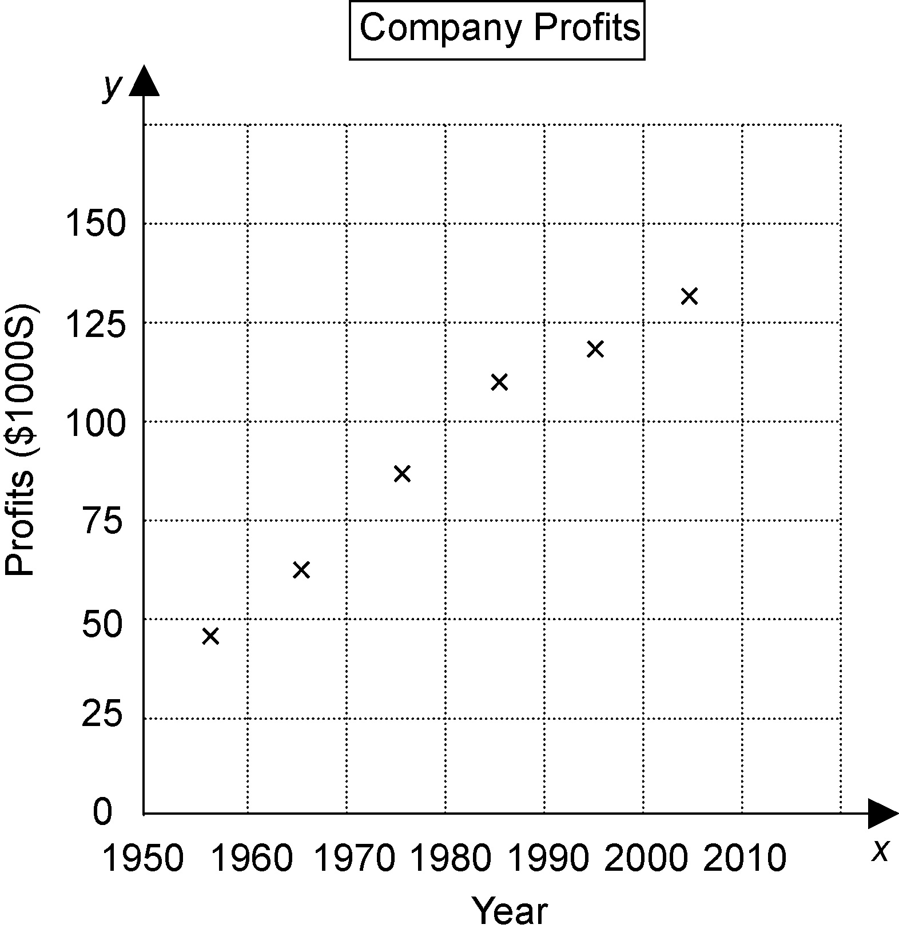
6. a)

b) The profits have been increasing over time.
c) About $100 000

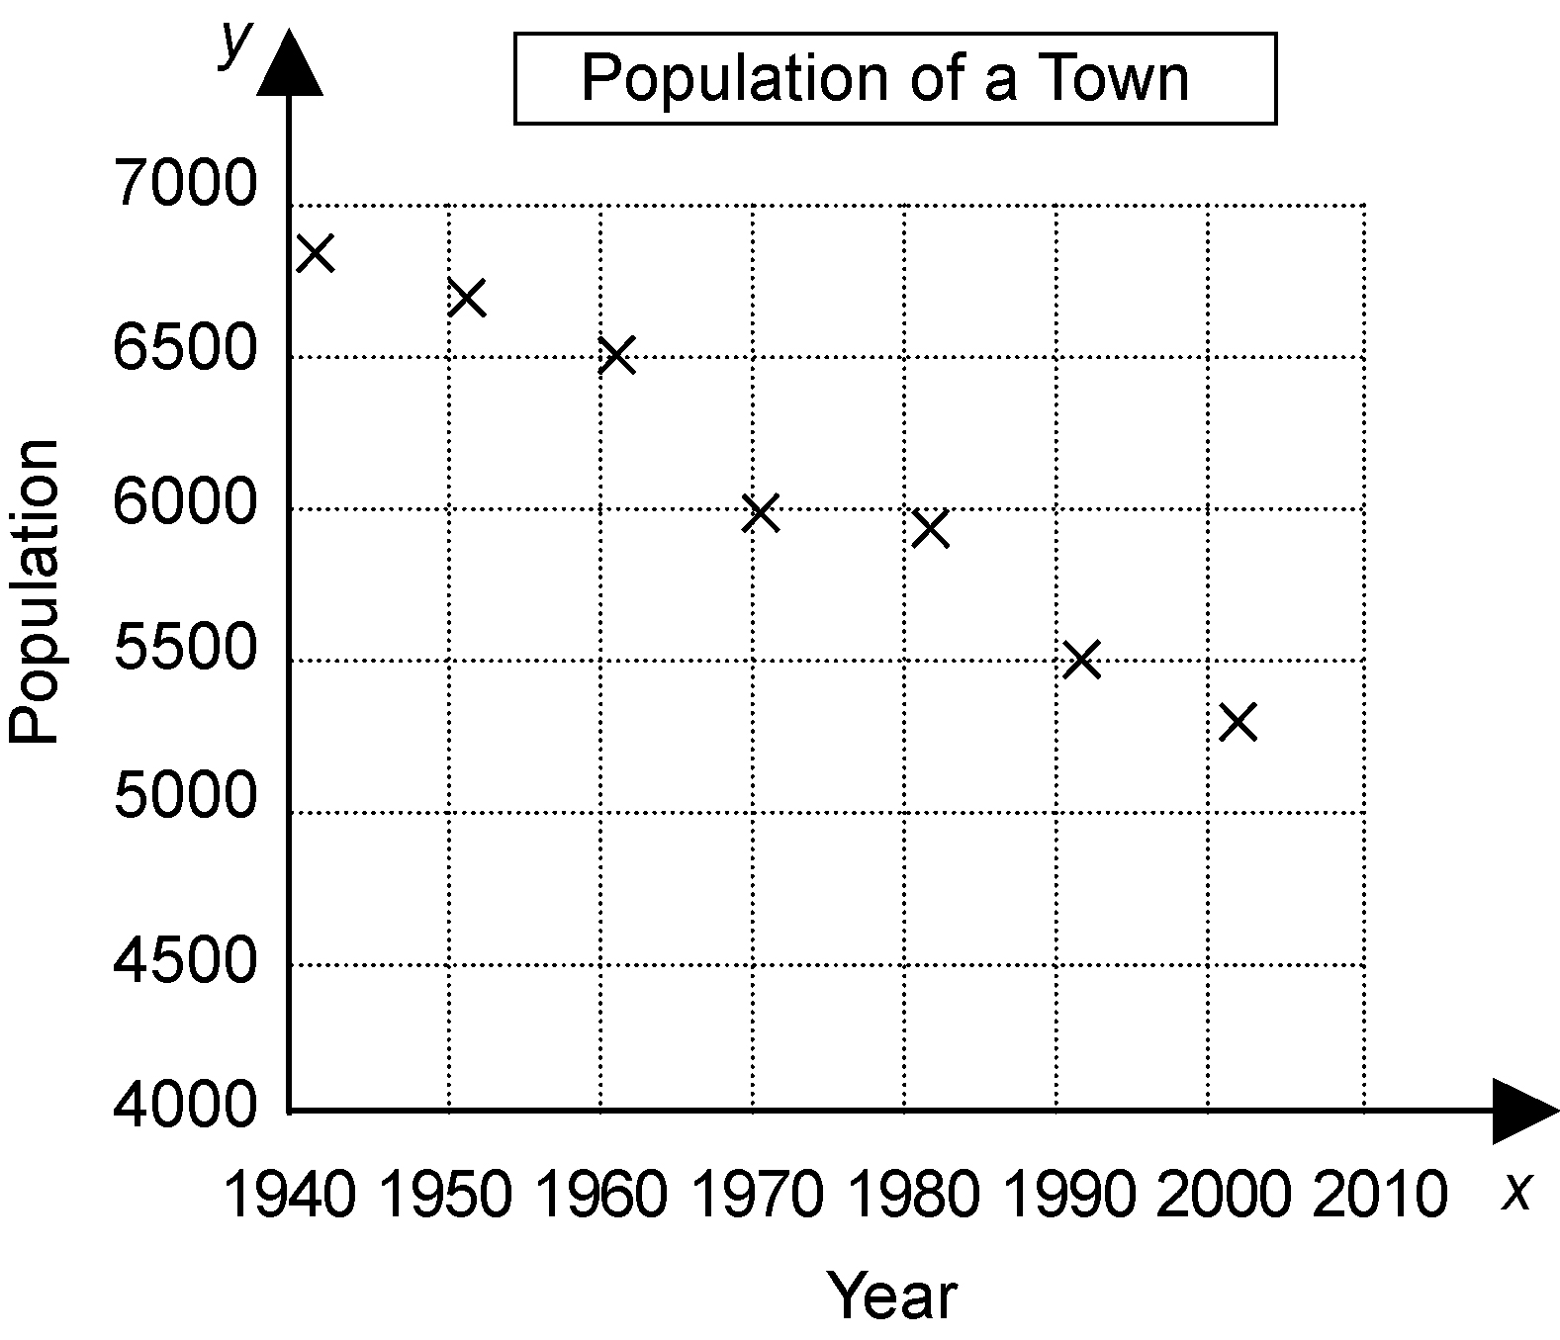
7. a)

b) Over time, the population of the town is decreasing.
c) about 5000
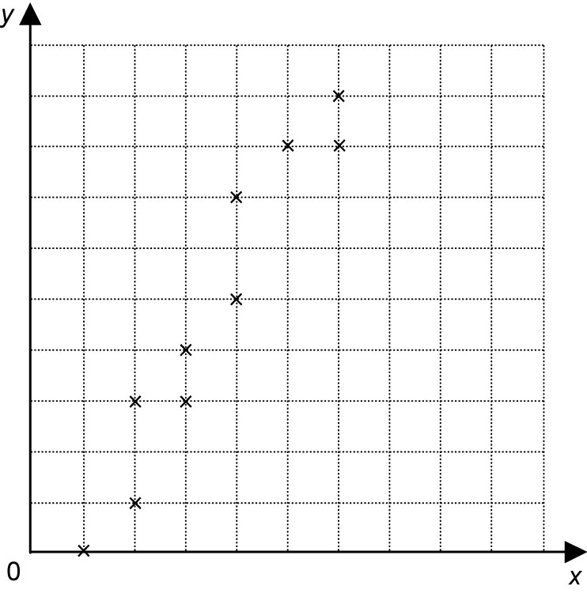
8. a)

linear
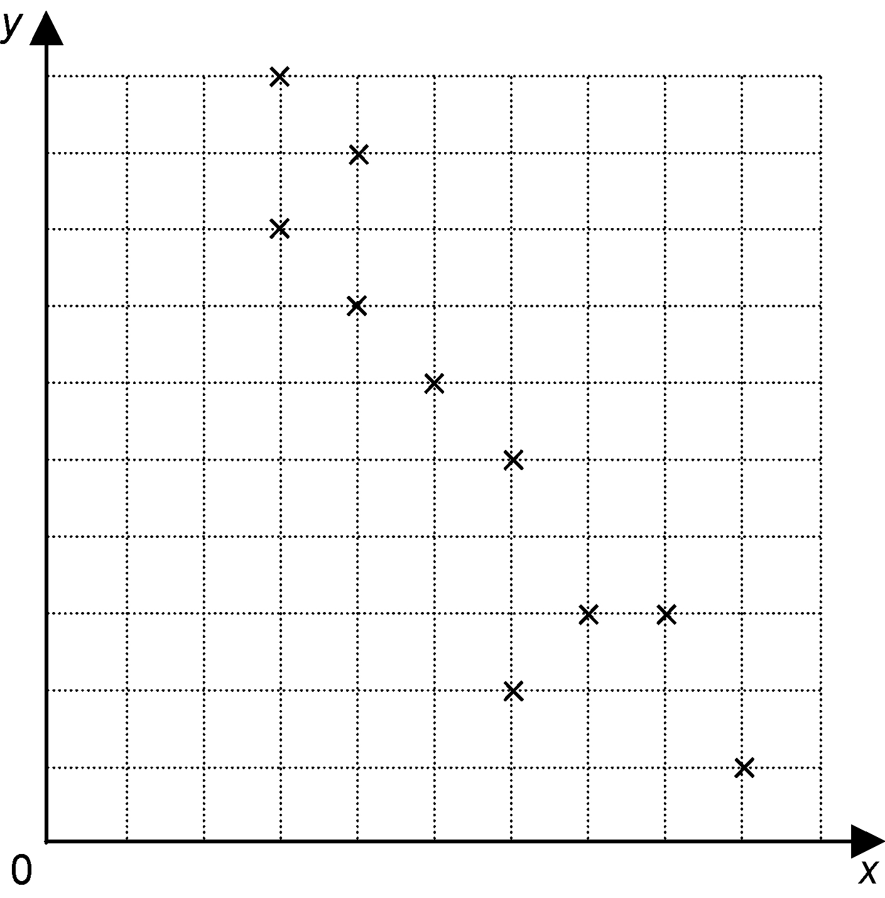
b)

linear
9. no; there are not enough points on the graph.
10. Charlie is sitting in a park a few blocks from home. She runs towards home, then remembers she was supposed to meet a friend at the mall. She runs to the mall.
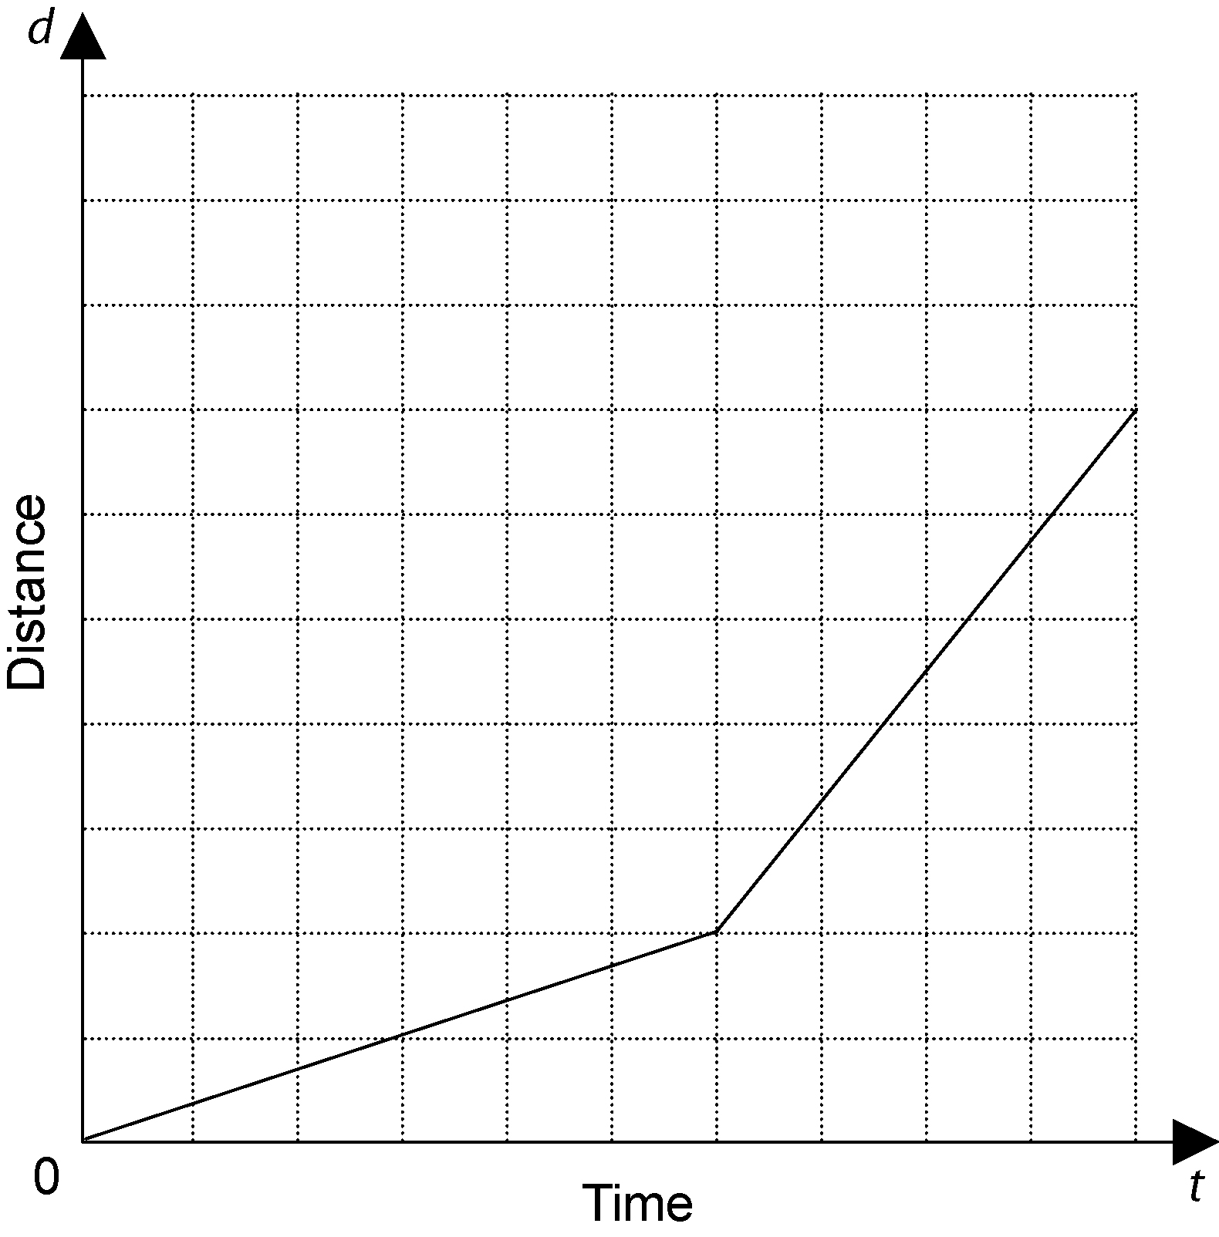
11.

BLM 2.PT.1 Chapter 2 Practice Test
1. B
2. D
3. A
4. a) The number of people who own cell phones increases as the cost of cell phones decreases.
The number of people who own cell phones does not increase as the cost of cell phones decreases.
b) It takes longer to find a specific entry in the telephone book if there are a large number of pages. It does not take longer to find a specific entry in the telephone book if there are a large number of pages.
c) During periods of extremely high water consumption, the quality of tap water decreases. During periods of extremely high water consumption, the quality of tap water does not decrease.
5. a) All the employees of the company
b) list all the employees in alphabetical order; randomly select an employee to begin; survey every tenth employee above and below that name on the list
c) randomly select three people from each department
d) no

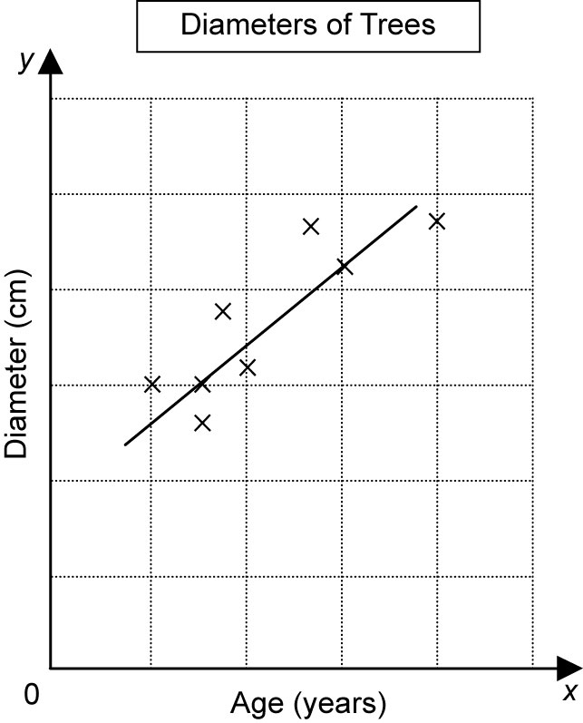
6. a)

b) linear
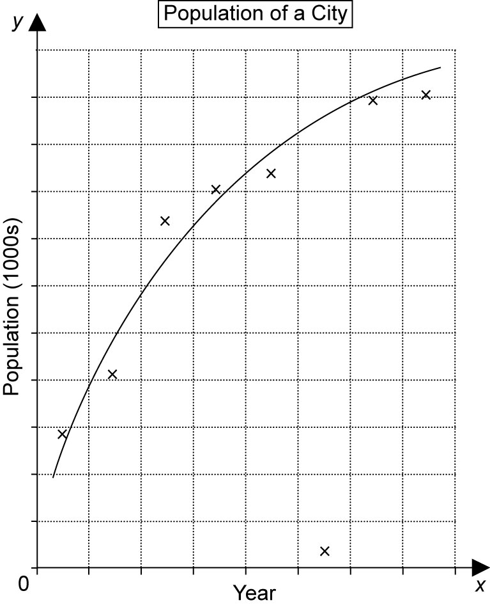
7. a)

b) The population increased rapidly from 1935 to about 1965. From 1965 to 2005, the population continued to grow, but far more slowly.
c) The population in 1985 is 421. This is an outlier. The rest of the data approximates a smooth curve, this data point must have been recorded incorrectly. It can be discarded.
e) about 670 000

BLM 2.CT.1 Chapter 2 Test
1. D
2. C
3. B
4. a) People with heavy backpacks make more frequent visits to the chiropractor.
People with heavy backpacks do not make more frequent visits to the chiropractor.
b) If you take a greater number of courses, you will have more homework.
If you take a greater number of courses, you will not have more homework.
c) When the exchange rate is favourable, the number of Canadians who vacation in the United States increases.
When the exchange rate is favourable, the number of Canadians who vacation in the
United States does not increase.
5. a) all the players in the league
b) number all the players using consecutive numbers; use a calculator or other source of random numbers to select players
c) randomly select three players from each team
d) survey all the players on one team
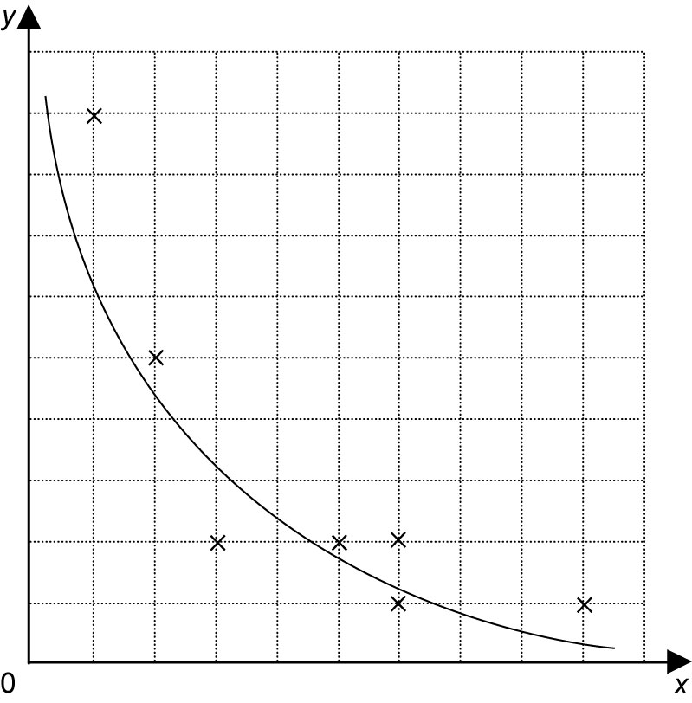
6.

The data appear to lie in a curve, so I drew a curve of best fit.

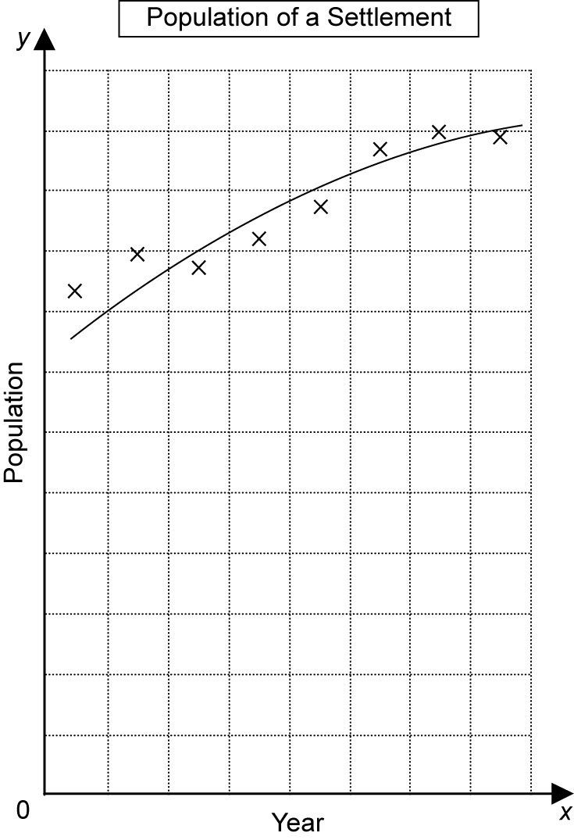
7. a)

b) The population remained fairly stable over the time period shown. There was a small rate of growth.
c) There are no outliers.
e) about 102

