Practice: Get Ready

Add and Subtract Integers

1. Add.
a) 6 + 7 b) (–3) + 9
c) 10 + (–2) d) (–4) + (–7)

2. Find each sum.
a) (–4) + 7 + (–3)
b) 11 + (–2) + 5
c) (–3) + (–8) + (–1)
d) 19 + (–7) + (–2)

3. Subtract.
a) 18 – 3 b) 6 – 8
c) (–7) – (–5) d) 8 – (–4)

4. Find each difference.
a) (–3) – (–4) b) (–6) – (–1)
c) (–6) – 8 d) 3 – (–5)

Multiply and Divide Integers

5. Multiply.
a) 4 × (–3) b) (–3) × (–5)
c) (–8) × 2 d) (–2)(–7)

6. Divide.
a) 14 ÷ (–7) b) (–15) ÷ 3
c) d)

Multiply Rational Numbers

7. Multiply.
a) b)
c) d)

8. Multiply.
a) b)
c) 0.2 × (–0.45) d) (–0.7)(–0.6)

Powers

9. Write each as a power.
a) 2 × 2 × 2 × 2 × 2
b) 6 × 6 × 6
c) t × t × t × t × t × t
d) (–4) × (–4)

10. Expand each power, then evaluate.
a) 3⁴ b) 5⁵
c) 2³ d) 9²

Perimeter and Area

11. Find each perimeter.

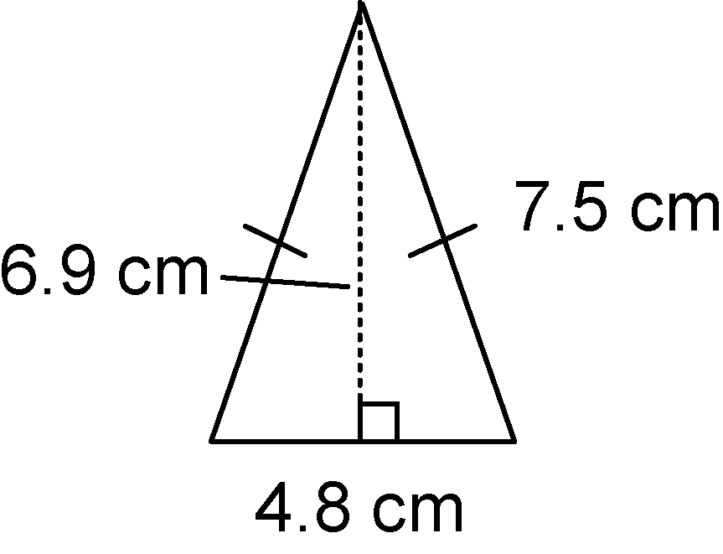
a)

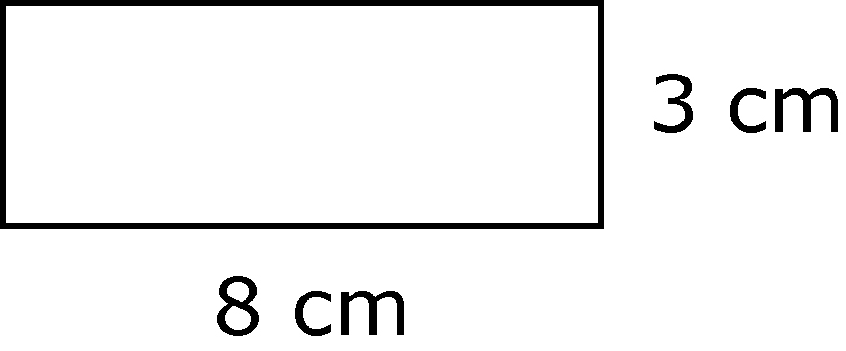
b)

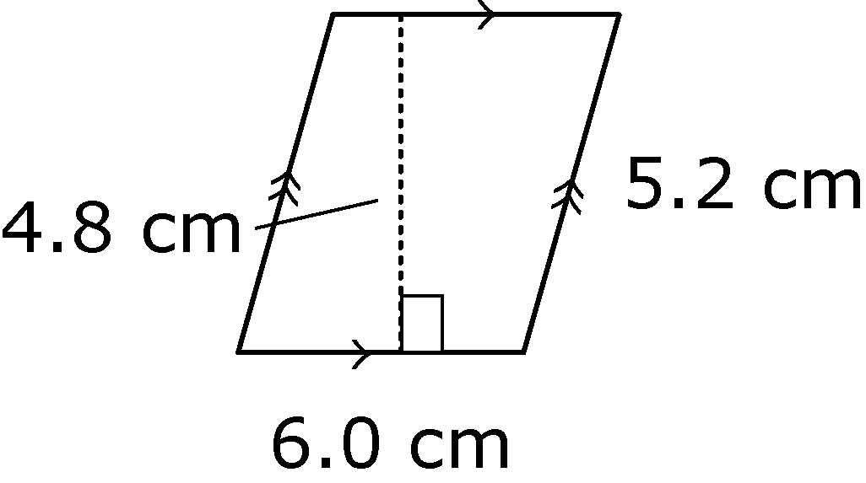
c)

12. Find the area of each figure
in question 11.

