Use Algebra Tiles

Algebra tiles can also be used to solve simple equations. The first example uses Example 2 b)
in your text:
You know that n ÷ 3 is equal to – 4. Use of an x-tile to represent n ÷ 3.

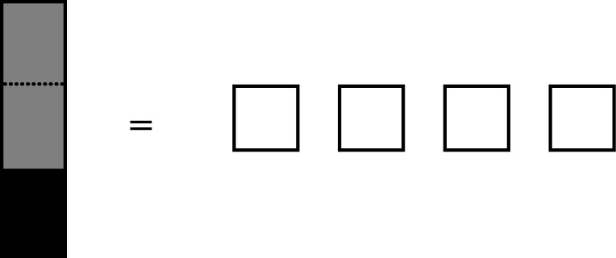

To make a complete x-tile, form three equal groups on both sides:

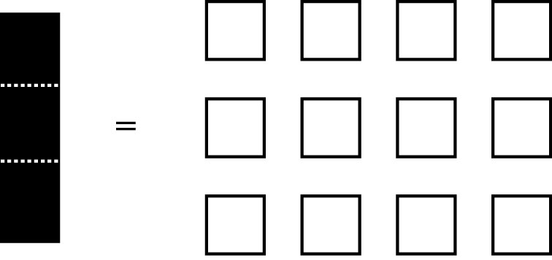

The solution is n = –12.

This example uses Example 2 c) from your text: –v = 9. This equation shows that –v is
equal to +9.

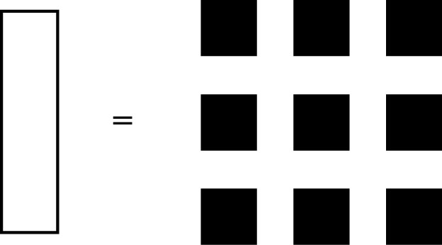
To find +v, add an x-tile to both sides.

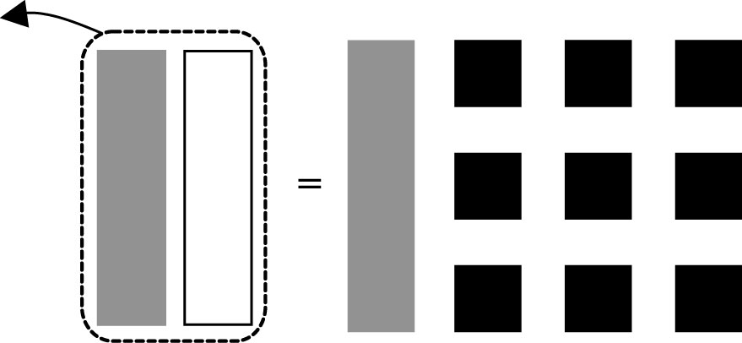

Now, add nine unit tiles to both sides to isolate the variable.
