Construct a Geometric Model With
The Geometer’s Sketchpad®
Example 3 uses an equation to model a geometric relationship. You can use The Geometer’s Sketchpad® to draw a geometric model.

Open a new sketch in The Geometer’s Sketchpad®. Draw a triangle, and measure the angles.

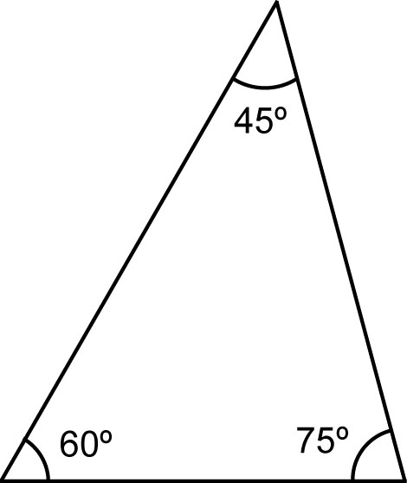

Measure the ratio of the middle angle to the smallest angle. Measure the ratio of the largest angle to the smallest angle. Click and drag vertices of the triangle until these ratios are 2:1 and 3:1.

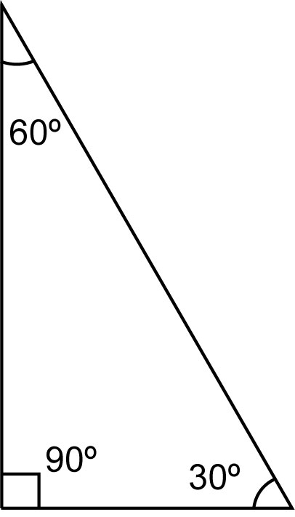

The angles of the triangle are 30°, 60°, and 90°.

