Practice: Solve Multi-Step Equations

1. Solve.
a) 6x + 3 + 2x = 19
b) 10m – 3m + 8 = 43
c) 4a + a + 9 = 44
d) 15 – 3b + b = 3
e) 2y + 4 + 3y = 9
f) 7f – 12 + f = 20
g) 9q + 2 – 8q – 13 = 0
h) 8 – 3k + 5k = 0
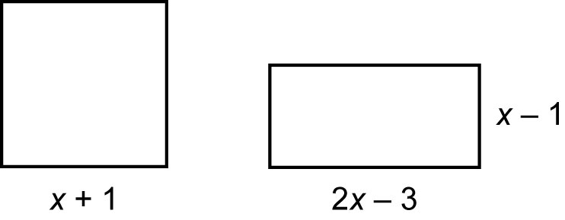
2. Find each root.
a) 3b + 4 = 2b + 6
b) 7p – 18 = 3p – 2
c) 2x + 4 = 5x – 5
d) 8g + 3 = g + 10
e) 6h – 5 = 2h + 3
f) 4m – 9 = m + 7
g) 5r – 6 = 2r + 3
h) –3y + 15 = y – 13

3. Solve.
a) 4(x – 3) = 3x – 7
b) 2(a – 8) + 3(a + 6) = 17
c) 3(2p + 1) = 5(p + 1)
d) 5d = 4(d + 2)
e) 2(3t + 5) – 4(2t – 1) = 6
f) 5(k + 3) = 2(4k + 7) – 5
4. Solve, then check.
a) 2m + 1 – m = 4
b) q + 4 + 2q – 19 = 0
c) g – 3 + 4g = 2g – 6
d) 2(2b + 7) = 3(b + 3) + 3

5. A square and a rectangle have the same perimeter. Find the side lengths of each figure.

6. In a triangle, the measure of the middle angle is triple the measure of the smallest angle, and the measure of the largest angle is 55° greater than the measure of the smallest angle. Find the measures of the angles.

