Practice: Solve Equations Involving
Fractions

1. Solve.
a)
b)
c)
d)

2. Find each root.
a) 2 = (s + 7)
b)
c) (r – 1) = 6
d)
e)
f)

3. Find each root.
a)
b)
c)
d)
e)
f)
4. Solve and check.
a)
b)
c) (9 + g) = g + 1
d)

5. The perimeter of the small square is
one-third the perimeter of the large square. What are the side lengths of the squares?
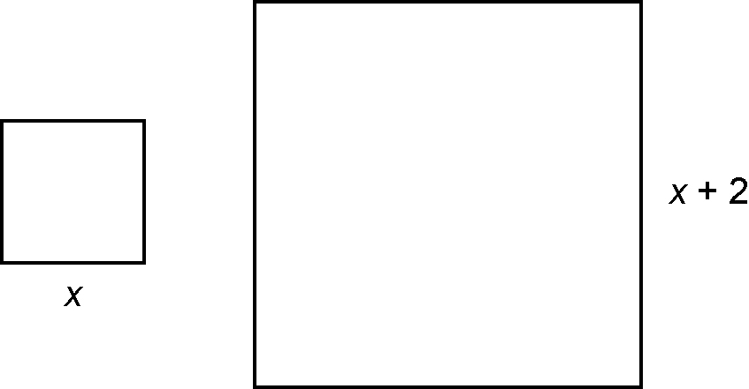

6. The height of a triangle is 2 cm less than its width. The area of the triangle is
24 cm². What are the measures of the
base and height?

