Cross-Multiplication Solution Method
Example 2 addresses equations involving more than one fraction. An alternate technique, called
cross-multiplication, can also be used to solve equations with more than one fraction. Note that the technique of cross-multiplication can only be used if you have two rational expressions equal to each other. If you have more than two expressions, you must clear denominators using the lowest common denominator.

Notice what happens after dividing out common factors:

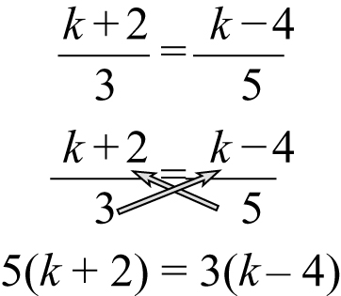

When you have an equation involving just two rational expressions, you can cross-multiply to clear the denominators.

