Practice: Modelling With Formulas

1. The formula for area of a circle is A = π r ² where r is the radius of the circle. Which is the formula rearranged to isolate r?
A
B r = πA
C r =
D

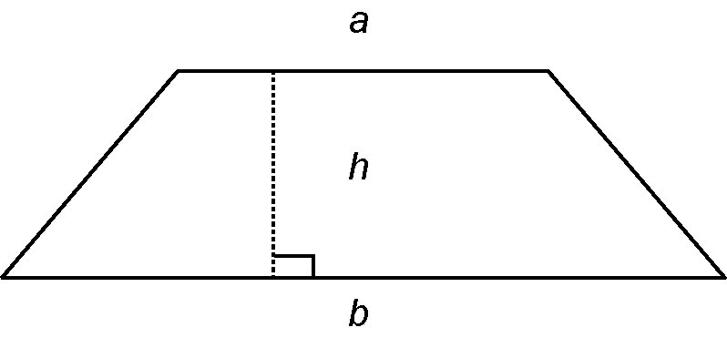
2. The formula for the area of a trapezoid is

Which is the formula rearranged to
isolate h?
A
B h = 2A – (a + b)
C
D
3. Rearrange each formula to isolate the variable indicated.
a) P = 4s for s
b) I = Prt for P
c) for b
d) P = 2(l + w) for l
e) d = st for t
f ) V = π r ²h for h

4. The approximate number of pounds, P, in
a kilogram, K, is given by the formula
P = 2.2K.
a) Christine’s mass is 34 kg. Convert
34 kilograms to pounds.
b) Rearrange the formula to express K in terms of P.
c) Katherine weighs 78 pounds. Convert 78 pounds to kilograms.

