Use a Computer Algebra System Directly
A Computer Algebra System (CAS) can be useful for rearranging formulas. Method 2 for a CAS on
a TI-89 calculator shows entering each step and having the CAS produce the result of that step. However, a CAS can rearrange a formula directly, without intermediate steps. This method, shown below, is useful for checking your work.

Use the solve function from the F2 Algebra menu to rearrange the formula in terms of x.

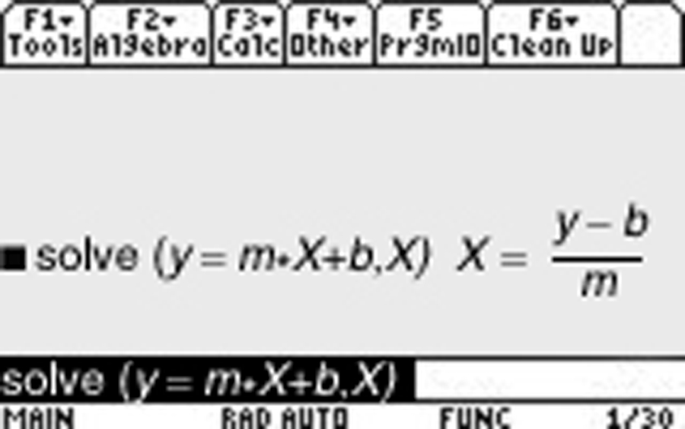

or

