Student Success: Terrific Triangles
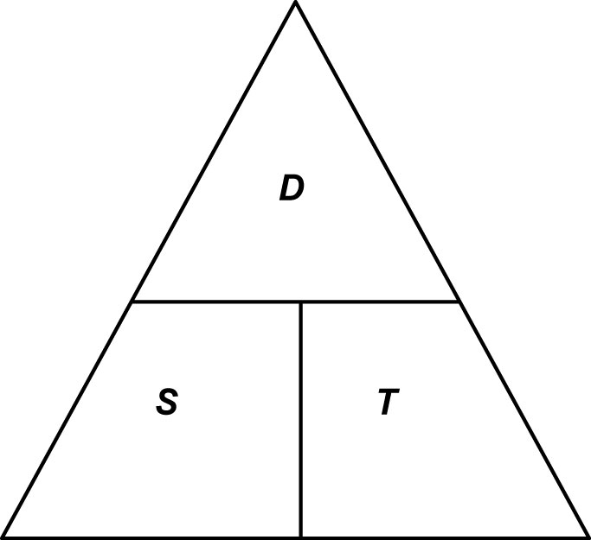
This triangle shows the relationship between speed (S),
distance (D), and time (T).

Cover the letter you want, to get a formula for that letter.

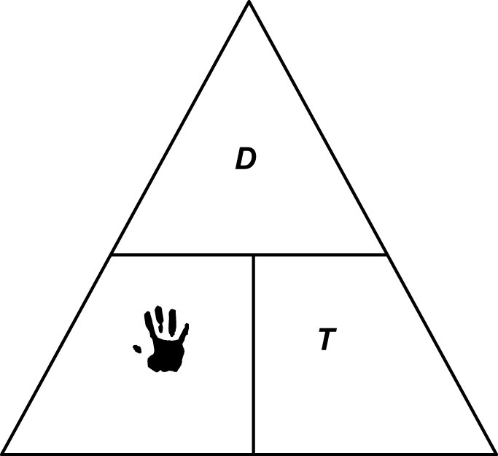

Example 1
If you drive 300 km and it takes 4 hours, your speed in km/hr is

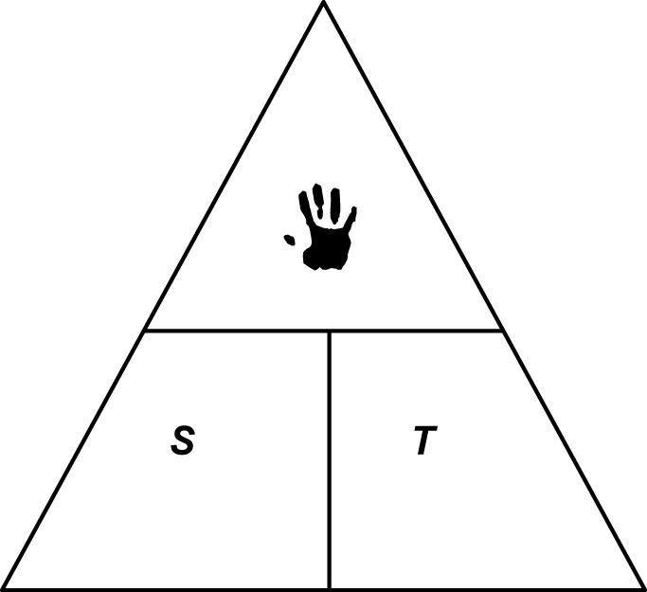

Example 2

A formula for distance (D) is

So, if you drive at 80 km/h for 3 hours, the distance travelled is

For each of the formulas below, construct a Terrific Triangle. Then, write the other formulas related to the first one.

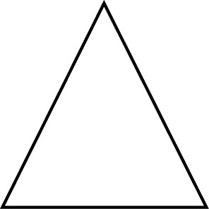
1. The density of an object is given by $D=\frac{M}{V}$ where M is the mass (g) and V is the
volume (cm³).
__________________________________________________________________
__________________________________________________________________
__________________________________________________________________

2. Ohm’s Law of electricity states that the voltage V (volts) is related to the current
I (amperes), and the resistance R (ohms) by the formula $V=\text{IR}$.
__________________________________________________________________
__________________________________________________________________
__________________________________________________________________

3. Actual distance D (km) on a map is given by $D=\text{MS}$ where M is the measure on
the map and S is the scale of the map.
__________________________________________________________________
__________________________________________________________________
__________________________________________________________________

4. Interest I ($) on an investment is given by I = PRT where P ($) is the amount
invested, R (%) is the rate and T (yr) is the time.
__________________________________________________________________
__________________________________________________________________
__________________________________________________________________

5. The area of a rectangle is $A=\text{lw}$.
__________________________________________________________________
__________________________________________________________________
__________________________________________________________________
6. The volume of a rectangular prism is V = lwh.
__________________________________________________________________
__________________________________________________________________
__________________________________________________________________

7. The area of a triangle is A = 0.5bh.
__________________________________________________________________
__________________________________________________________________
__________________________________________________________________

8. Sales tax T ($) on a purchase is found from the formula $T=\text{rP}$ where r (%) is the
sales tax rate and P ($) is the purchase price.
__________________________________________________________________
__________________________________________________________________
__________________________________________________________________

9. a) Use the density formula $D=\frac{M}{V}$ to complete the table:
 | Type of Wood | Mass (g) | Volume (cm³) | Density (g/cm³)
 | Pine | 450 | 1216
 | Oak | 300 |  | 0.59
 | Teak |  | 500 | 0.63
 | Balsa |  | 1000 | 0.17
 | Ebony | 500 |  | 1.12

b) The density of water is 1 g/cm³. Does all wood float? Justify your answer.
_______________________________________________________________
_______________________________________________________________
_______________________________________________________________

