Chapter 4 Test

Multiple Choice

For each question, select the best answer.

1. Which is the solution for 2x – 3 = 7?
A 2 B 5
C 12 D 8

2. Which equation has the solution m = –4?
A 3m + 7 = –5
B m – 3 = 1
C 2m – 1 = –7
D m + 2 = –6

3. The formula for area of a triangle is. Which is the formula rearranged to isolate h?
A h = + b B
C D

4. Alyssa is 3 years older than Jillian. The sum of their ages is 19. Which equation represents the sum of their ages?
A J + 3J = 19 B J + J + 3 = 19
C 3J = 19 D J – 3J = 19

Short Response

5. Solve.
a) p + 4 = 6
b) 5m = –30
c) 7d – 4 = 17
d) 4x + 9 = 2x + 7
e) b = 14 + 2(3 – b) + 1
f) 2(h + 2) + 7 = 5(h + 1)

6. Find each root.
a)
b) (2k – 5) = 3
7. A trapezoid has three equal sides. The perimeter of this trapezoid is given by the formula P = 3a + b.
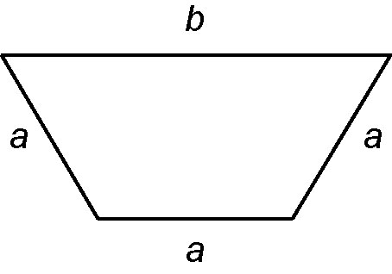

a) Rearrange the formula to isolate b.
b) Rearrange the formula to isolate a.
c) The perimeter of the trapezoid
is 32 cm and the length of side b is
11 cm. Find the length of a.

Extend

Show all your work.

8. Solve, then check.
6 – 3(4k + 1) = 5 + (10 – 8k)

9. Lauren is 3 years older than Megan and Alyssa is 3 years younger than Megan.
The sum of their ages is 42. How old is each girl?

10. Campbell works for a cable company. He earns $9.10 per hour, plus $12.00 for each upgraded contract he sells.
a) Last week Campbell worked 12 h and sold 5 contract upgrades. How much did he earn?
b) On March Break, Campbell is scheduled to work 40 h. He hopes to earn $640. How many upgrades does he need to sell?

