Practice: Get Ready

Collect Like Terms

1. Simplify.
a) 6m + 7m + m b) 5x – 3x + 9x
c) 7y – y – 3y d) 4p + 2p – p

2. Simplify.
a) 4x + 7 –3x + 1
b) 5b + 2 + 4b + 6
c) 3 + 3w –2 – w
d) 9 – 7a + 4 + 9a

Distributive Property

3. Simplify.
a) 2(4x – 3) b) 6(a + 3)
c) –7(2y – 5) d) –3(8 + 2b)
e) 3(2m + 1) f) –6(1 – v)
g) –(n + 2) h) 3(5 + g)

4. Simplify.
a) 3(5x + 4) + 2(4x + 1)
b) 2(3a – 6) + (a – 4)
c) 5(2y – 1) + (8y + 2)
d) 6(b – 5) – 2(b + 3)
e) 2(4z + 1) – 3(z + 2)
f) 5(2k – 3) – (k + 8)

Geometric Relationships
5. Find the measure of each angle x.

a)

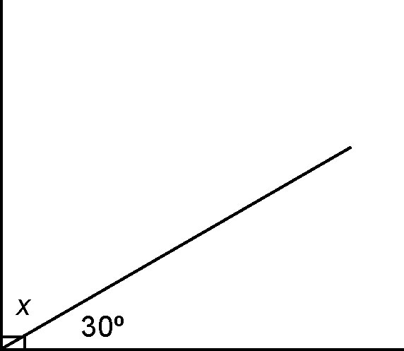
b)

6. Find the measure of each unknown angle.
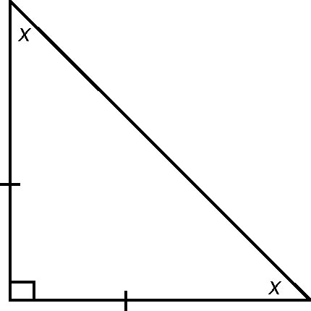
a)

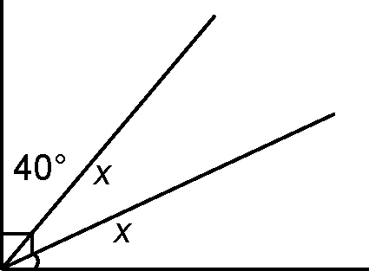
b)

Lowest Common Denominator

7. Find the LCD for each pair of fractions.
a) b)
c) d)

8. Find the LCD for each set of fractions.
a) b)
c) d)

9. Evaluate.
a) b)
c) d)

10. Find each sum or difference.
a) b)
c) d)

