Performance Task
Tools   grid paper  Technology Tools   graphing calculators   The Geometer’s  Sketchpad®   computers  Related Resources  BLM T4 The Geometer’s Sketchpad® 3  BLM T5 The Geometer’s Sketchpad® 4  BLM G10 Grid Paper  BLM A8 Application General Scoring Rubric | Seismic disturbances (shot point) result in vibrations that pass through the Earth. Sometimes, these vibrations pass through the Earth, strike a boundary, and reflect back to the surface. The path of the vibration is called a ray path (red lines). Imagine that there is a boundary 10 m below the Earth’s surface and that the speed of the vibration, as it passes through the layer, is 5 m per millisecond. The value x is a distance, along the surface from the shot point, at which the vibration emerges.  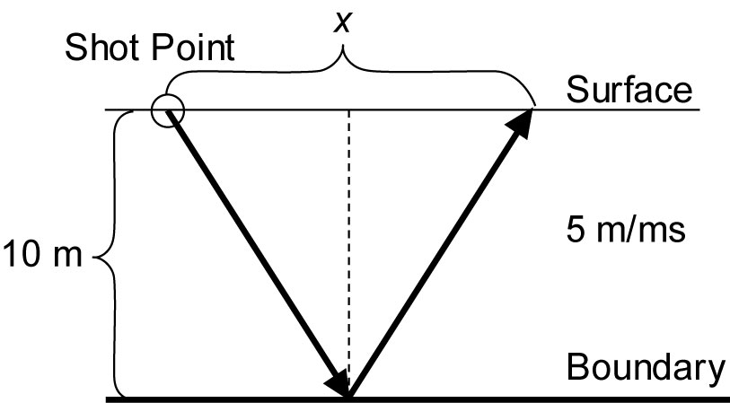  a) Given that the vibration (ray path) comes out of the surface 150 m away from the shot point, what is the total length of the ray path?  b) Pick any value between 200 m and 300 m to represent a distance along the surface and find the total length of the ray path.  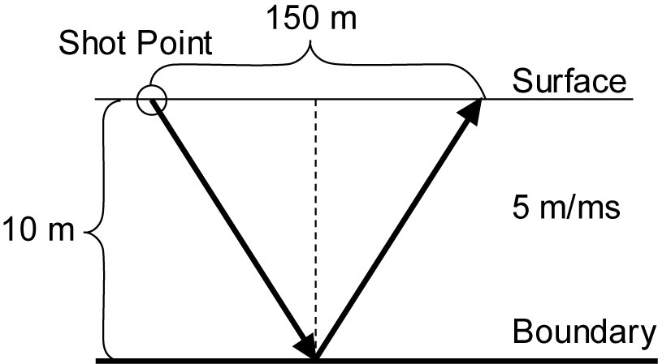  c) Given that the triangles, on either side of the dashed line, are equal, construct a formula that represents the total length of the ray path.  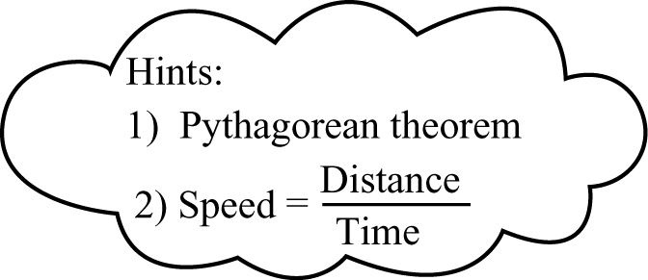  d) Use the formula that you constructed to determine the length of the ray path for 5 distances (50 m–150 m) along the surface from the shot point. Organize your data into a table, and construct a graph.

