Practice: Direct Variation

1. Find the constant of variation for each direct variation.
a) The cost for a long-distance telephone call varies directly with time. A 12-min phone call cost $0.96.
b) The total mass of magazines varies directly with the number of magazines. The mass of 8 magazines is 3.6 kg.
c) The distance travelled varies
directly with time. In 3 h, Alex drove 195 km.

2. The cost, C, in dollars, of wood required to frame a sandbox varies directly with the perimeter, P, in metres, of the sandbox.
a) A sandbox has perimeter 9 m. The wood cost $20.70. Find the constant of variation for this relationship. What does this represent?
b) Write an equation relating C and P.
c) Use the equation to find the cost of wood for a sandbox with perimeter
15 m.

3. The cost, C, in dollars, to park in a downtown parking lot varies directly with the time, t, in hours. The table shows the cost for different times.
t (h) | C ($)
0 | 0
0.5 | 1.50
1 | 3.00
1.5 | 4.50
2 | 6.00
2.5 | 7.50
a) Graph the data in the table.
b) Write the constant of variation for this relationship. What does it represent?
c) Write an equation relating C and t.
4. The distance, d, in kilometres, Kim travels varies directly with the time, t, in hours, she drives. Kim is travelling at 80 km/h.
a) Assign letters for variables. Make a table of values to show the distance Kim travelled after 0 h, 1 h, 2 h, and
3 h.
b) Graph the relationship.
c) What is the constant of variation for this relationship?
d) Write an equation in the form y = kx.

5. a) Describe a situation this graph could
represent.
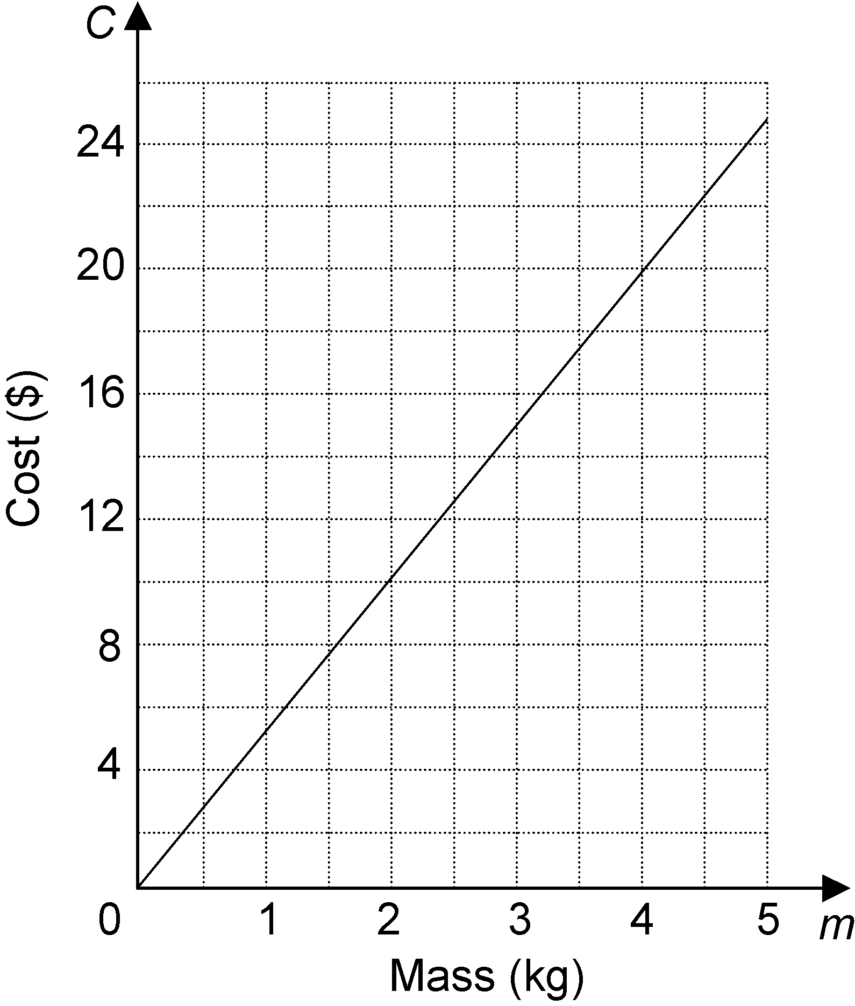
b) Write an equation for this relationship.

