Practice: Partial Variation

1. Identify each relation as a direct variation or a partial variation.
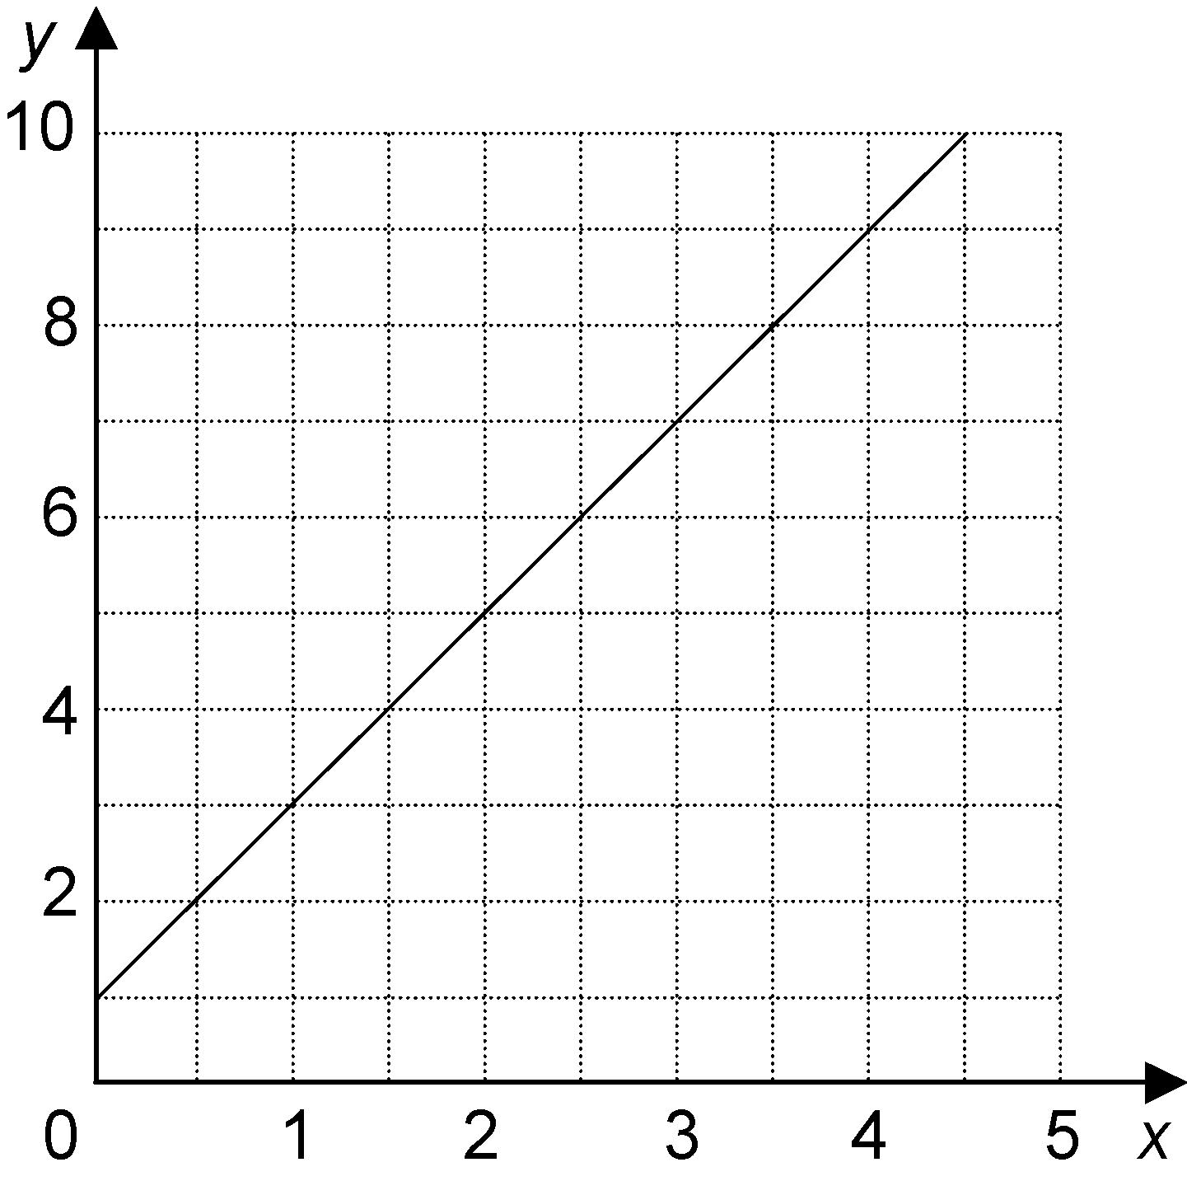
a)

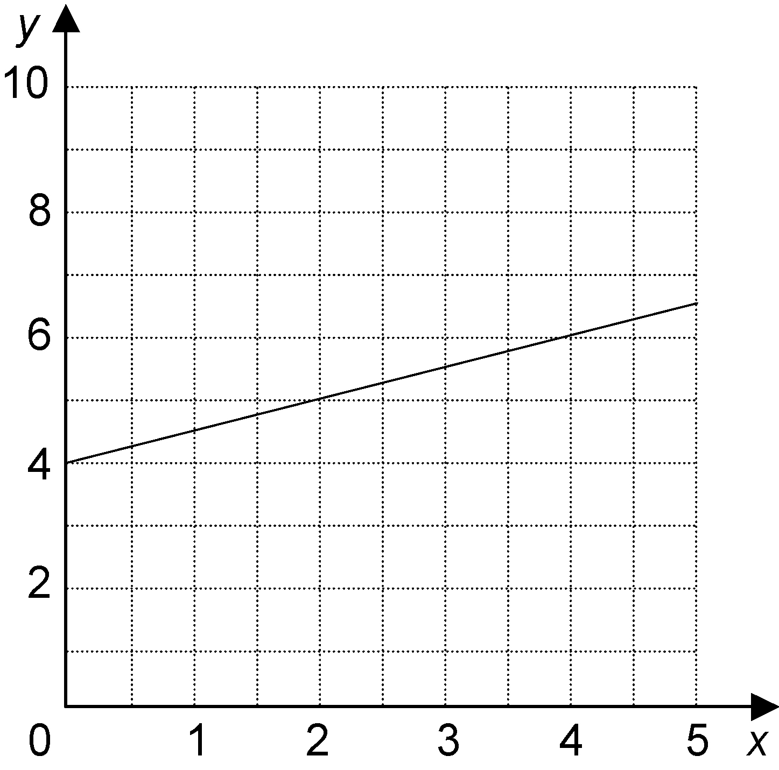
b)

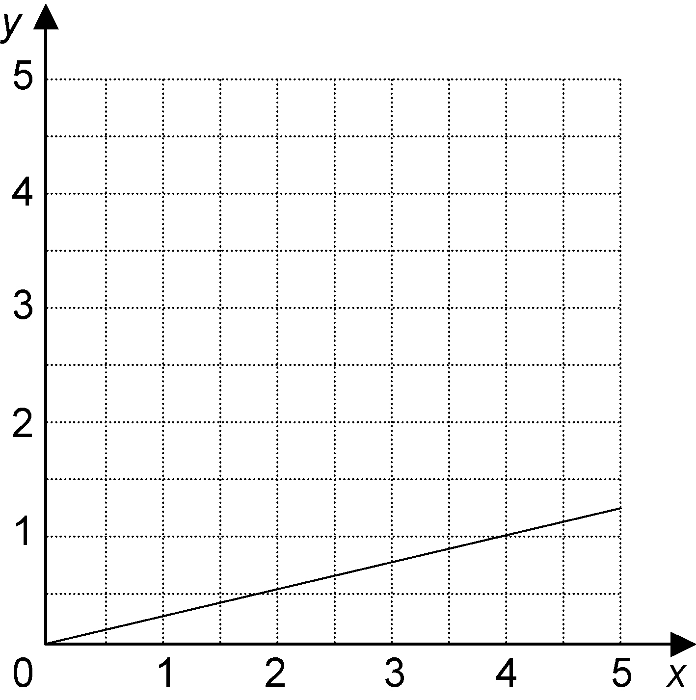
c)

2. Identify each relation as a direct variation or a partial variation.
a) y = 3x + 2 b) y = 2x
c) C = 0.65n d) h = 5t + 2

3. The relationship in the table is a partial variation.
x | y
0 | 3
1 | 4
2 | 5
3 | 6
4 | 7
a) Use the table to identify the initial value of y and the constant of variation.
b) Write an equation in the form
y = mx + b.
c) Graph the relation. Describe
the graph.

4. Latoya is a sales representative. She earns a weekly salary of $240 plus 15% commission on her sales.
a) Copy and complete the table of values.
Sales ($) | Earnings ($)
0
100
200
300
400
500
b) Identify the initial value and the constant of variation.
c) Write an equation relating Latoya’s earnings, E, and her sales, S.
d) Graph the relation.

