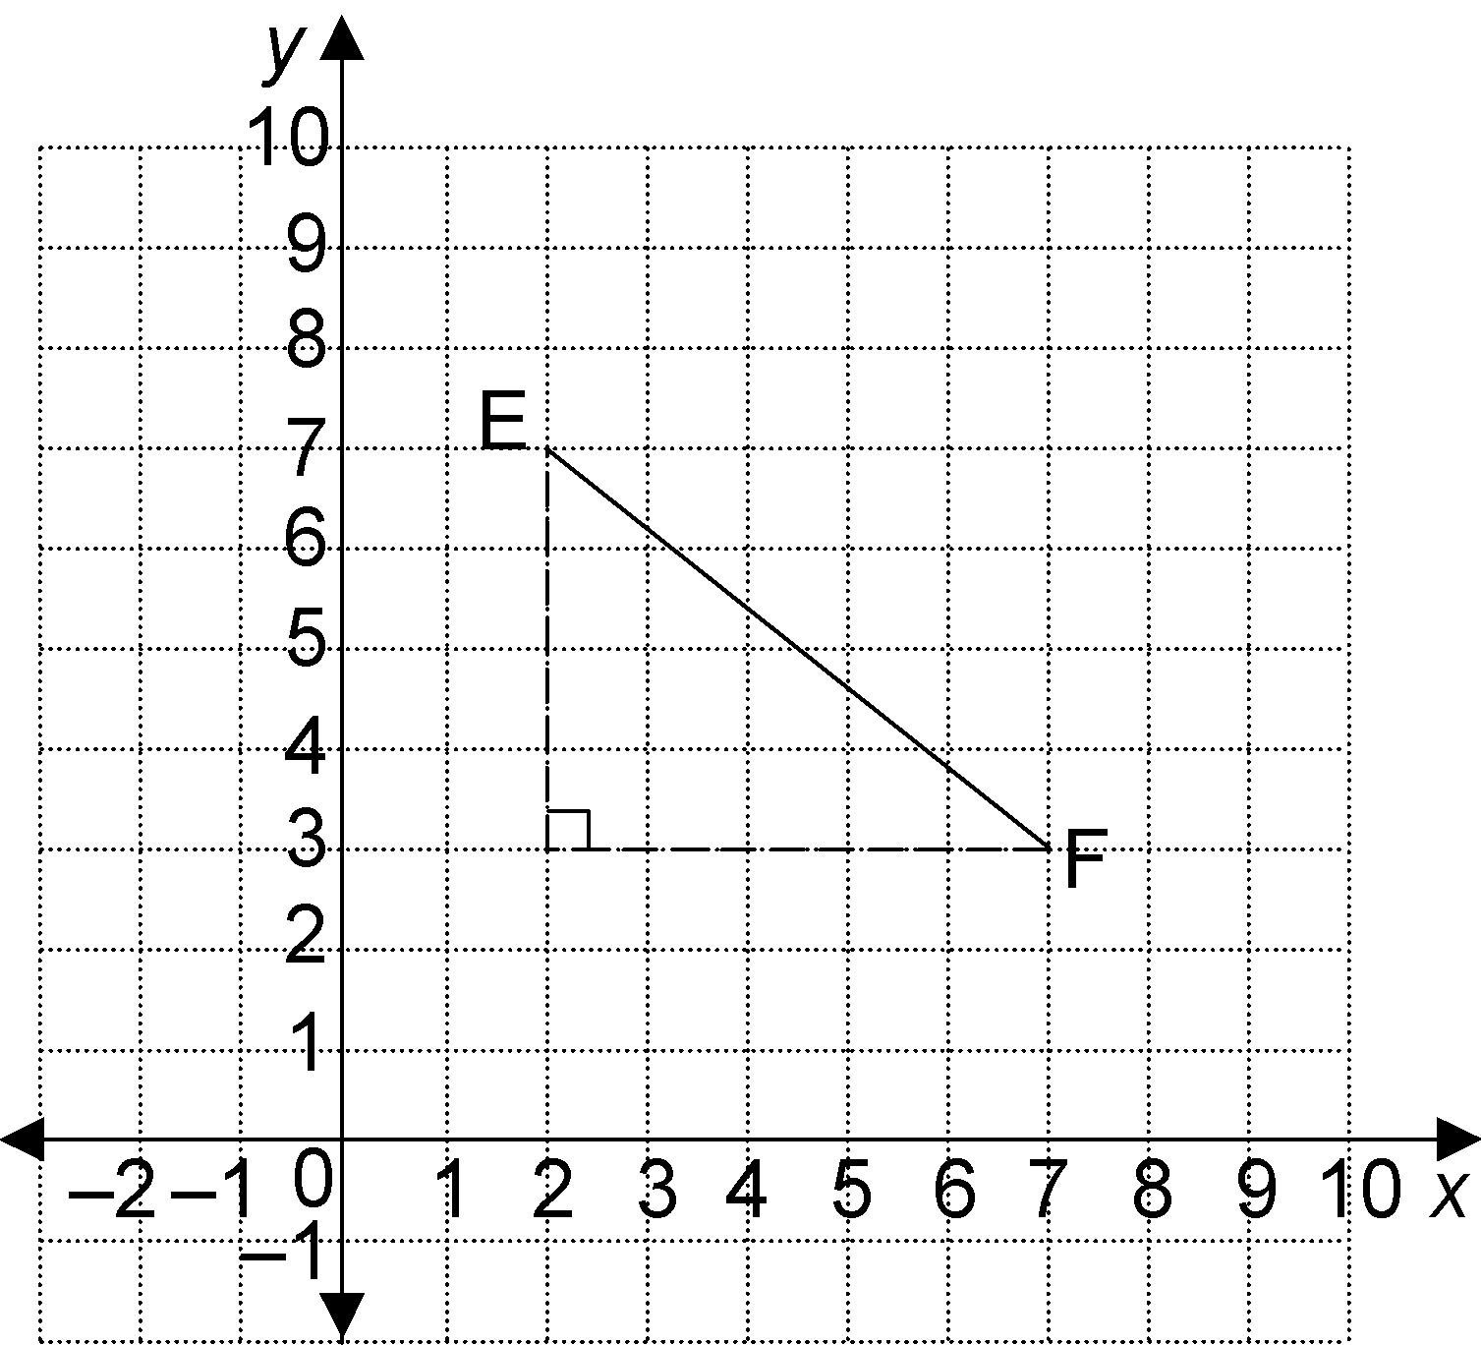
Practice: Slope

1. Find the slope of each object.
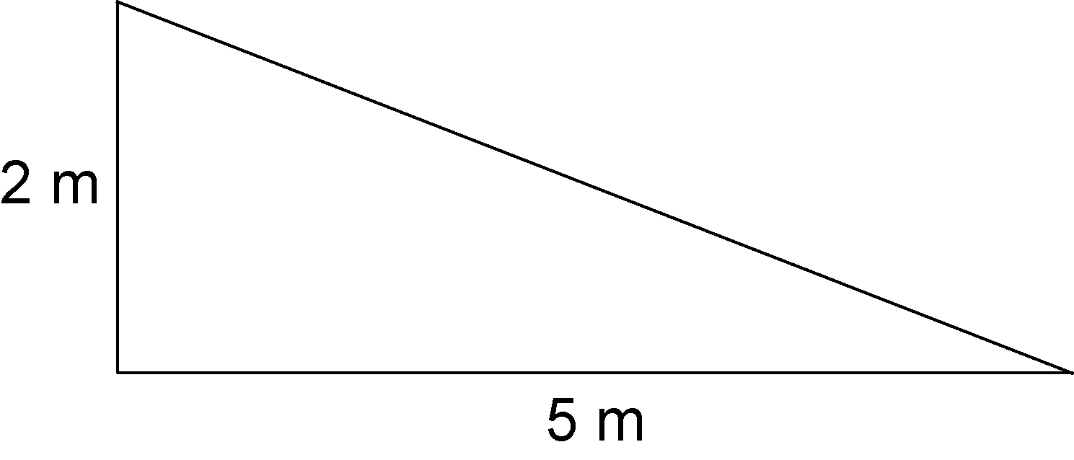
a)

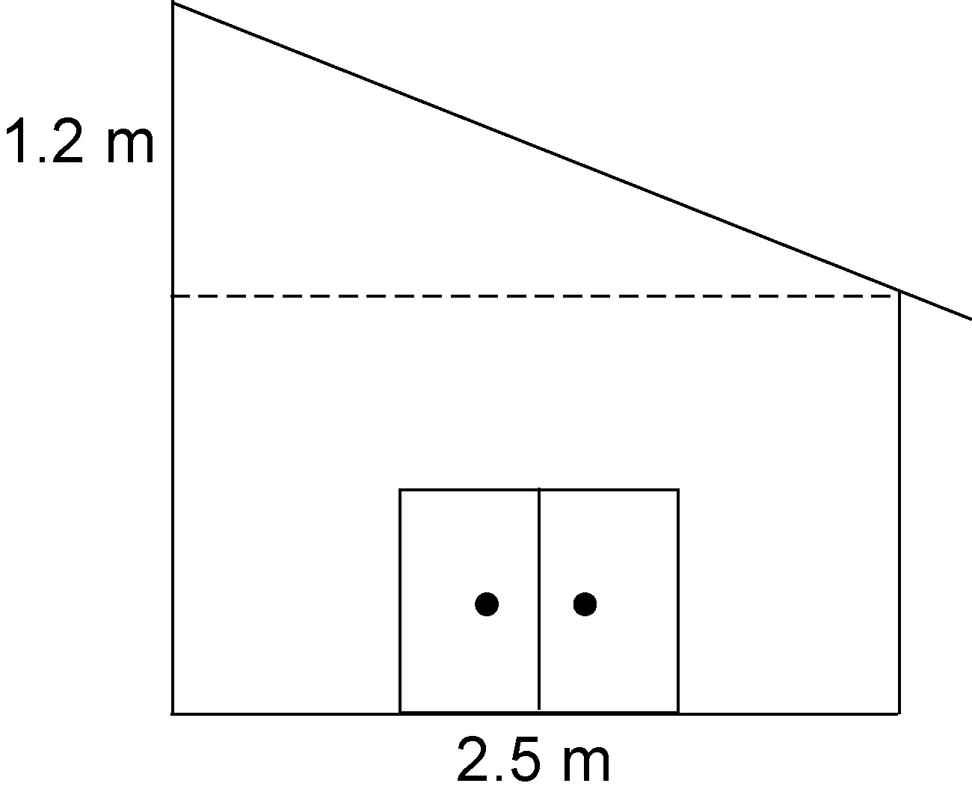
b)

2. Find the slope of each line segment.
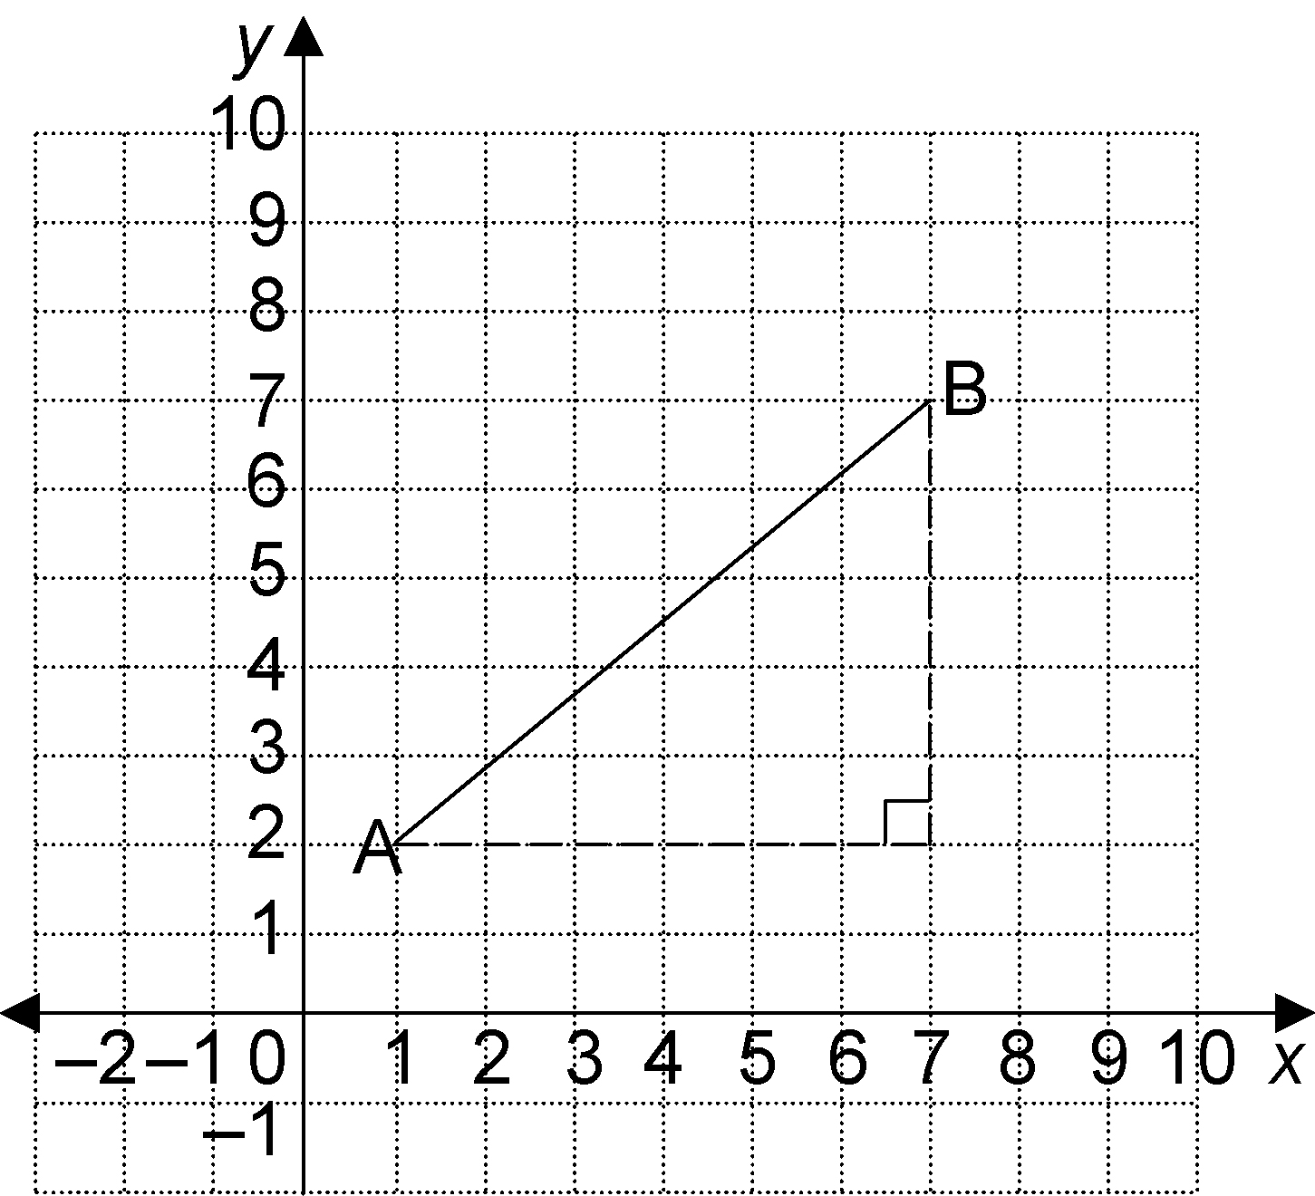
a)

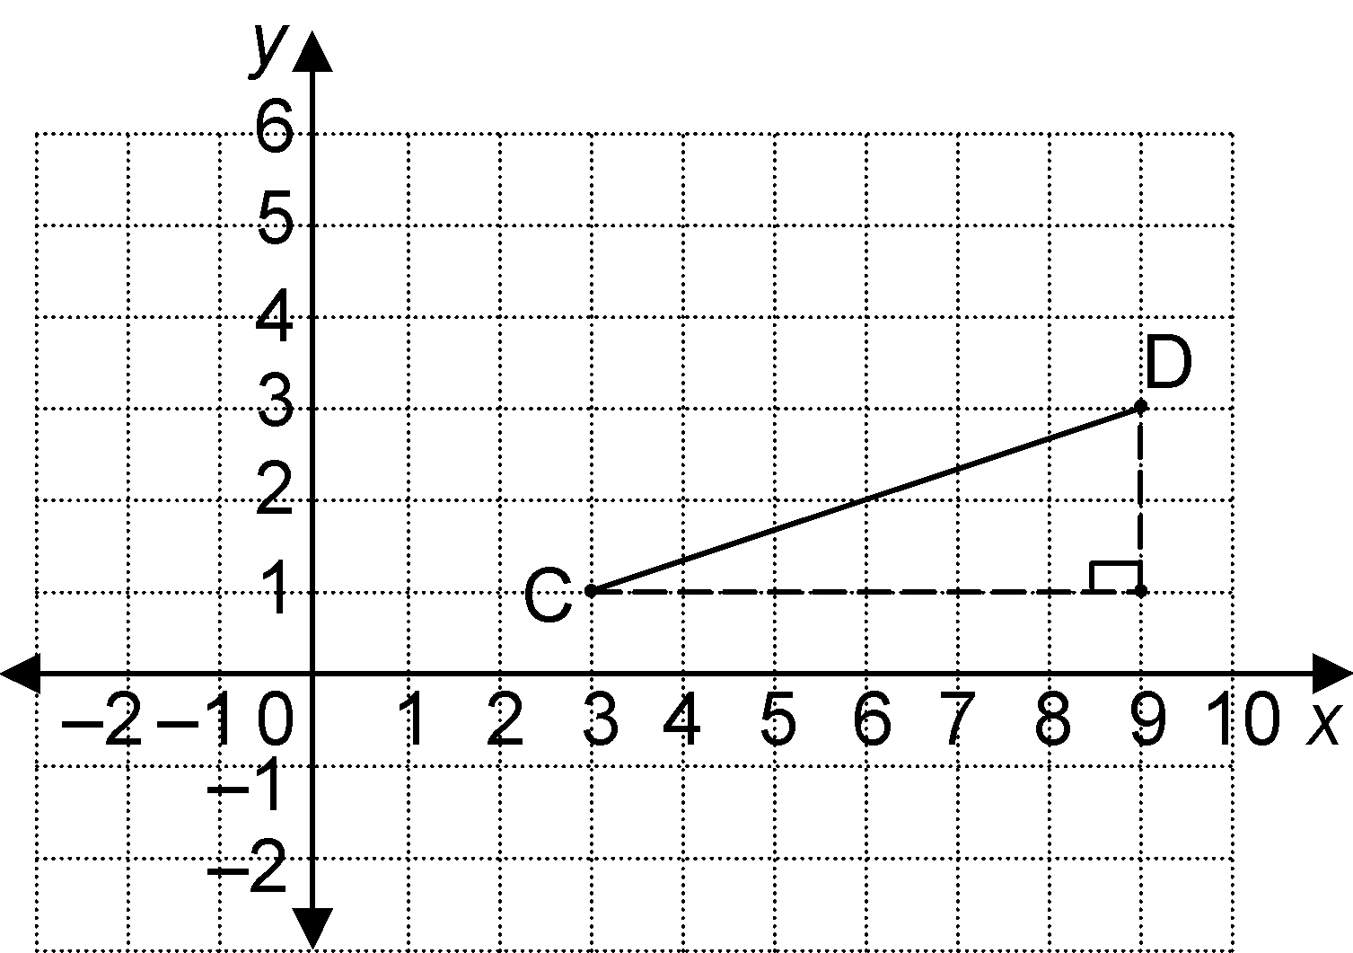
b)

c)

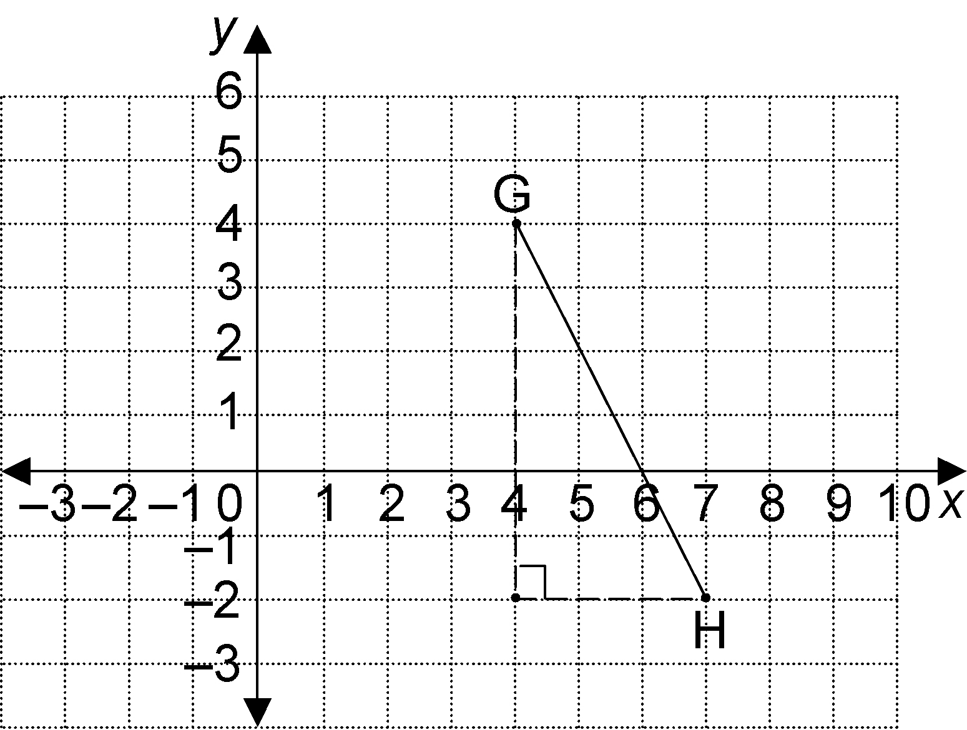
d)

3. For safety, the slope of a staircase must
be greater than 0.58 and less than 0.70.
A staircase has a vertical rise of 2.4 m over a horizontal run of 3.5 m.
a) Find the slope of the staircase.
b) Is the staircase safe?

4. Find the slope of each line segment.
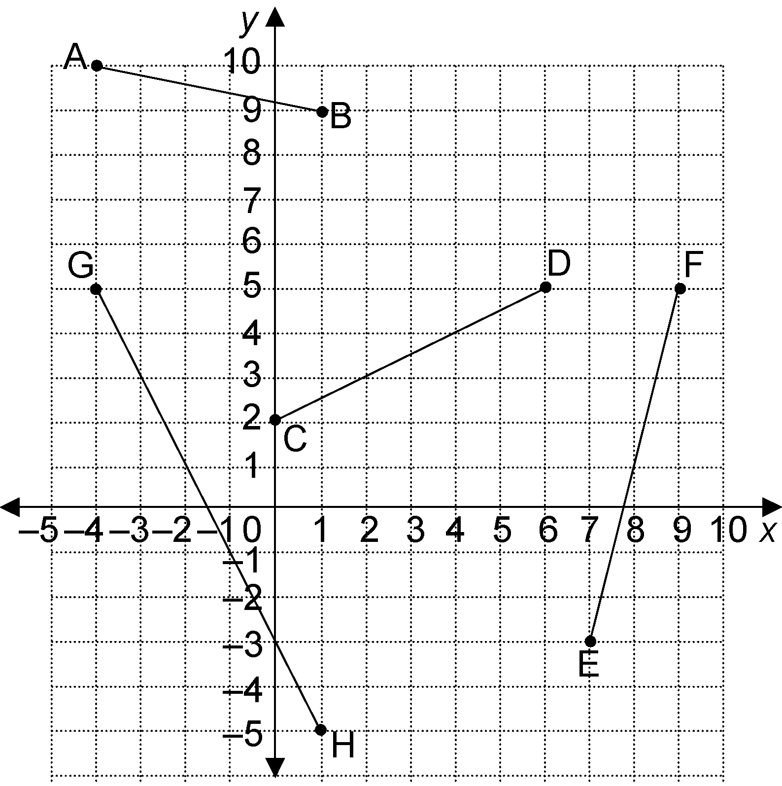

a) AB
b) CD
c) EF
d) GH

5. Point A (2, 3) is plotted on the grid. Draw a line segment AB with slope $−\frac{1}{2}$. What are possible coordinates of B?
