Practice: Slope as a Rate of Change

1. At rest, Vicky takes 62 breaths every 5 min. What is Vicky’s rate of change of number of breaths?

2. When he is sleeping, Jeffrey’s heart beats 768 times in 12 min. What is his rate of change of number of heartbeats?

3. A racecar driver completed a 500-km closed course in 2.8 h. What is the rate of change, or speed?

4. The graph shows the speed of the cars on a roller coaster once the brakes are applied.
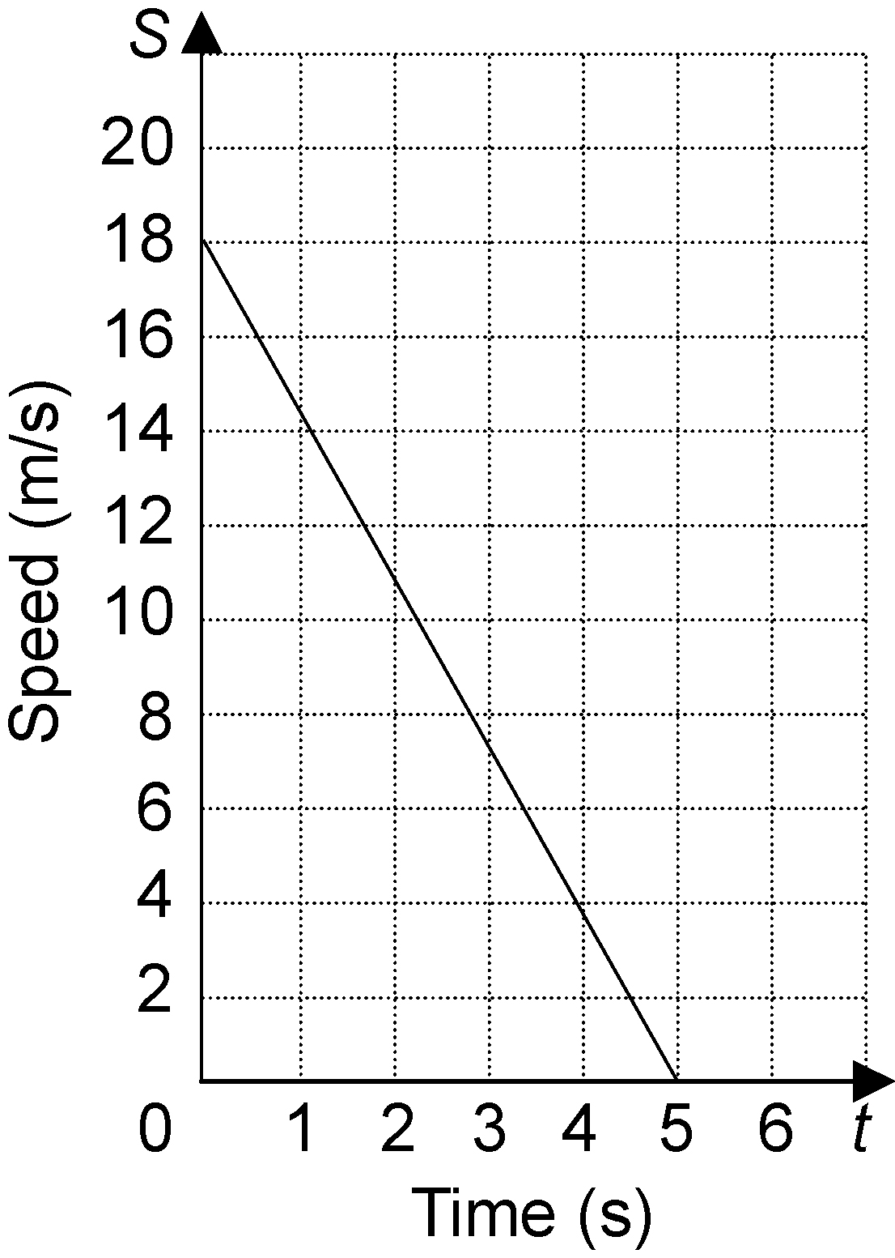
a) Find the slope of the graph.
b) Interpret the slope as a rate of change.

5. a) Make a table relating the number of
squares to the diagram number. Graph the data in the table.

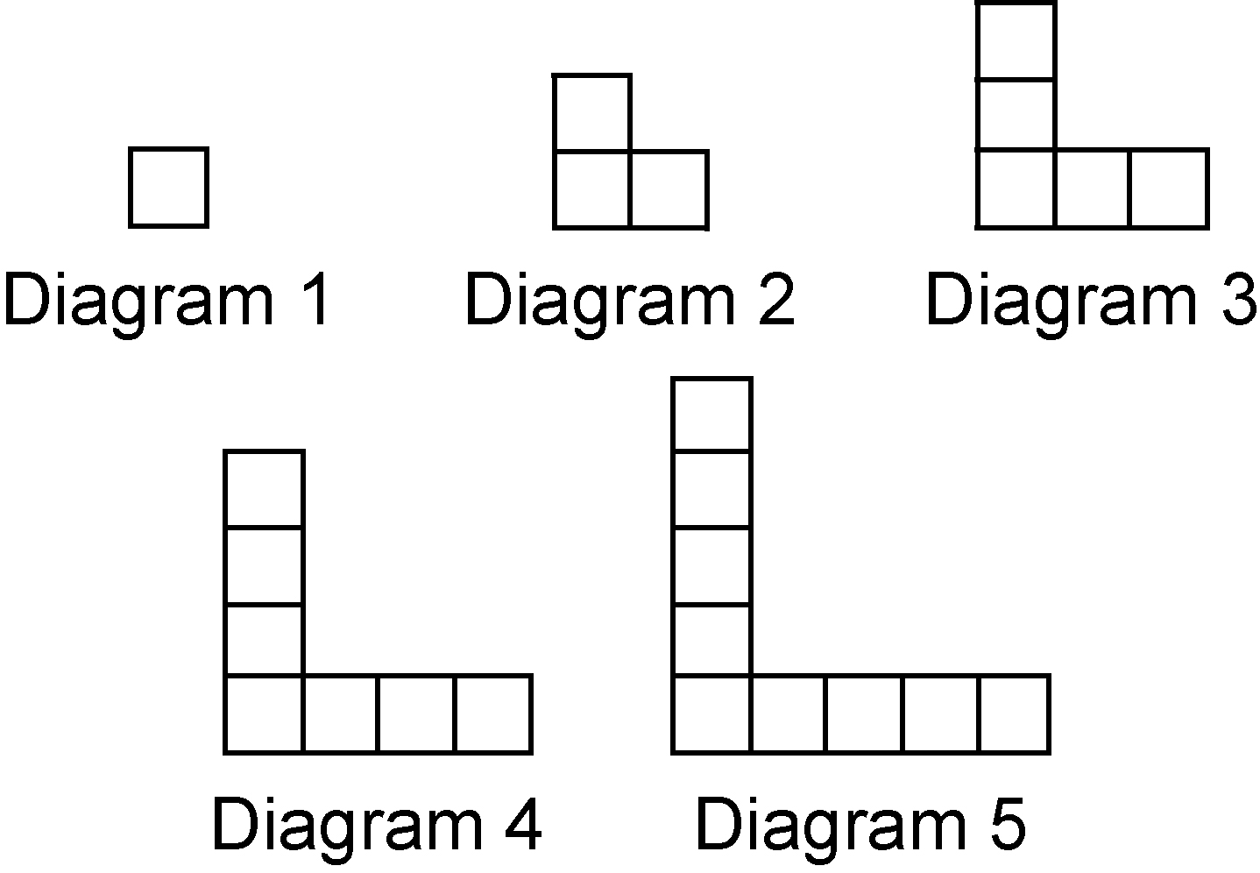

b) Find the slope of the graph.
c) Interpret the slope as a rate of change.

