Practice: Connecting Variation, Slope,
and First Differences

1. Look at this graph of a relation.

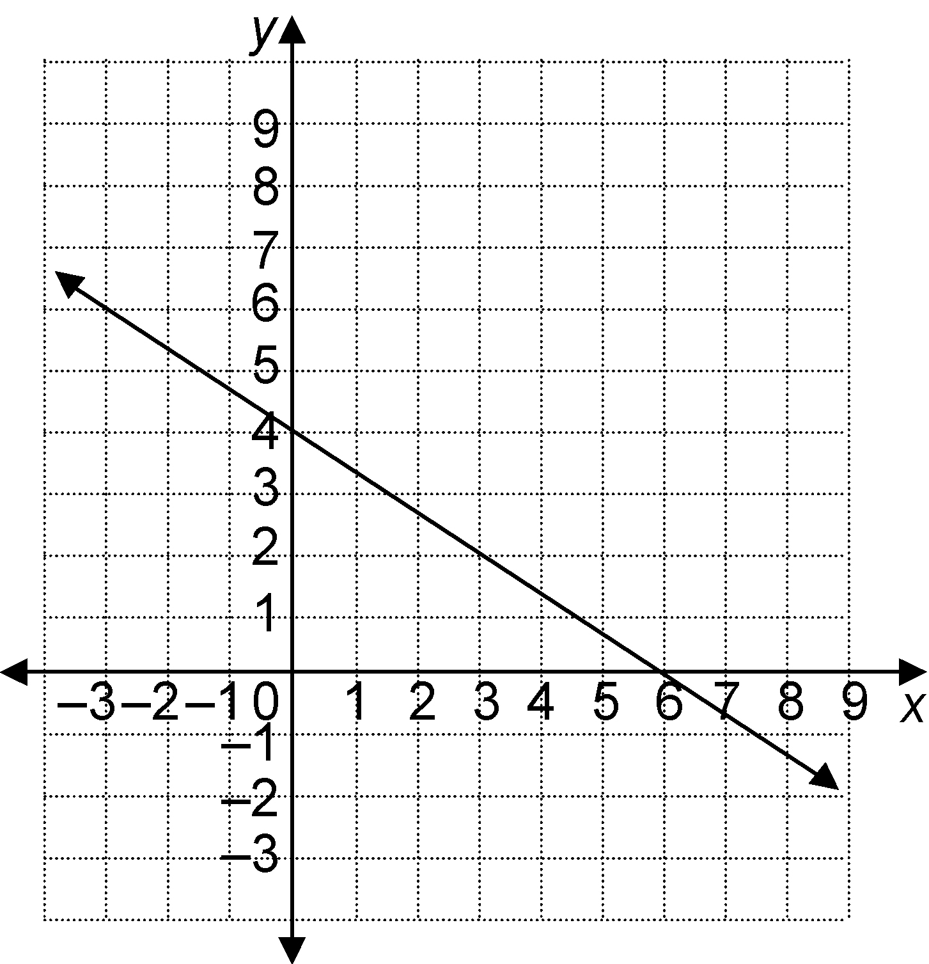
a) Calculate the slope.
b) Determine the vertical intercept.
c) Write an equation for the relation of the form y = mx + b.
2. Look at this graph of a relation.

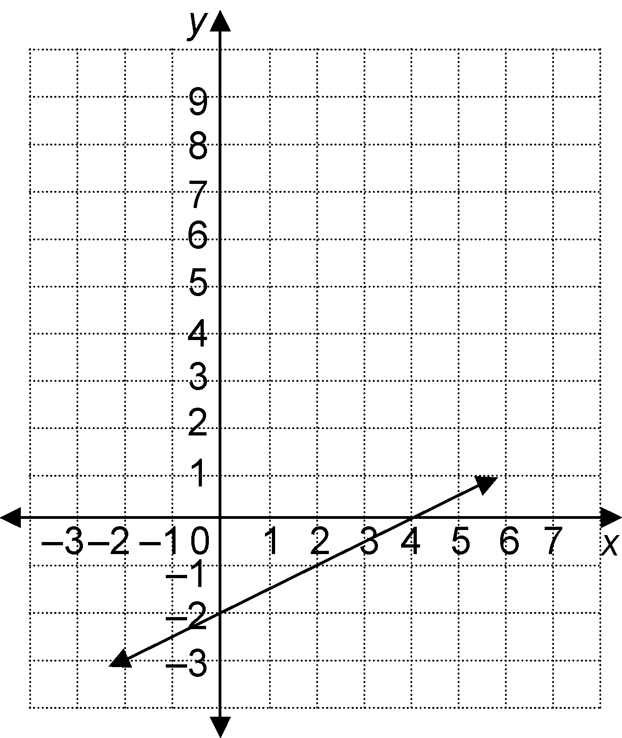
a) Calculate the slope.
b) Determine the vertical intercept.
c) Write an equation for the relation.
3. A relation is represented by the equation
y = 3x – 5.
a) Is this relation a direct variation or a partial variation?
b) Identify the initial value of y.
c) Identify the constant of variation.
d) Make a table of values for x-values from 0 to 4.
e) Graph the relation.

4. The table represents a relation.
x | y
0 | –1
1 | 3
2 | 7
3 | 11
4 | 15
5 | 19
a) Use a graph to represent the relation.
b) Use words to represent the relation.
c) Identify the vertical intercept and the slope. Write an equation to represent the relation.

5. A large cheese pizza costs $8.00, plus $0.50 for each topping.
a) Make a table to represent the relation.
b) Graph the relation.
c) Write an equation to represent the relation.

6. Represent this relation using words, with numbers, and with an equation.
