Chapter 5 Review

5.1 Direct Variation, pages 238–245
1. a) Graph the data in the table.
x | y
0 | 0
1 | 0.5
2 | 1.0
3 | 1.5
4 | 2.0
5 | 2.5
b) What is the constant of variation for this relationship?
c) Write an equation relating y and x.
2. Evan earns $7/h babysitting. The amount he earns, in dollars, varies directly with the time, in hours, he babysits.
a) Assign variables. Make a table of values showing Evan’s earnings for 0 h, 1 h, 2 h, 3 h, and 4 h.
b) Graph the relationship.
c) Identify the constant of variation. What does this represent?
d) Write an equation in the form y = kx.
5.2 Partial Variation, pages 246–253
3. Classify each relation as a direct variation, a partial variation, or neither. Explain.
a) d = 45t b) y = 2x² + 3
c) y = 2x + 3 d) d = 45t + 12
4. The relationship between the variables in the table is a partial variation.
x | y
0 | 1
1 | 6
2 | 11
3 | 16
4 | 21
5 | 26

a) Identify the initial value of y and the constant of variation.
b) Write an equation in the form
y = mx + b.
c) Graph the relation. Describe the graph.

5. The owner of a small business is having brochures printed. The design cost is $1500. Printing costs $0.08 per brochure. The relationship between cost and the number of brochures is a partial variation.
a) Identify the fixed cost and the variable cost.
b) Write an equation for this relationship.
c) What is the total cost for 800 brochures?

5.3 Slope, pages 254–263

6. Find the slope of each line segment.
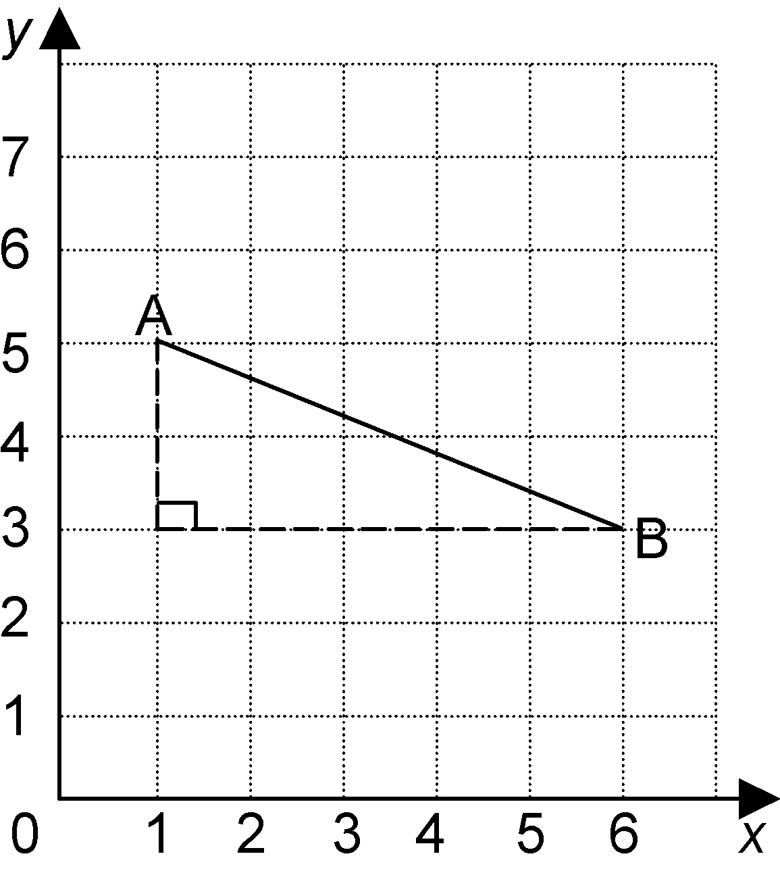
a)

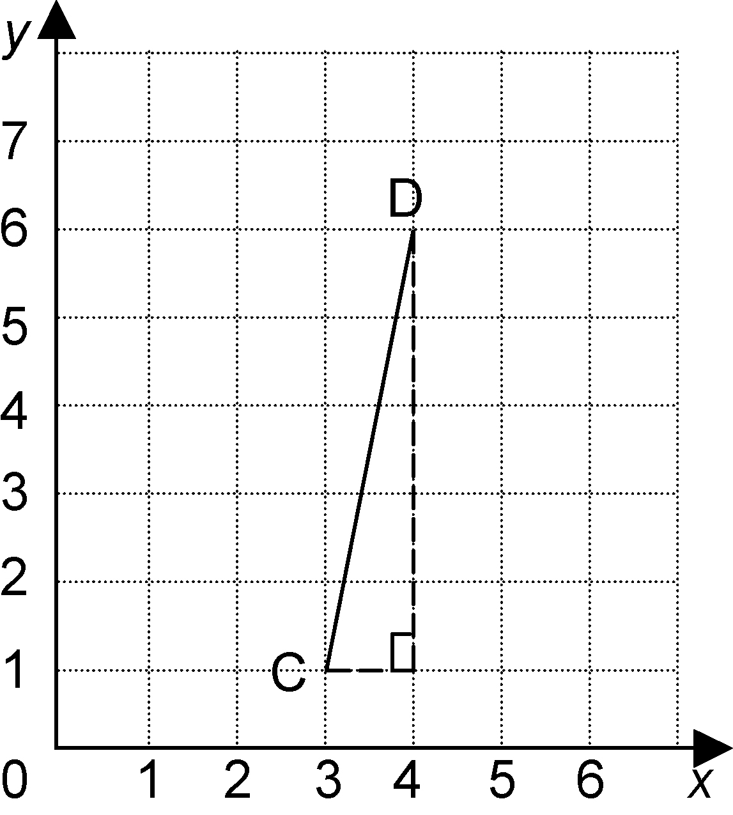
b)

7. Calculate the slope of each line segment.
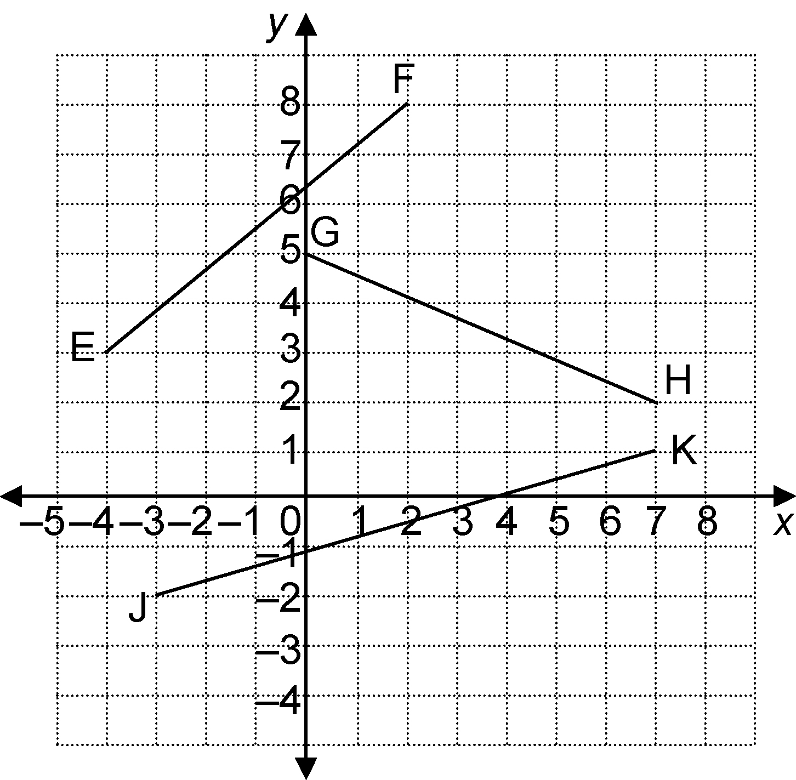

a) EF b) GH c) JK

8. One endpoint of line segment AB is
A(3, 4). The slope of this line segment
is $\frac{2}{3}$. Find possible coordinates for B.

5.4 Slope as a Rate of Change,
pages 264–271

9. It took 8 min to fill a 52-L bucket.
a) What is the rate of change of the volume of water?
b) Graph the volume of water in the bucket over time.

10. Tom and Ana ran a race. The graph shows the distance each person ran in 10 s.
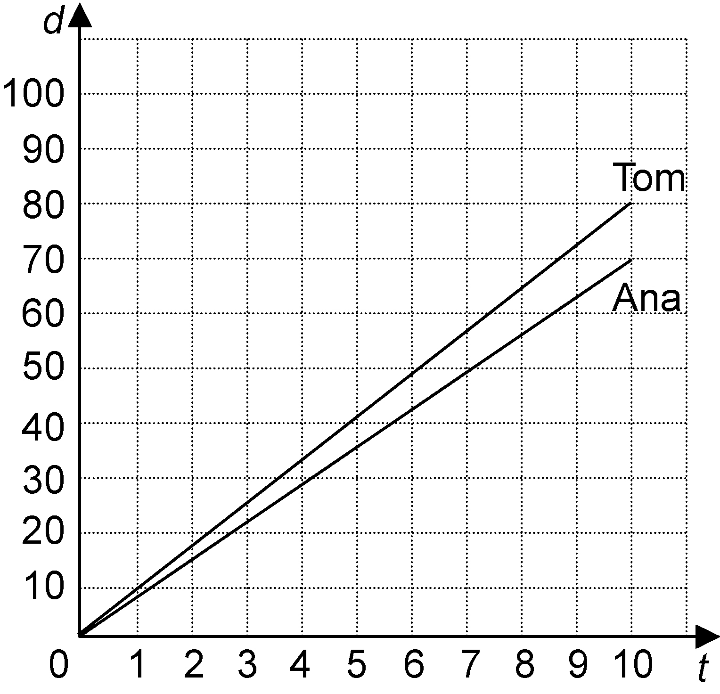
Who ran faster? How much faster?

5.5 First Differences, pages 271–278

11. Use first differences. Is each relation linear or non-linear?
a) b)
x | y |  | x | y
0 | –1 |  | 0 | 0
1 | 2 |  | 1 | –2
2 | 5 |  | 2 | –4
3 | 8 |  | 3 | –6
4 | 11 |  | 4 | –8
5 | 14 |  | 5 | –10

12. a) Make a table comparing the side
length of a square to its perimeter for side lengths 1, 2, 3, 4, and 5.
b) Is the relationship between side length and perimeter linear or non-linear?

5.6 Connecting Variation, Slope, and First
Differences, pages 279–287

13. Represent the relation y = x + 2 using numbers, a graph, and words.

