Chapter 5 Test

Multiple Choice

For each question, select the best answer.

1. Which relation is a direct variation?
A y = 5x B y = 2^{x}
C y = 5x² D y = 5x – 2

2. The cost of tea varies directly with the mass. Liz bought 4.5 kg of tea for $10.35. What is the constant of variation?
A 0.43 B 14.85
C 5.85 D 2.30

3. What is the slope of this ramp?
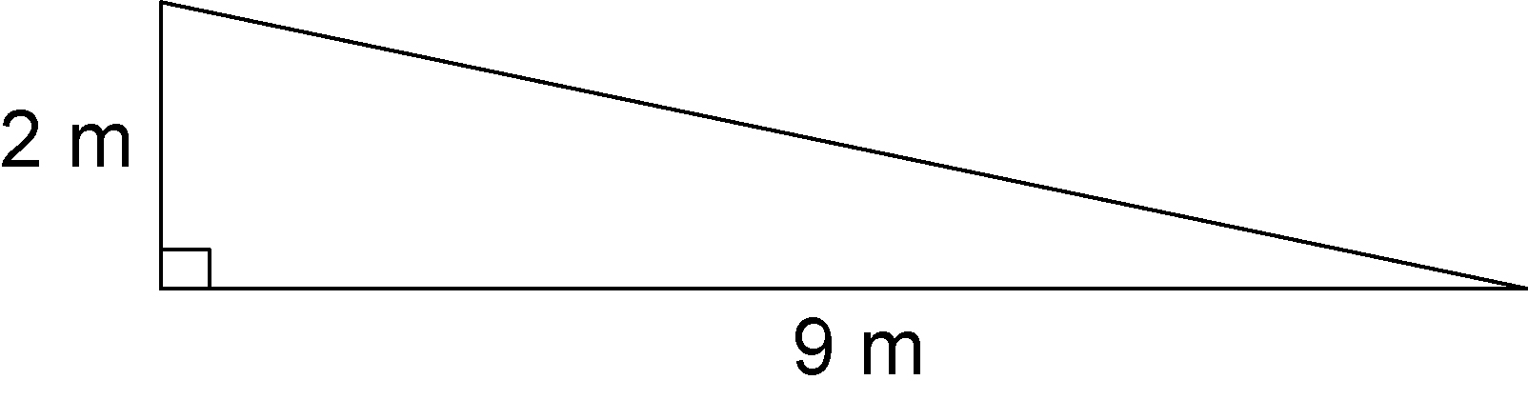
A 2 B $\frac{2}{9}$
C 18 D $\frac{9}{2}$

4. Which equation represents this relation?
x | y
0 | 4
1 | 1
2 | –2
3 | –5
4 | –8
A y = –3x + 4 B y = 4x – 3
C y = 3x + 4 D y = 3x – 4

5. The cost of a newspaper advertisement is $750 plus $80 for each day it runs. Which equation represents this relation?
A C = 80n – 750 B C = 80n + 750
C C = 750n + 80 D C = 750n – 80
Short Response

6. a) Calculate the slope.
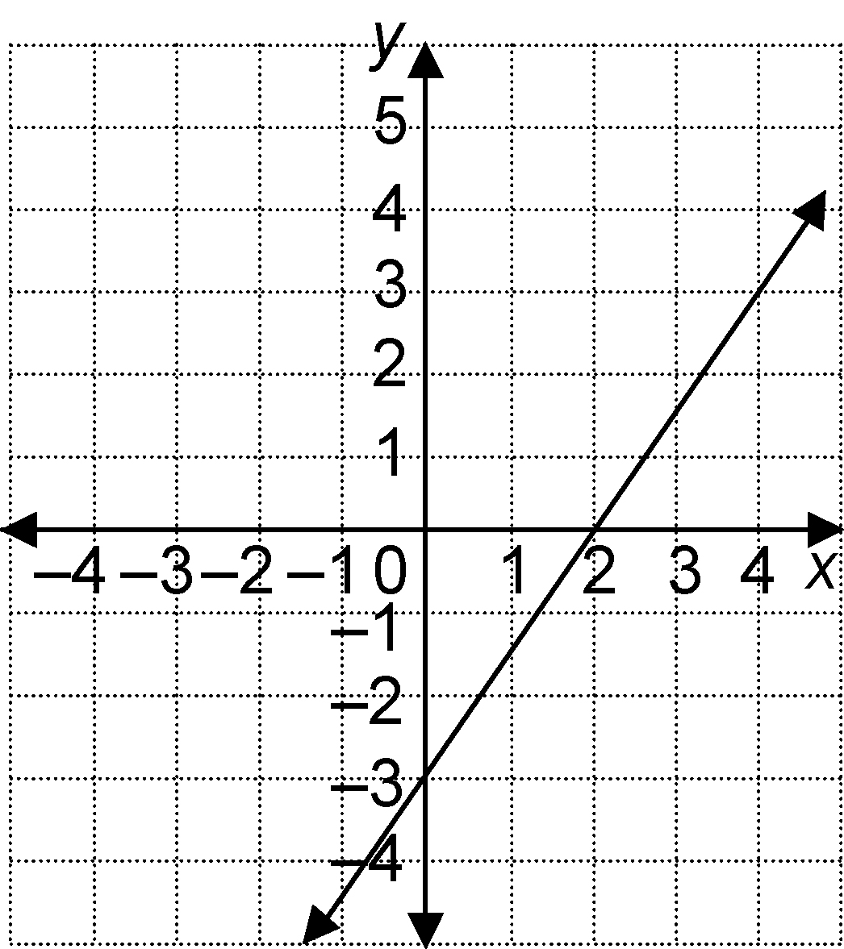
b) Find the vertical intercept.
c) Write an equation for the relation.

7. The cost to ship goods varies directly with the mass. Paul paid $20.40 to ship a package with mass 24 kg. Write an equation for this relationship.

8. Is this relation linear or non-linear? How can you tell without graphing?
x | y
2 | 0.16
4 | 0.64
6 | 1.44
8 | 2.56
9. Sheila works in a bookstore. She earns $240 per week, plus $0.15 for every bestseller she sells.
a) Write an equation for this relationship.
b) Last week, Sheila sold 19 bestsellers. How much did she earn?

Extend
Show all your work.

10. This graph shows the volume of water in a child’s pool over time as the pool is draining.
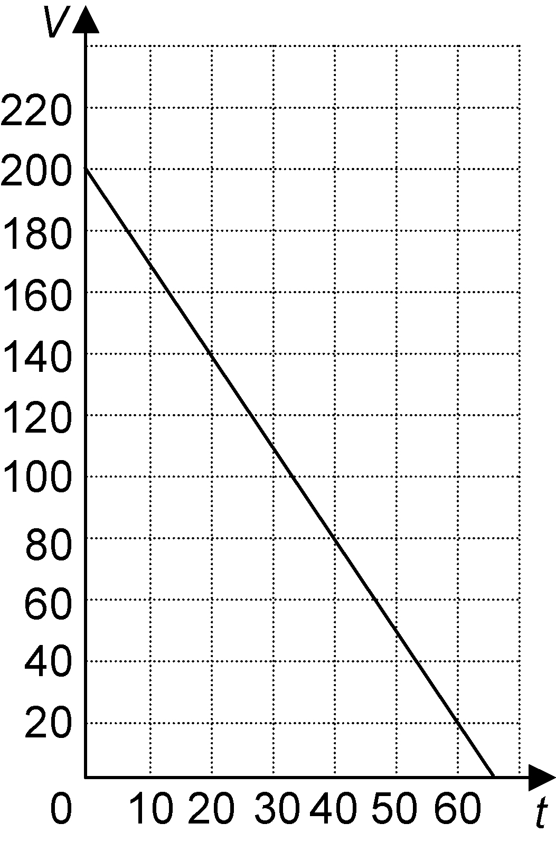
a) Calculate the rate of change of the volume of water. How does the rate of change relate to the graph?
b) Write an equation for the relationship.
c) Suppose the rate of change changes to –4 L/min. How long will it take the pool to empty?

