Chapter 5 Practice Test

Multiple Choice

For each question, select the best answer.
1. Which relation is a partial variation?
A y = 25x B y = 2^{x}
C y = 5x² D y = 2x – 5
2. Sophie’s earnings vary directly with the number of hours she works. She earned $25 in 4 h. What is the constant of variation?
A 0.16 B 6.25
C 100 D 21
3. What is the slope of this staircase?
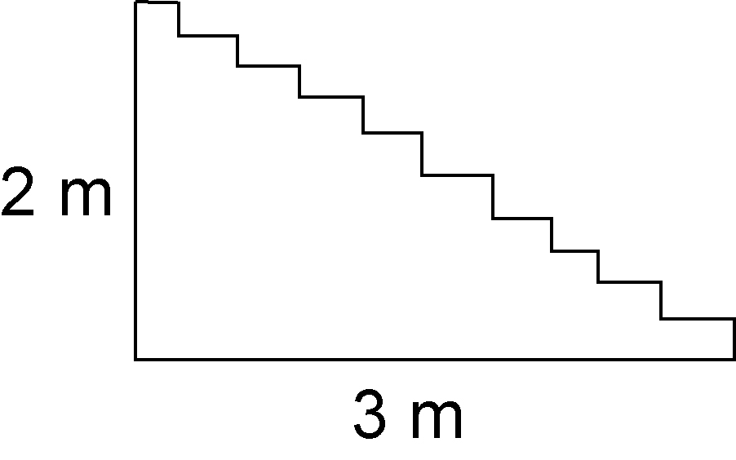
A 6 B $\frac{3}{2}$
C 2 D $\frac{2}{3}$
4. Which equation represents this relation?
x | y
0 | –1
1 | –3
2 | –5
3 | –7
4 | –9
A y = –x – 2 B y = 2x – 1
C y = –2x – 1 D y = 2x + 1
5. The cost to cater a party is $200 plus
$15 for each guest. Which equation represents this relation?
A C = 15n + 200 B C = 15n – 200
C C = 200n + 15 D C = 200n – 15
Short Response

6. a) Calculate the slope.
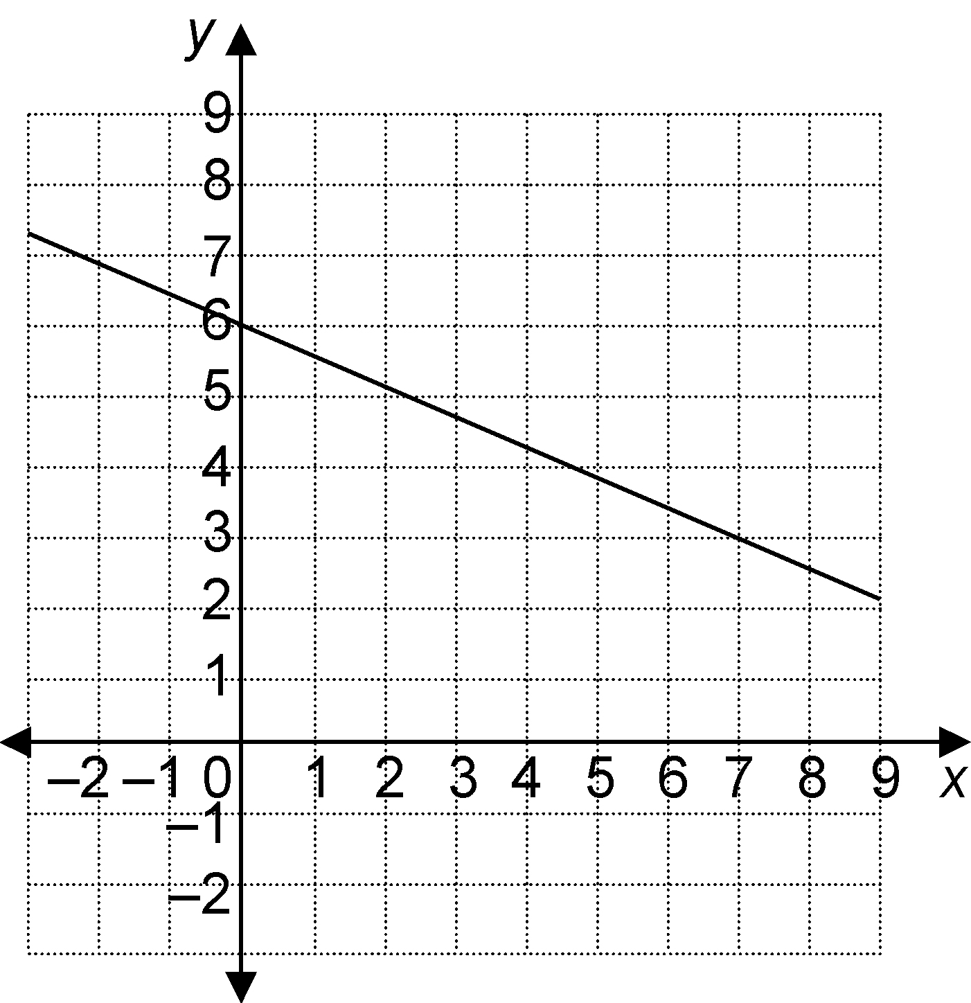

b) Find the vertical intercept.
c) Write an equation for the relation.

7. The distance travelled varies directly with time. Anthony ran 49.6 m in 8 s.
a) Write an equation for this relationship.
b) Graph the relation.

8. Is this relation linear or non-linear? How can you tell without graphing?
x | y
4 | 8.4
8 | 16.8
12 | 25.2
16 | 33.6

9. The cost to install wood trim is $50, plus $6/m of trim installed.
a) Write an equation for this relationship.
b) 18 m of trim were installed. What was the total cost?

Extend
Show all your work.

10. This graph shows the relationship between the cost of a taxi trip and the length of
the trip.
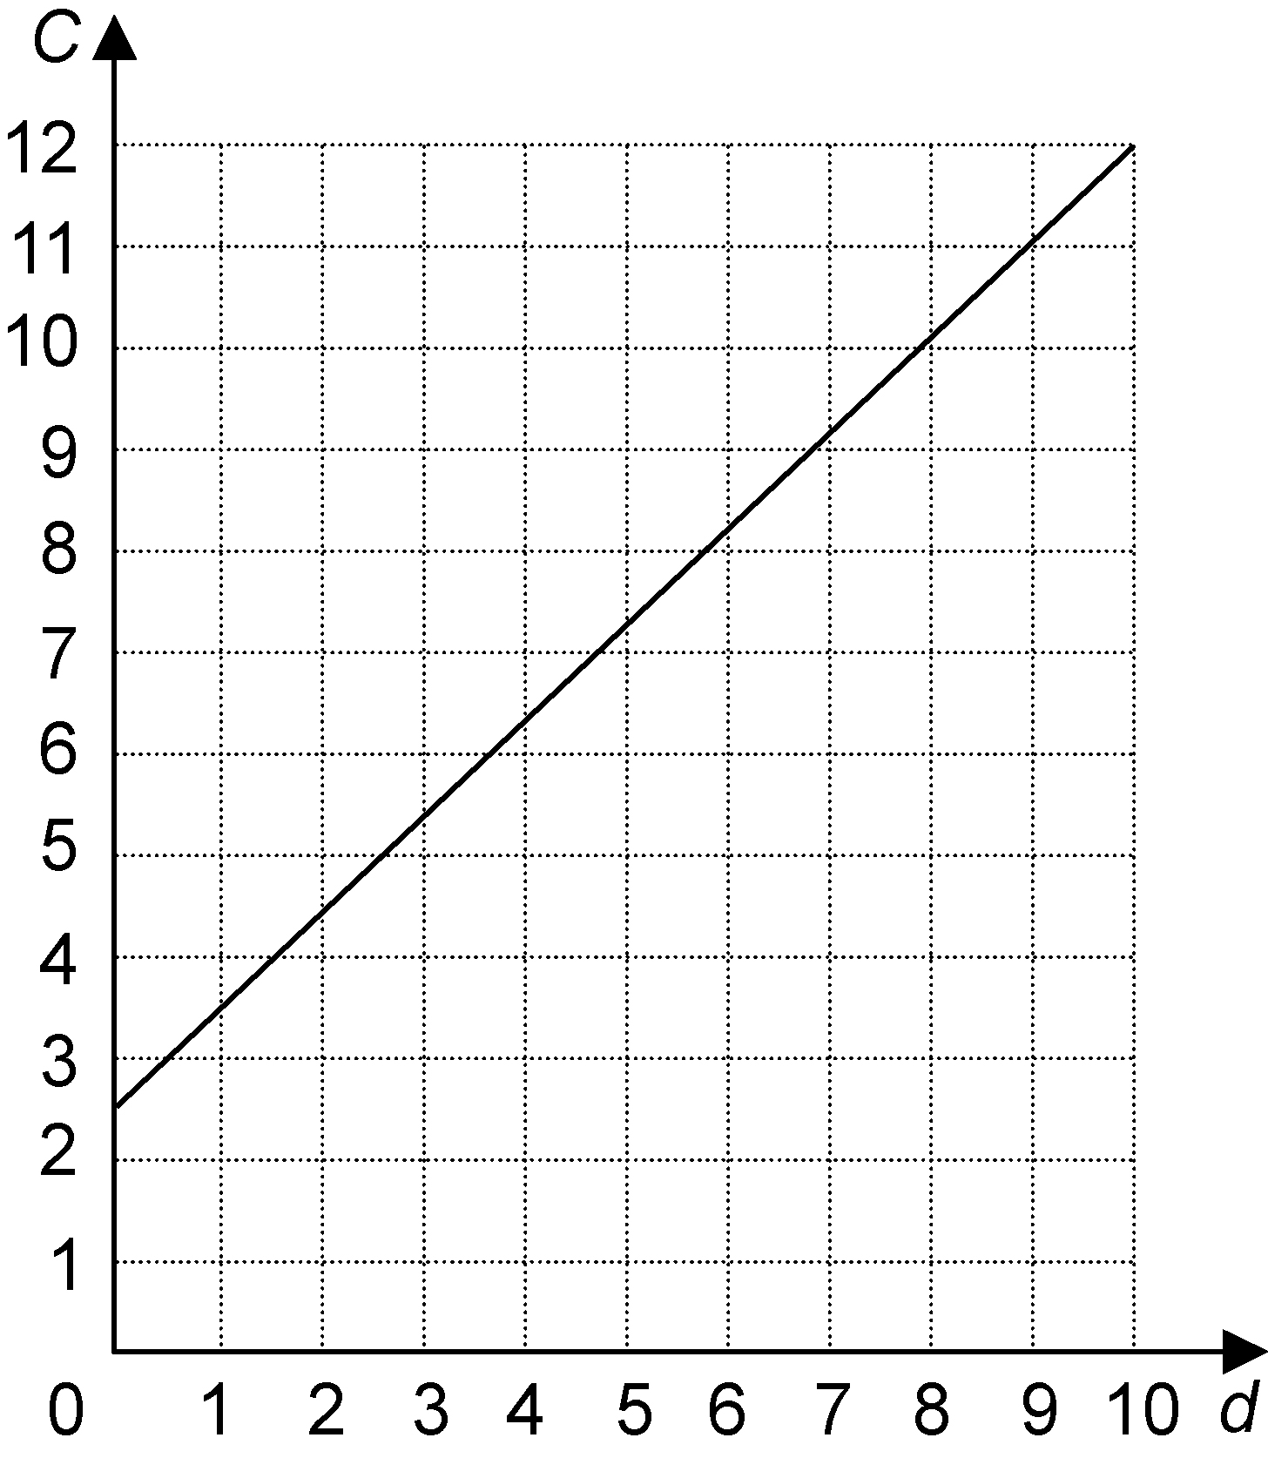
a) Calculate the rate of change of cost. How does the rate of change relate to the graph?
b) Write an equation for the relationship.
c) Suppose the flat fee changed to $3.00. How would the equation change? How would the graph change?

