BLM 5.GR.1 Practice: Get Ready
1. a) C b) D c) A d) B
2. a) b) $\frac{4}{4}$ c) $−2\frac{1}{8}$
3. a) 0.3 b) 0.8 c) −0.625 d) −3.20
4. a) $\frac{3}{4}$ b) $−\frac{3}{5}$ c) d) $\frac{5}{4}$
5. a) 1:4 b) 1:3 c) 7:15 d) 3:4
6. 36 g
7. $135
8. a) 19% b) 36.5% c) 30.3% d) 19.2%
9. a) 1.75 b) 12 c) 6.12 d) 12.8
BLM 5.1.1 Practice: Direct Variation
1. a) 0.08 b) 0.45 c) 65
2. a) 2.30; the cost per metre, in dollars, of wood
b) C = 2.3P
c) $34.50
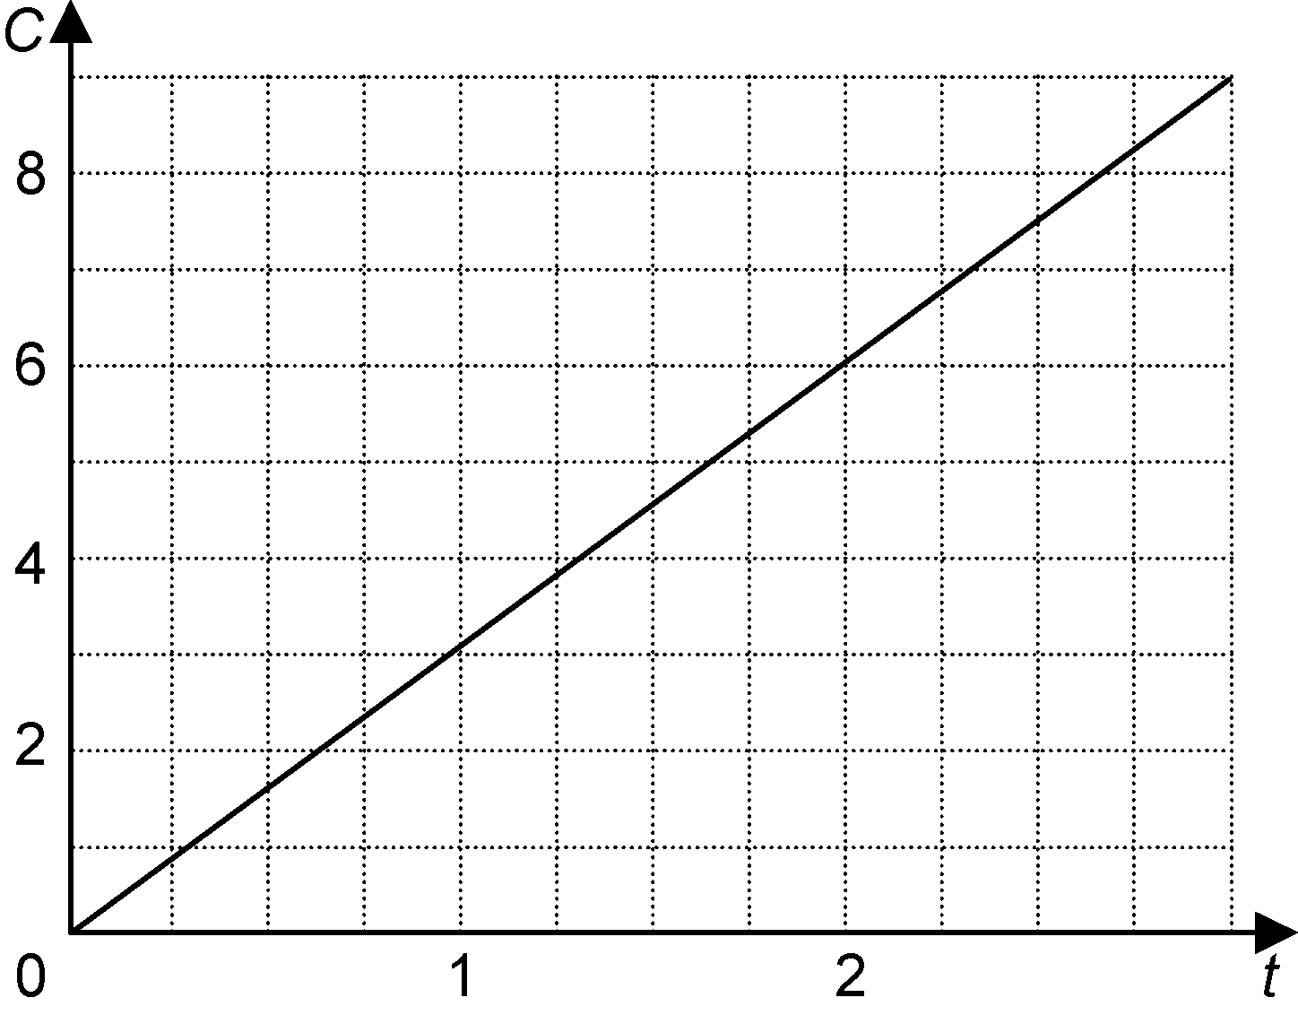
3. a)

b) 3.00; the cost per hour to park in this parking lot
c) C = 3.00t
4. a)
t (h) | d (km)
0 | 0
1 | 80
2 | 160
3 | 240

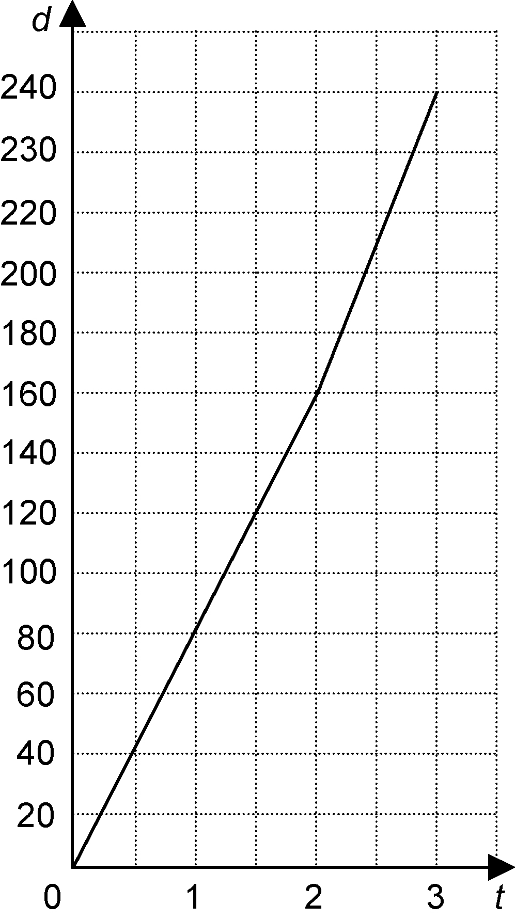
b)

c) 80 d) d = 80t
5. a) Tomatoes cost $2.50 per kg.
b) C = 2.5m
BLM 5.2.1 Practice: Partial Variation
1. a) partial variation
b) partial variation
c) direct variation
2. a) partial variation
b) direct variation
c) direct variation
d) partial variation
3. a) 3; 1 b) y = x + 3
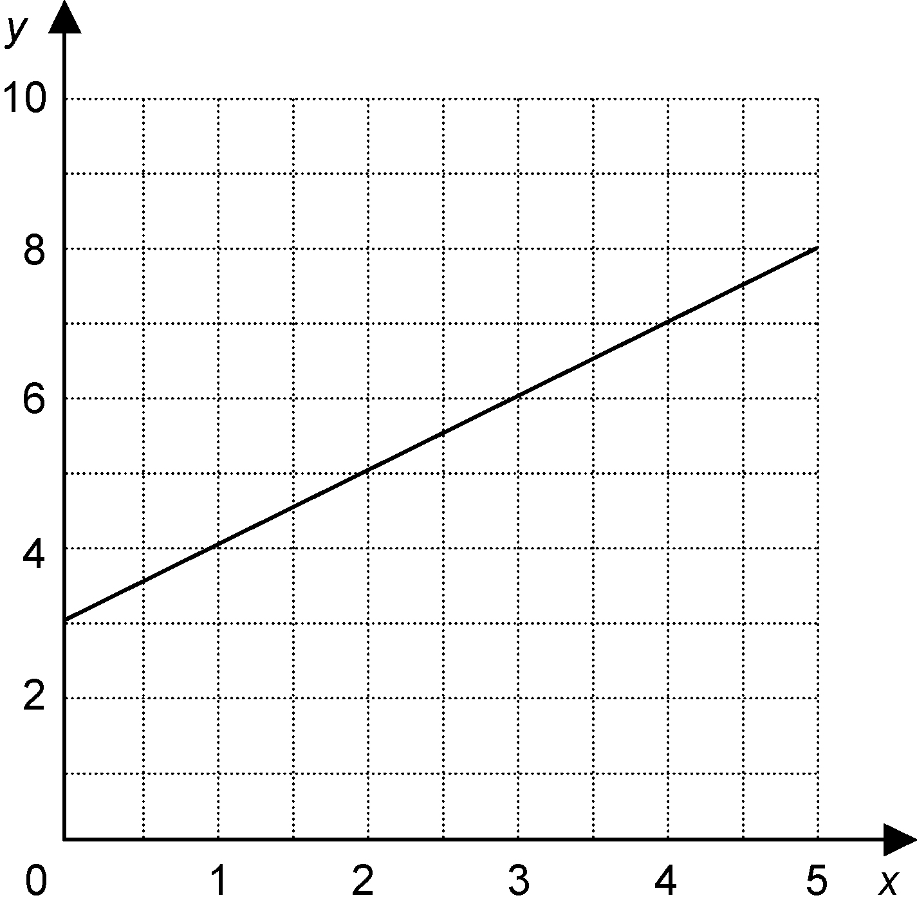
c)

The graph intersects the y-axis at (0, 3). As the
x-values increase by 1, the y-values also increase
by 1.

4. a)
Sales ($) | Earnings ($)
0 | 240
100 | 255
200 | 270
300 | 285
400 | 300
500 | 315
b) 240; 0.15
c) E = 0.15S + 240
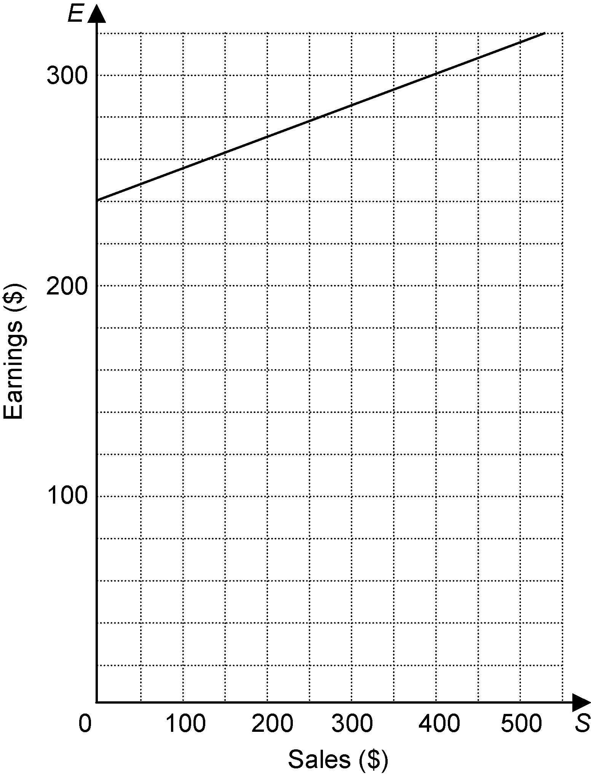
d)

BLM 5.3.1 Practice: Slope
1. a) −$\frac{2}{5}$ b) −0.48
2. a) b) $\frac{1}{3}$ c) $−\frac{4}{5}$ d) −2
3. a) 0.69 b) Yes
4. a) $−\frac{1}{5}$ b) $\frac{1}{2}$ c) 4 d) −2
5. Answer may vary. Possible answer: B(6, 1)
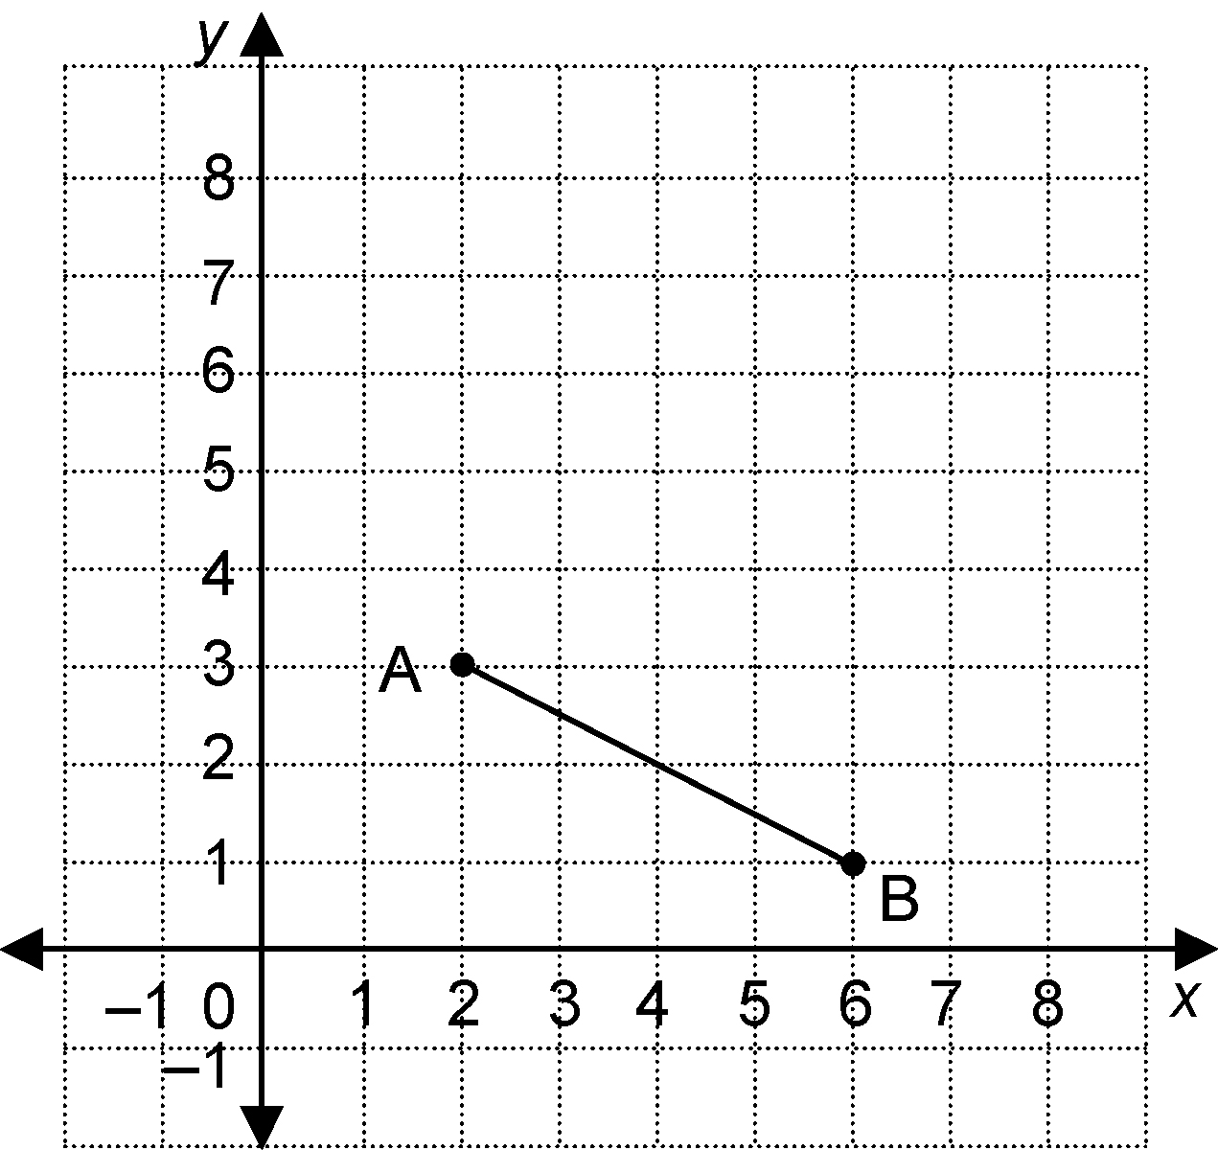

BLM 5.4.1 Practice: Slope as a Rate of Change
1. 12.4 breaths/min
2. 64 beats/min
3. 179 km/h
4. a) −3.6
b) Once the brakes are applied, the speed of the cars decreases at a rate of 3.6 m/s.
5. a)
Diagram  Number | Number of  Squares
1 | 1
2 | 3
3 | 5
4 | 7
5 | 9
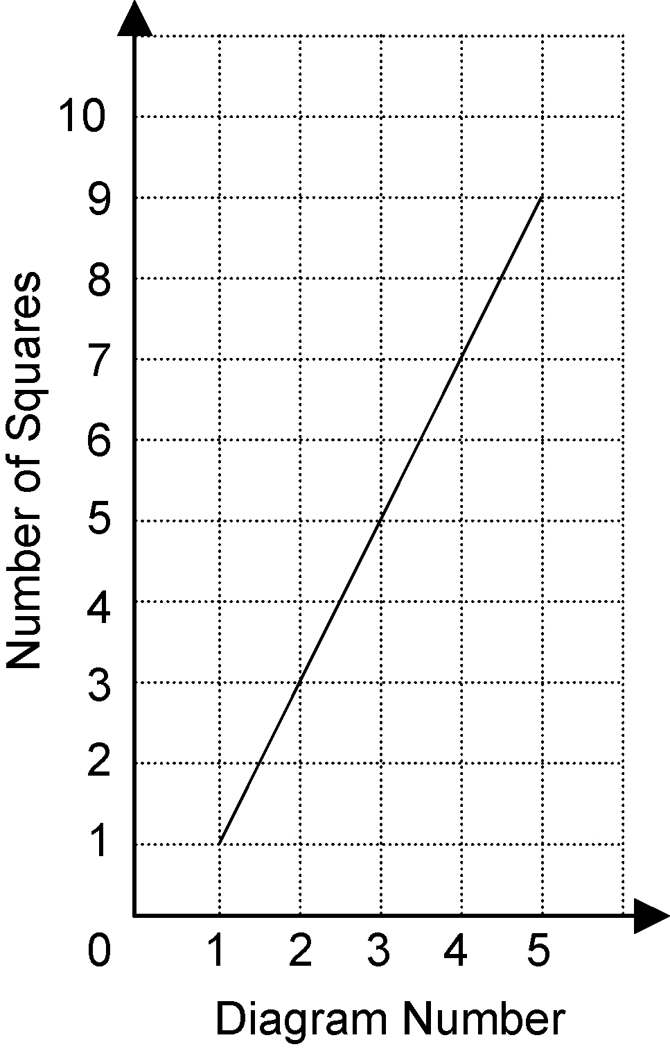
b) 2
c) Each diagram has two more squares than the previous diagram.
BLM 5.5.1 Practice: First Differences
1. a, d)
x | y | First Differences
0 | −3
1 | −1 | 2
2 | 1 | 2
3 | 3 | 2
4 | 5 | 2
5 | 7 | 2

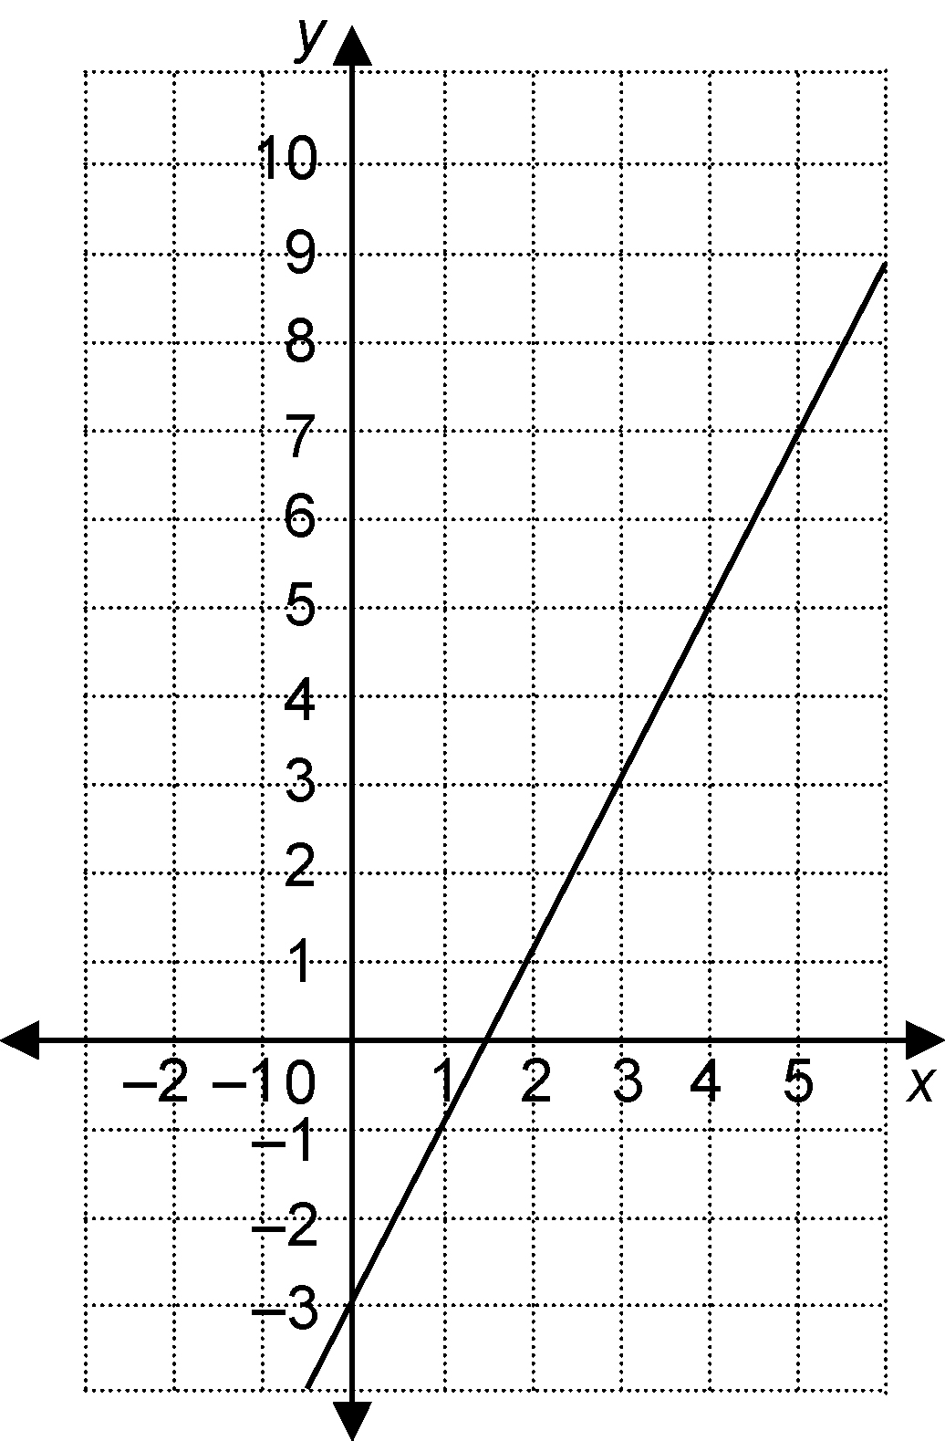
b)

c) linear
2. a, d)
x | y | First Differences
0 | 0
1 | 0.5 | 0.5
2 | 2 | 1.5
3 | 4.5 | 2.5
4 | 8 | 3.5
5 | 12.5 | 4.5
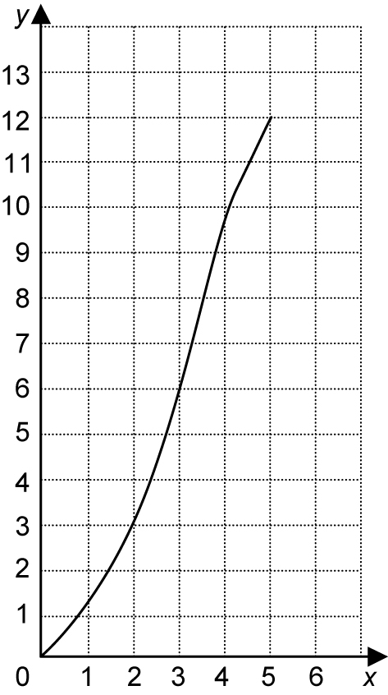
b)

c) non-linear
3. If the first differences are equal, the relation is linear. If the first differences are not equal, the relation is non-linear.
4. a)
x | y | First Differences
0 | 8
1 | 10 | 2
2 | 13 | 3
3 | 17 | 4
non-linear
b)
x | y | First Differences
0 | 2
1 | 6 | 4
2 | 10 | 4
3 | 14 | 4
linear
5. a)
x | y | First Differences
1 | 2
2 | 4 | 2
3 | 8 | 4
4 | 16 | 8
non-linear
b)
x | y | First Differences
1 | −3
2 | −6 | −3
3 | −9 | −3
4 | −12 | −3
linear
c)
x | y | First Differences
1 | 2
2 | 3 | 1
3 | 4 | 1
4 | 5 | 1
linear
d)
x | y | First Differences
1 | 2
2 | 5 | 3
3 | 10 | 5
4 | 17 | 7
non-linear
6. a) 2b + 4 b) p − 3
c) 4y + 5 d) −3x + 4
e) 8a + b f) 9r + 1
g) 3s + 5t h) h + g
7. a) 6v − 6 b) 6a − 5b
c) 7k + 5 d) 10x² + x
e) −3m² + 4 f) −5y + 4
g) 7h + 7 h) 6p² − 5q²
8. a) 3a + 7b − 6 b) 9x + xy − 2y
c) 2m⁴ − 3m² + 4 d) 5xy + y²
9. a) 2x b) P = 6x c) 36 cm

BLM 5.6.1 Practice: Connecting Variation, Slope, and First Differences
1. a) $−\frac{2}{3}$ b) 4 c) $y = −\frac{2}{3}x + 4$
2. a) $\frac{1}{2}$ b) −2 c) $y = \frac{1}{2}x − 2$
3. a) partial variation
b) −5
c) 3
d)
x | y
0 | −5
1 | −2
2 | 1
3 | 4
4 | 7
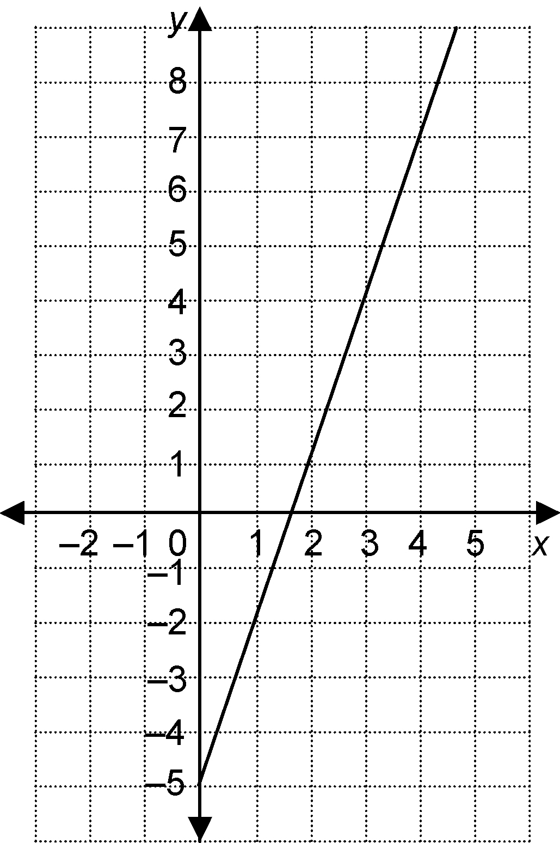
e)

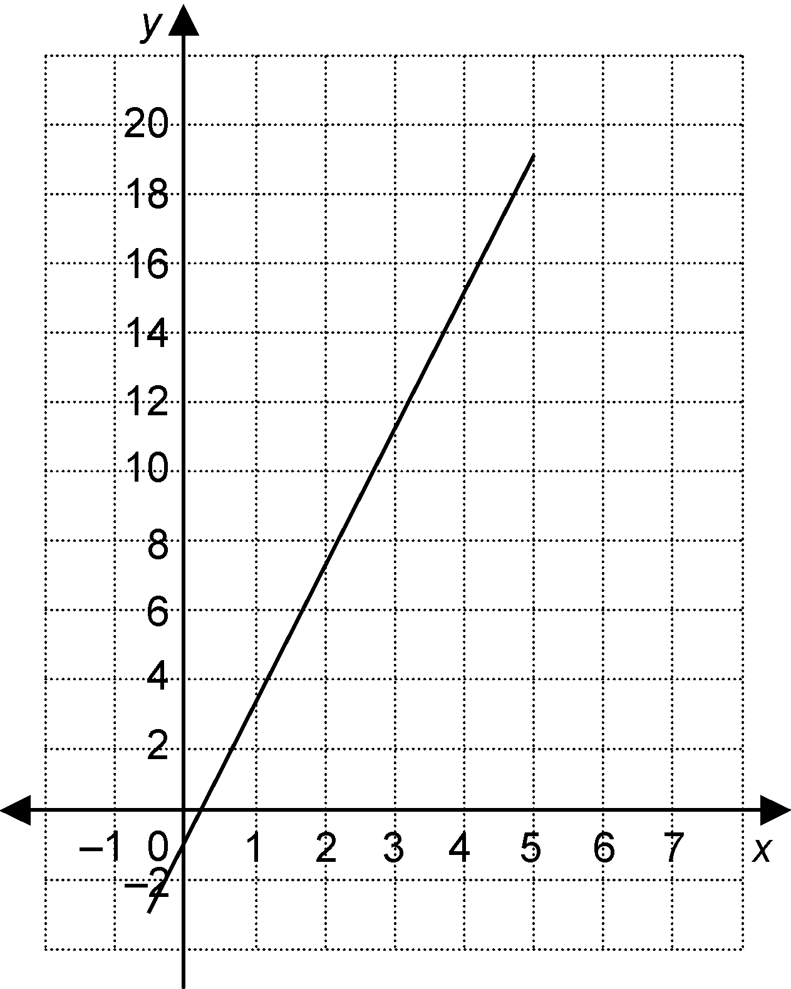
4. a)

b) The relationship between x and y is a partial variation. The initial value is −1 and the constant of variation is 4.
c) −1; 4; y = 4x − 1
5. a)
Number of  Toppings, n | Cost ($), C
0 | 8.00
1 | 8.50
2 | 9.00
3 | 9.50
4 | 10.00
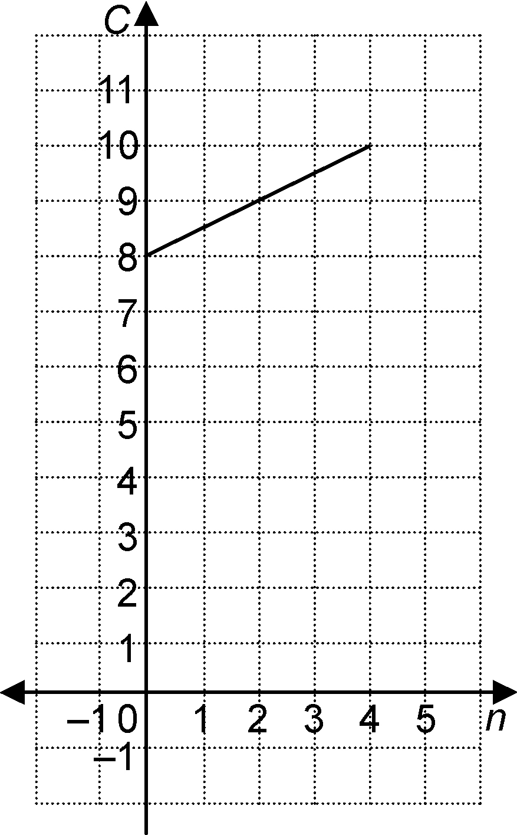
b)

c) C = 0.50n + 8.00
6. y varies partially with x, the initial value is −2 and the constant of variation is $−\frac{3}{4}$
x | y
−4 | 1
0 | −2
4 | −5
$y = −\frac{3}{4}x − 2$
BLM 5.CR.1 Chapter 5 Review
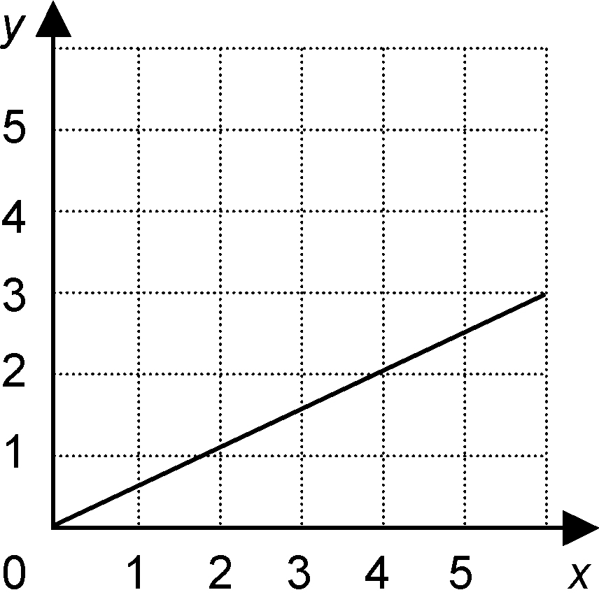
1. a)

b) $\frac{1}{2}$ c) $y = \frac{1}{2}x$
2. a)
Time, t | Earnings, E
0 | 0
1 | 7
2 | 14
3 | 21
4 | 28
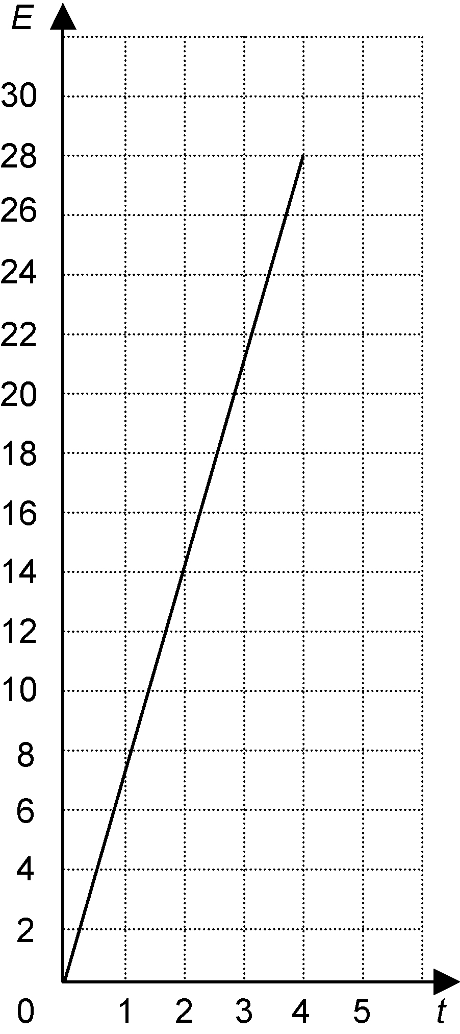
b)

c) 7; the amount Evan earns each hour he babysits
d) y = 7x
3. a) direct variation
b) neither
c) partial variation
d) partial variation
4. a) 1; 5
b) y = 5x + 1
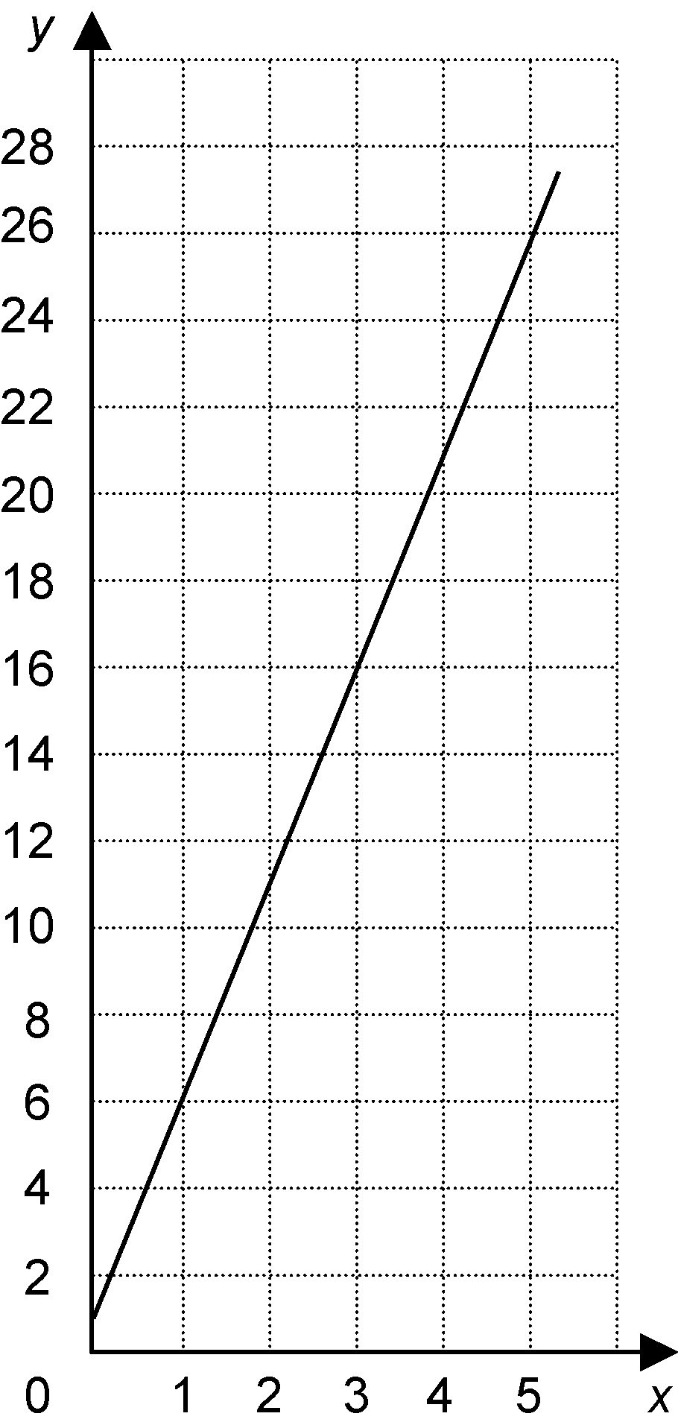
c)

The graph intersects the y-axis at (0, 1).
As the x-values increase by 1, the y-values
increase by 5.
5. a) fixed cost: $1500
variable cost: $0.08 times the number of brochures

b) C = 0.08n + 1500
c) $1564
6. a) $−\frac{2}{5}$ b) 5
7. a) b) c)
8. Answers may vary. Possible answer: B(6, 6)
9. a) 6.5 L/min
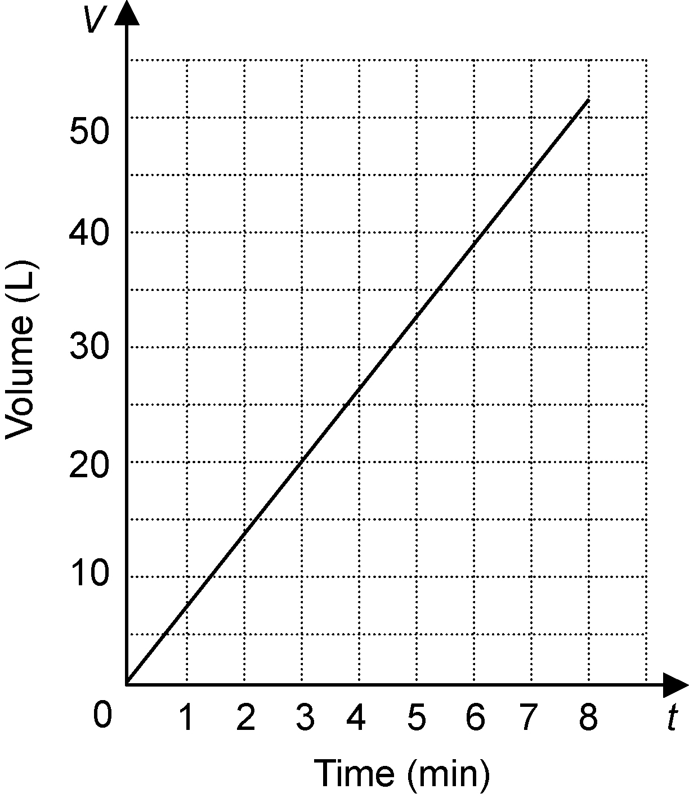
b)

10. Tom; 1 m/s
11. a) linear
b) linear
12. a)
Side Length | Perimeter
1 | 4
2 | 8
3 | 12
4 | 16
5 | 20
b) linear
13.
x | y
0 | 2
1 | 3
2 | 4
3 | 5
4 | 6
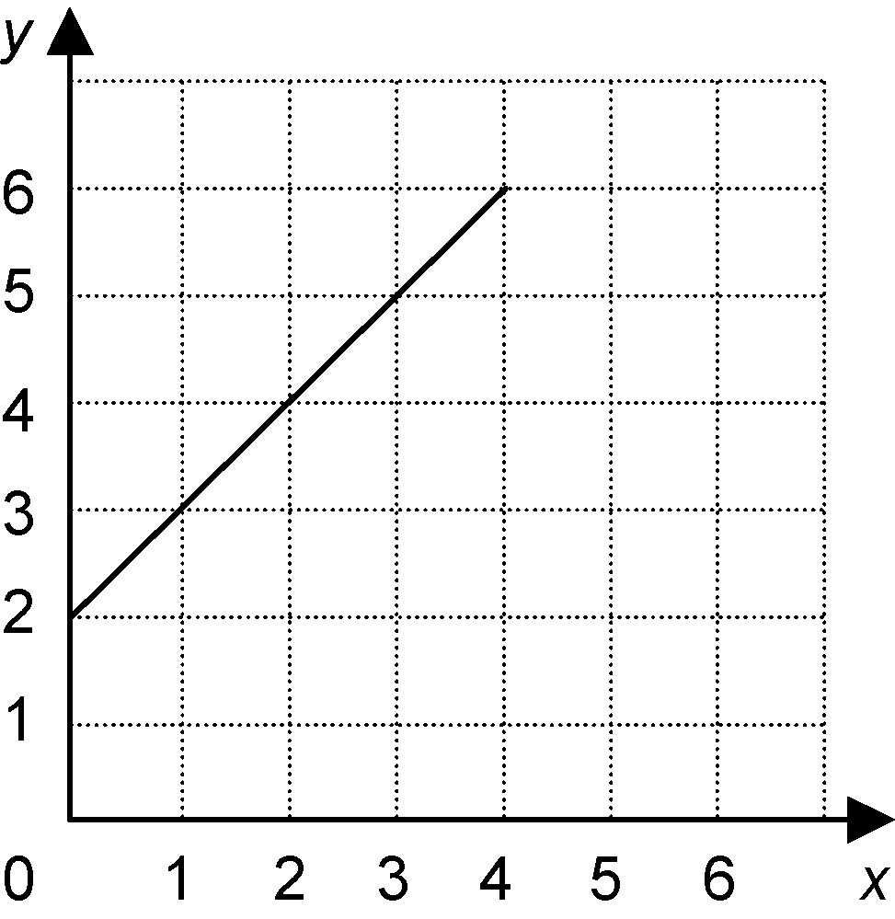
The length of a rectangle is 2 more than its width.

BLM 5.PT.1 Chapter 5 Practice Test
1. D
2. B
3. D
4. C
5. A
6. a) $−\frac{3}{7}$ b) 6 c) $y = −\frac{3}{7}x + 6$
7. a) d = 6.2t
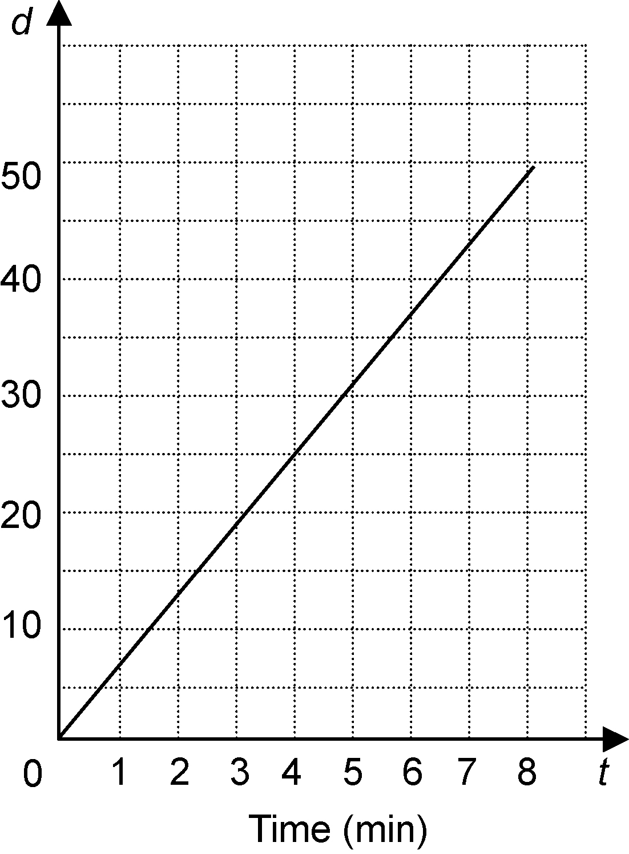
b)

8. Linear; I found the first differences and noticed they were all equal.
9. a) C = 6l + 50
b) $158
10. a) $0.95/km; the rate of change is the slope
b) C = 0.95d + 2.50
c) The fixed portion of the equation would change from 2.50 to 3.00. The graph would shift up so the vertical intercept is 3.
BLM 5.CT.1 Chapter 5 Test
1. A
2. D
3. B
4. A
5. B
6. a) $\frac{3}{2}$ b) −3 c) $y = \frac{3}{2}x −3$
7. C = 0.85m
8. Non-linear; I found the first differences and noticed they were not equal.
9. a) E = 0.15n + 240 b) $242.85
10. a) −3 L/min; the rate of change is the slope
b) V = 200 − 3t
c) 50 min

