Practice: The Equation of a Line in
Slope y-Intercept Form: y = mx + b

1. Copy and complete the table.
 | Equation | Slope | y-Intercept
a) | y = 4x + 1
b) | y = $\frac{x}{2}$ – 3
c) | y = –2x
d) | y = –x + 2

2. Find the slope and y-intercept of each line.
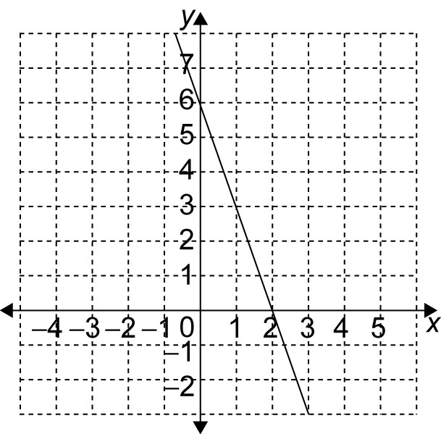
a)

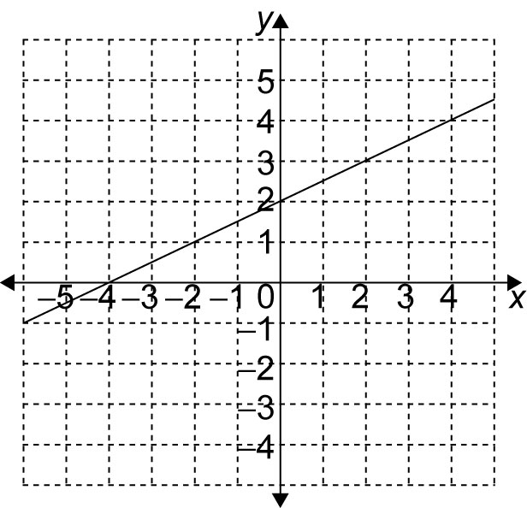
b)

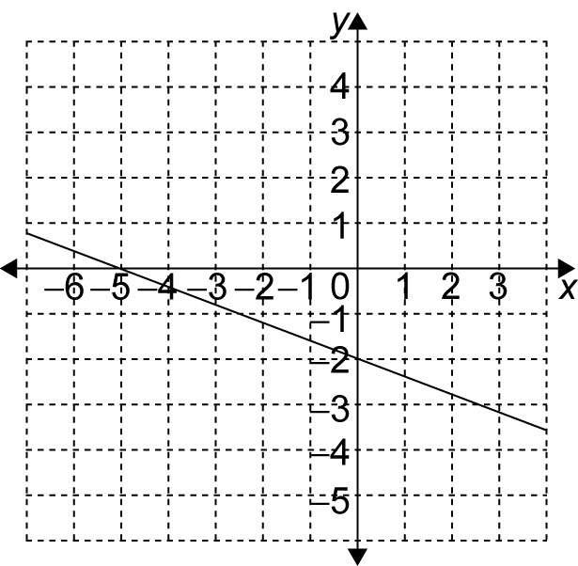
c)

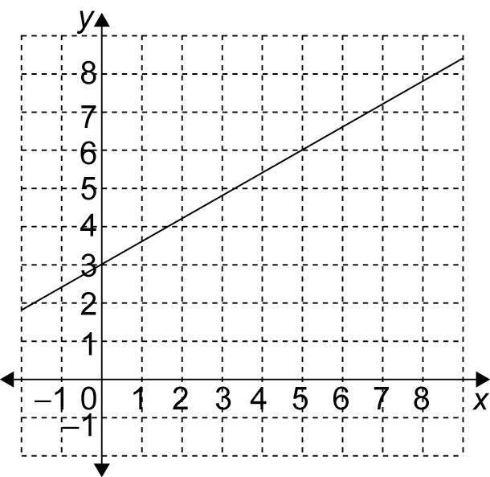
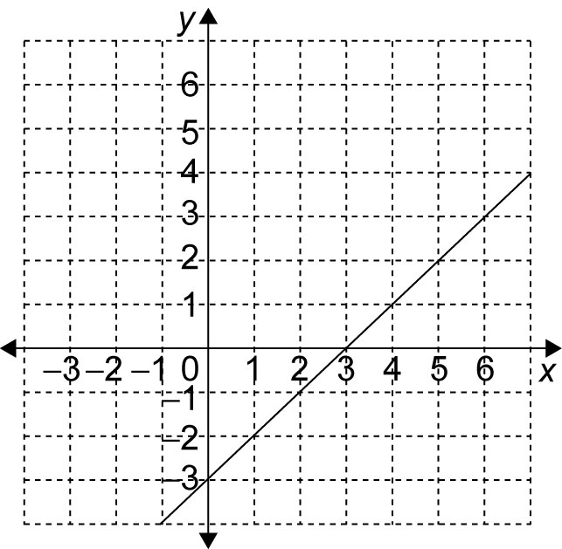
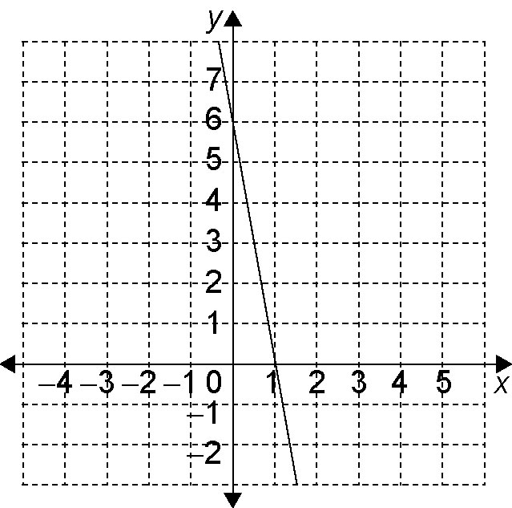
d)

3. Write the equation of each line in
question 2.

4. Write the equation of each line.

a)

b)

5. Write the equation of a line with each slope and y-intercept.
 | Slope | y-Intercept
a) | –2 | 1
b) |  | –4
c) | 5 | 0
d) |  | 3

6. Find the slope and y-intercept of each line, if they exist. Graph each line.
a) y =
b) y = x – 4
c) y = 5
d) y =

