Practice: Graph a Line Using Intercepts

1. Identify the x- and y-intercept of each line.
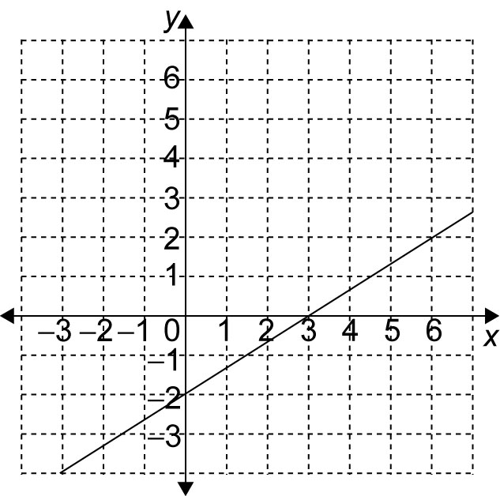
a)

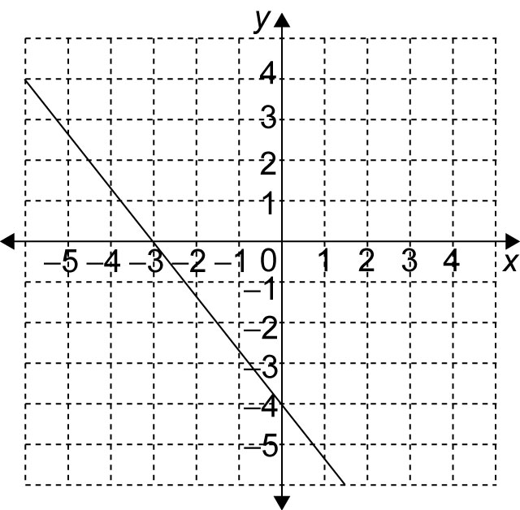
b)

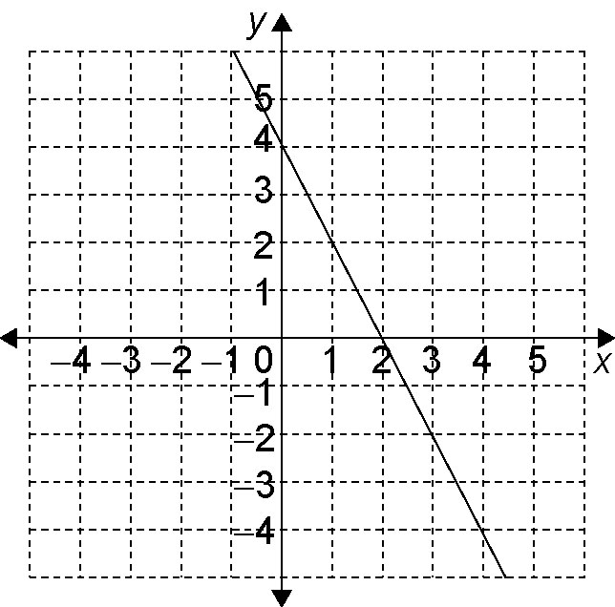
c)

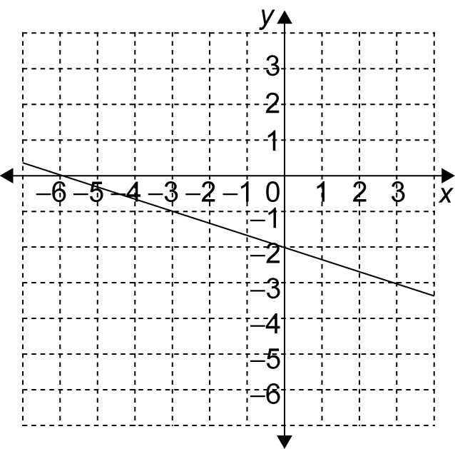
d)

2. The x- and y-intercepts for some lines are given. Use the intercepts to graph the line.
a) x-intercept: 3 y-intercept: –1
b) x-intercept: –2 y-intercept: –3
c) x-intercept: 6 y-intercept: 1
d) x-intercept: 3 y-intercept: none

3. Use the graph to find the slope of each line in question 2.

4. Identify the x- and y-intercepts of each line.
a) 3x – y = 4
b) 5x + 2y – 3 = 0
c) x + 3y = 6
d) x – 6y = 3

