Practice: Find an Equation for a Line
Given Two Points

1. Find the slope of the line that passes through each pair of points.
a) A(2, 3) and B(4, 5)
b) M(0, 6) and N(2, 0)
c) S(8, 7) and T(0, 0)
d) C(3, 4) and D(6, 7)
e) P(5, 1) and Q(4, 5)
f) E(2, 3) and F(4, 5)
g) V(–1, 1) and W(2, –4)
h) J(2, –1) and K(1, –2)

2. Find an equation for each line.
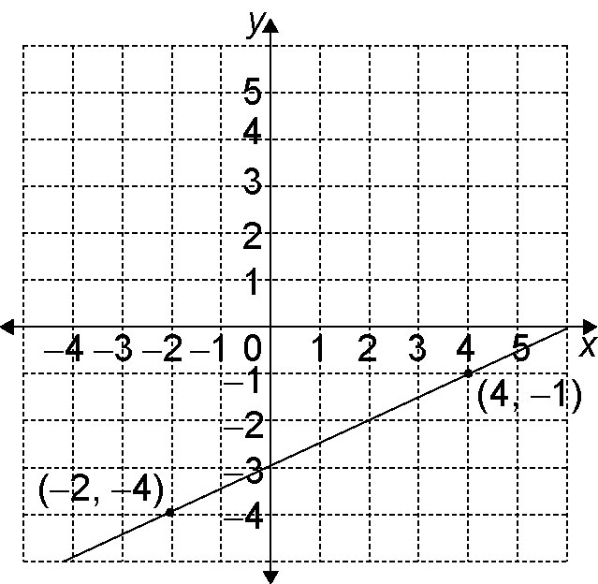
a)

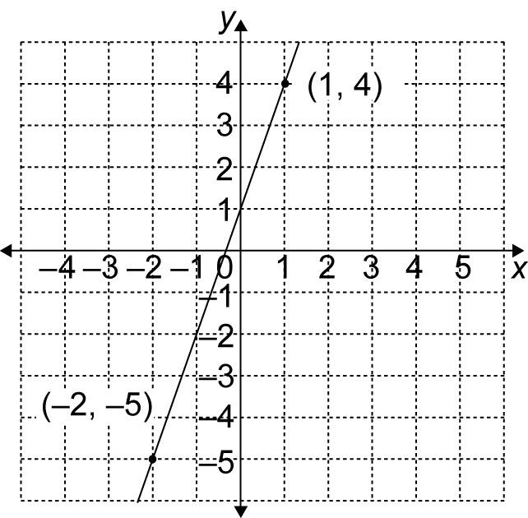
b)

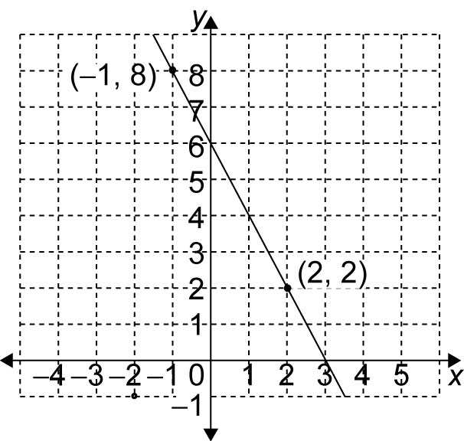
c)

3. Find an equation for the line that passes through each pair of points.
a) C(4, 5) and D(5, 1)
b) J(3, 2) and K(1, 0)
c) G(7, 7) and H(0, 4)
d) S(–3, 1) and T(–2, 7)
e) P(4, 5) and Q(2, 3)
f) M(–3, 3) and N(3, –5)
g) X(0, –1) and Z(5, –4)
h) A(4, –1) and B(–2, –2)

4. A line has an x-intercept of 3
and a y-intercept of 4.
a) Find the slope of the line.
b) Write an equation for the line.

5. A line passes through the origin
and A(4, 6).
a) Find the slope of the line.
b) Write an equation for the line.

