Practice: Linear Systems

1. What are the coordinates of the point of intersection of each linear system?
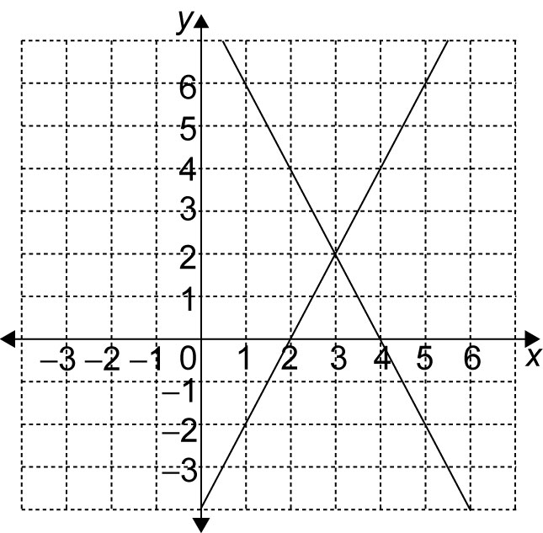
a)

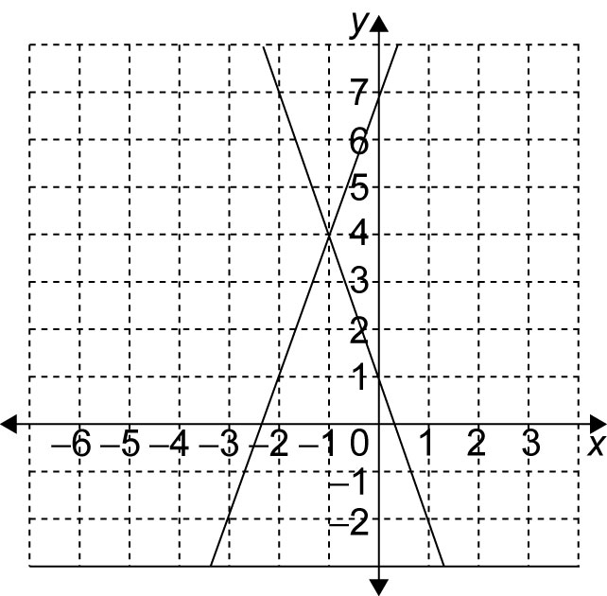
b)

2. What is the solution to each linear system?
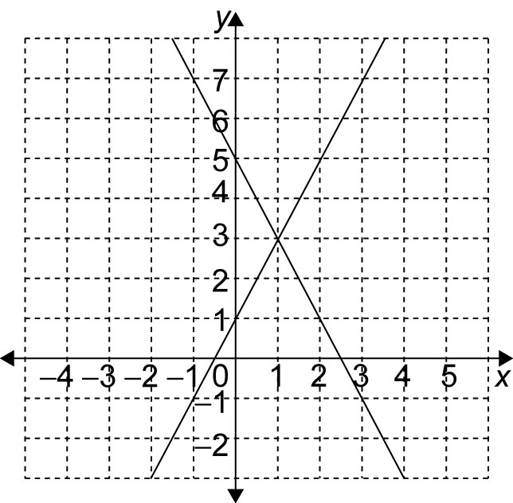
a)

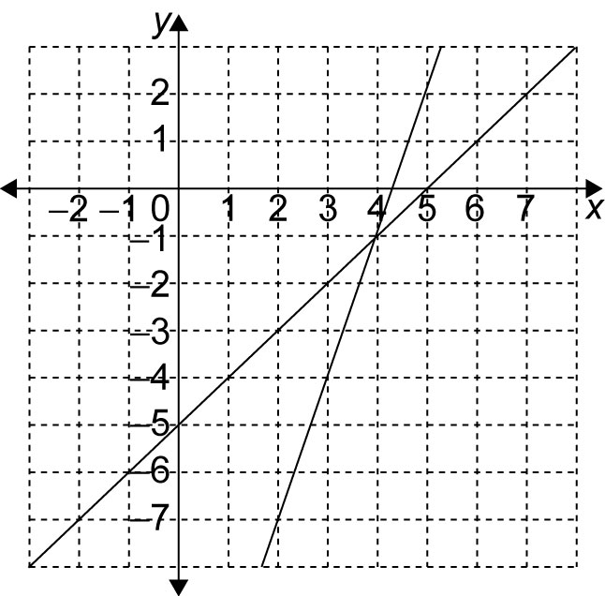
b)

3. Solve each linear system. Check your solution in both equations.
a) x + y = 4 and y = x
b) 2x + y = 8 and y = 2x
c) 3x + y = 1 and y = 3x + 7
d) x + y = 3 and x – y = –1

4. Which is the point of intersection for the linear system y = 2x + 1 and y = 3x – 1?
A (2, 2)
B (2, 5)
C (5, 2)
D (5, 5)

5. Which is the solution to the linear system
y = 2x – 2 and y = x + 7?
A (4, 1)
B (4, –6)
C (4, 6)
D (4, –1)

