Chapter 6 Review

6.1 The Equation of a Line in Slope
y-Intercept Form: y = mx + b,
pages 296–307

1. Find the slope and y-intercept of each line.
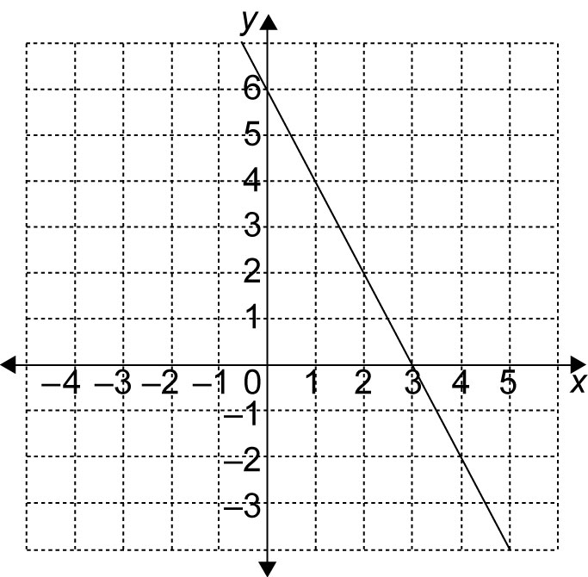
a)

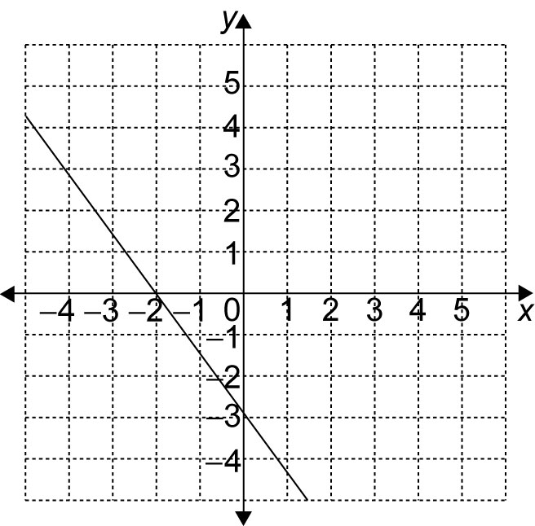
b)

2. Identify the slope and y-intercept of
each line.
a) y = 4x – 5
b) y = x + 2

3. Write the equation of a line with each slope and y-intercept. Then, graph
each line.
a) m = –1, b = 0
b) m = , b = 5
6.2 The Equation of a Line in Standard
Form: Ax + By + C = 0, pages 308–314

4. Express each equation in
the form y = mx + b.
a) 6x – y = 4
b) x + 4y = 28

5. Identify the slope and y-intercept of each equation.
a) 8x + y = 4
b) –3x + 2y = 8

6.3 Graph a Line Using Intercepts,
pages 315–322

6. Identify the x- and y-intercepts of each line. Then, graph the line
a) 4x – 2y = 8
b) x + 3y = 6
c) 2x – y = 4
d) 5x + 3y – 15 = 0

6.4 Parallel and Perpendicular Lines,
pages 326–329

7. Which lines are parallel?
2x – 3y + 12 = 0
3y = 2x + 6
3x – 2y = 0
3x + 2y = –4

8. Which lines in question 7 are perpendicular?

9. What is the slope of a line that is perpendicular to 3 – x + 4y = 0?

6.5 Find an Equation for a Line Given the
Slope and a Point, pages 330–337

10. Find the equation of a line with
a slope of –3, passing through (2, –5).

11. Find the equation of a line parallel to
2x + 5y = 1, with the same y-intercept as
x – 4y = 8.
6.6 Find an Equation for a Line Given
Two Points, pages 338–343

12. Find the equation for a line passing through (3, –4) and (2, 5).

13. Ingrid is walking in front of a motion sensor. After 1 s, she is 3.9 m from
the sensor. After 3 s, she is 1.7 m from
the sensor.
a) Find the slope for this relationship.
b) Write an equation of the form
d = mt + b that describes Ingrid’s motion.
c) After how many seconds will Ingrid’s distance from the motion sensor be 0?

6.7 Linear Systems, pages 344–351

14. What is the solution to this linear system?
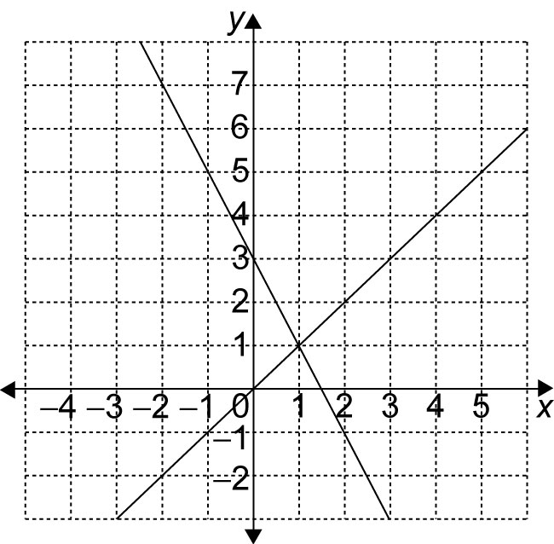

15. Solve the linear system
x + y = 6 and y – 2x = 0.

