Chapter 6 Test

Multiple Choice

For each question, select the best answer.

1. Which are the slope and y-intercept of the line y = –x – 4?
A m = 0, b = –4
B m = 0, b = 4
C m = 1, b = 4
D m = –1, b = –4

2. What are the x- and y-intercepts of the line 3x + 2y = 12?
A x-intercept = 4, y-intercept = –6
B x-intercept = –4, y-intercept = –6
C x-intercept = –4, y-intercept = 6
D x-intercept = 4, y-intercept = 6

3. What is the slope of a line parallel
to 4x + 2y = 7?
A 2 B –2
C D

4. What is the slope of a line perpendicular to 2x – y = 3?
A 2 B –2
C $\frac{1}{2}$ D $−\frac{1}{2}$

5. Which is the solution to the linear system
y = 2x and y = x + 4?
A (4, 1) B (4, –2)
C (4, 8) D (4, 4)

Short Response

6. Rearrange 8x + 2y + 11 = 0 into
the form y = mx + b.
7. Frank recorded his motion with a motion sensor and produced this graph.
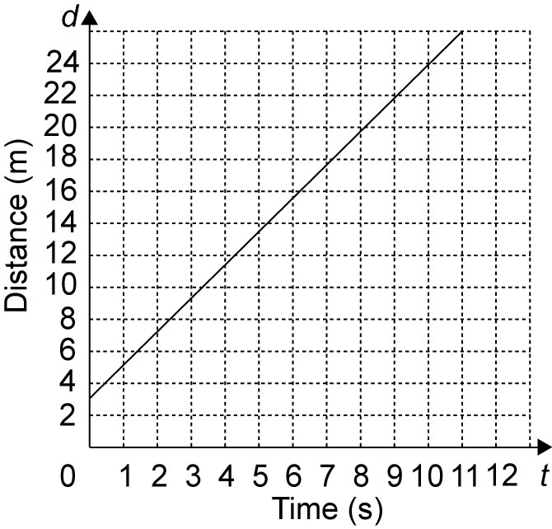

a) How far was Frank from the motion sensor when he started moving?
b) Was Frank moving toward the motion sensor or away from it? How fast was he moving?
c) Write an equation that describes this distance-time relationship.

8. Find an equation for a line
a) with slope 6 passing through (–1, 4)
b) that passes through (–5, 0) and (5, 6)

Extend

Show all your work.

9. A line is parallel to 5x + 2y – 8 = 0 and has the same y-intercept as x + 4y – 12 = 0. Find an equation for the line.

10. A retail store offers two different hourly compensation plans:
Plan A: $9.00 per hour
Plan B: $7.50 per hour worked plus a $4.50 shift bonus.
a) Graph the linear system. When would the earnings from the two plans be the same?
b) Describe a situation under which you would choose each plan.

