Practice: Get Ready

Linear Relations

1. Here is a distance-time graph.
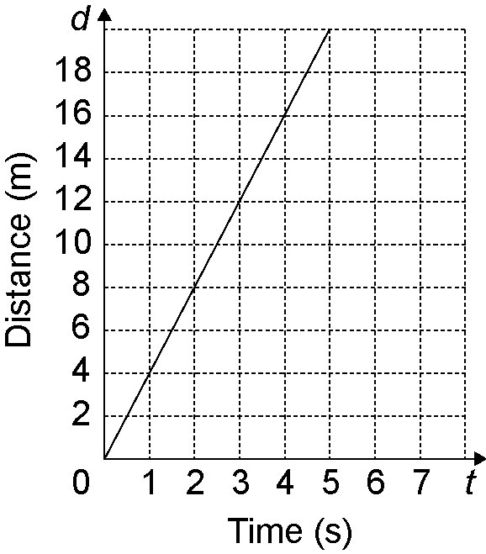
a) Find the slope of the graph.
Interpret the meaning of the slope.
b) Find the vertical intercept. What is the significance of this point?

2. Here is a table of values for a
linear relation.
x | y
2 | 1
4 | –1
6 | –3
a) Graph the line.
b) Find the slope of the line.
c) Find the y-intercept.

Line of Best Fit

3. The table shows the free throws attempted and free throws made for a group of basketball players.

Attempted | Made
12 | 7
9 | 5
8 | 5
5 | 3
5 | 4
6 | 3
a) Graph the data in the table. Draw a line of best fit.
b) A player attempts 10 free throws. Based on the trend, how many would you expect to be successful?

Slope

4. Find the slope of each line segment
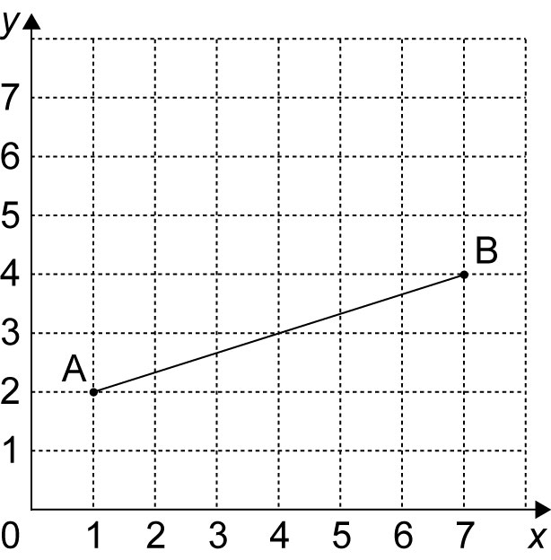
a)

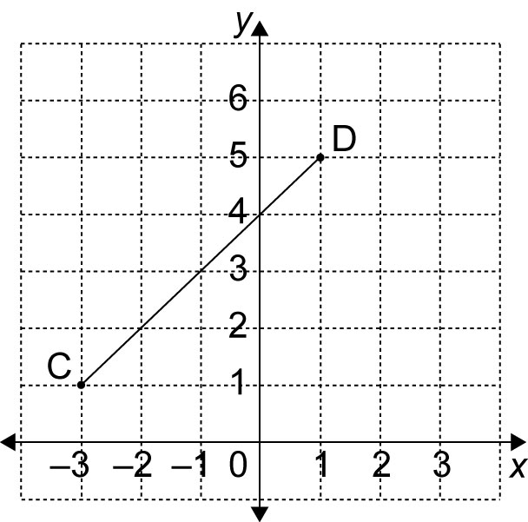
b)

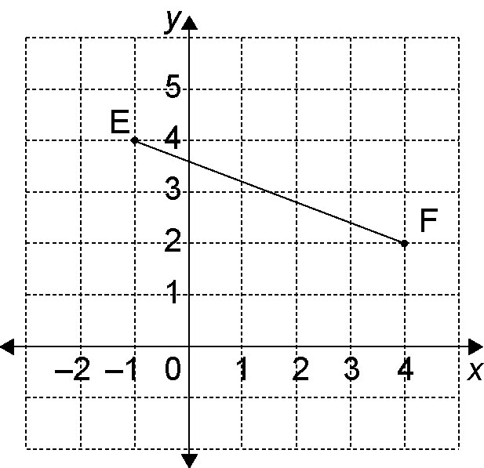
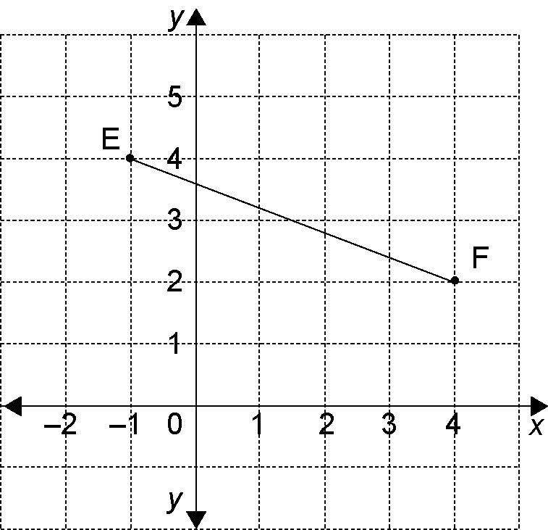
c)

