Chapter 6 Practice Test

Multiple Choice

For each question, select the best answer.

1. Which are the slope and y-intercept of the line y = 5x + 3?
A m = 3, b = 5
B m = –3, b = –5
C m = –5, b = 3
D m = 5, b = 3

2. What are the x- and y-intercepts of the line 5x – 4y = 20?
A x-intercept = 4, y-intercept = –5
B x-intercept = –4, y-intercept = –5
C x-intercept = –4, y-intercept = 5
D x-intercept = 4, y-intercept = 5

3. What is the slope of a line parallel
to x + 2y = 4?
A 2 B –2
C D

4. What is the slope of a line perpendicular to x + 2y = 4?
A 2 B –2
C D

5. Which is the solution to the linear system
y = 6 – x and y = x – 4?
A (1, 5) B (5, 1)
C (–1, 5) D (–5, –1)

Short Response

6. Rearrange x – 2y + 4 = 0 into
the form y = mx + b.

7. Erynn used a motion sensor to create this distance-time graph.
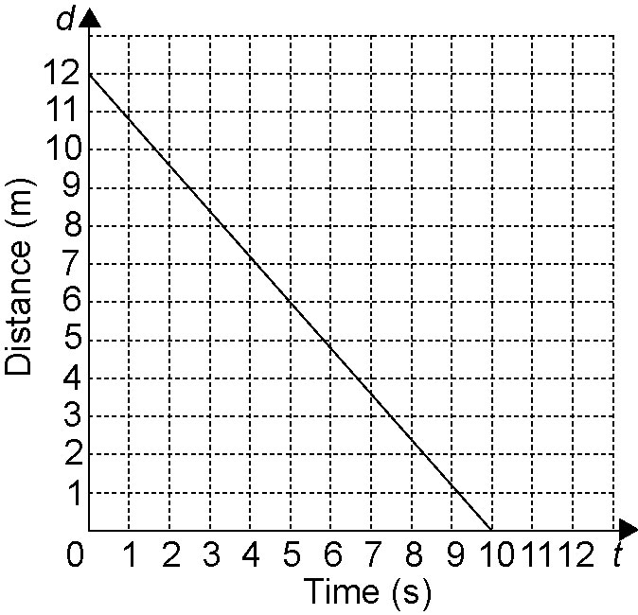

a) Find the slope and d-intercept. What information does each of these give us about Erynn’s motion?
b) Write an equation that describes this distance-time relationship.

8. Find an equation for a line
a) with slope –1 passing through (2, 2)
b) that passes through (10, 3) and (5, 6)

Extend

Show all your work.

9. A line is perpendicular to x + 3y – 4 = 0 and has the same y-intercept as
2x + 5y – 20 = 0. Find an equation for
the line.

10. A fitness club offers two membership plans.
Plan A: $30 per month
Plan B: $18 per month plus $2 for each visit to the club
a) Graph the linear system. When would the cost of the two membership plans be the same?
b) Describe a situation under which you would choose each plan.

