Use Technology: Using a Slider
Using The Geometer’s Sketchpad®, you can control the graph of a line using a slider.

On the Edit menu, click Preferences. Click the Text tab, and select For All New Points. Click OK.

Draw a line segment AB as shown. Draw a point C on the segment AB. Ensure that all objects are deselected. Select A, B, and C in order. On the Measure menu, click Ratio. Move point C back and forth, and observe what happens to the value of the ratio . Change the label of the ratio to m. You will use this ratio to control the slope of a line.
On the Graph menu, click New Function. When the New Function dialog box appears, click the measure m. Then, use the keypad to add *x + 2. Click OK.

On the Graph menu, click Plot Function. Move point C back and forth. Note what happens to the function.

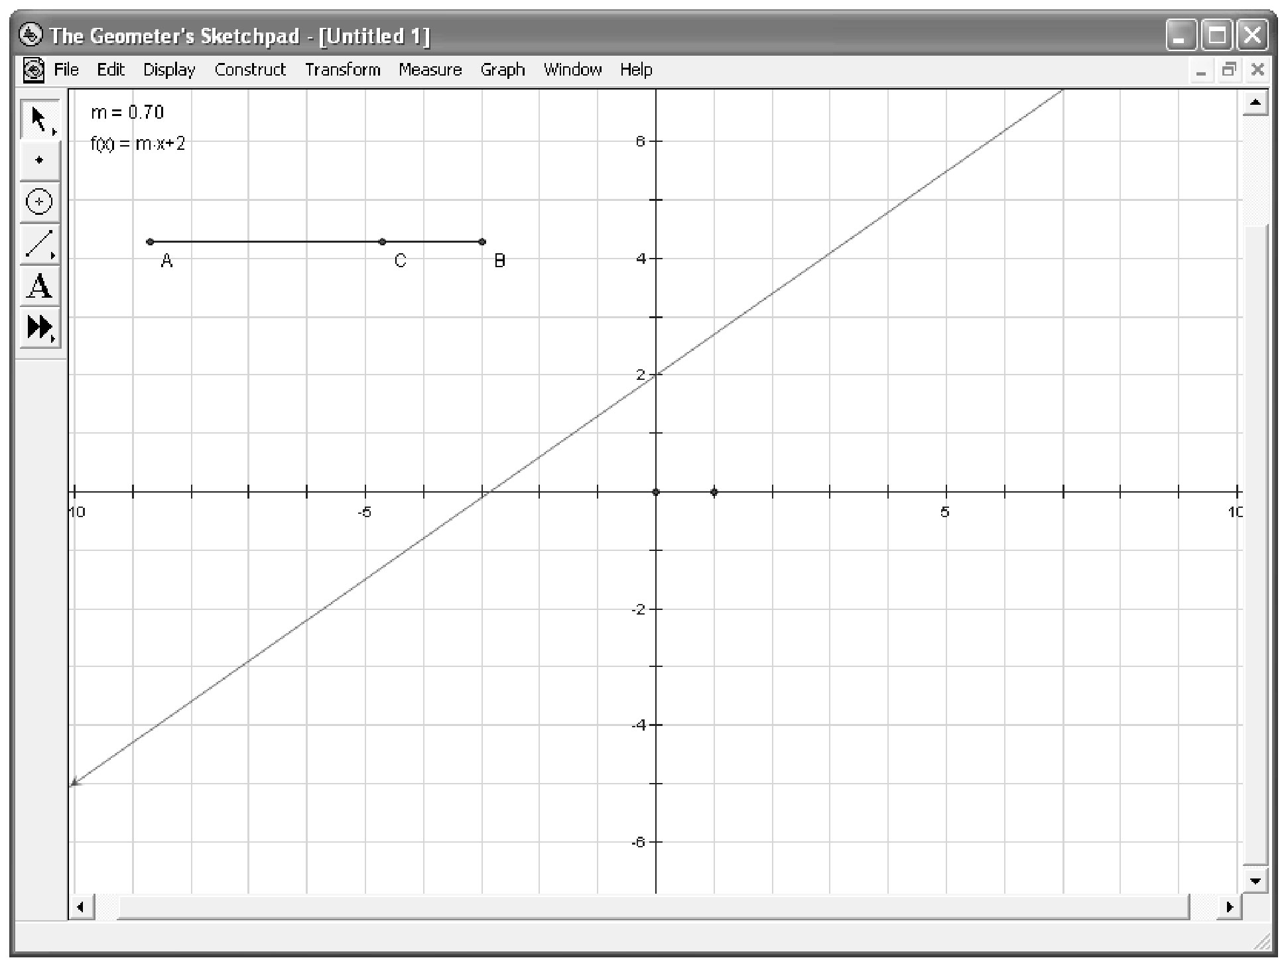

You can also right-click the point C, and click Animate Point to move C back and forth.

