BLM 6.GR.1 Practice: Get Ready
1. a) 4; the slope is the speed, in this case, 4 m/s
- 0; the object was at “home” when it started
moving
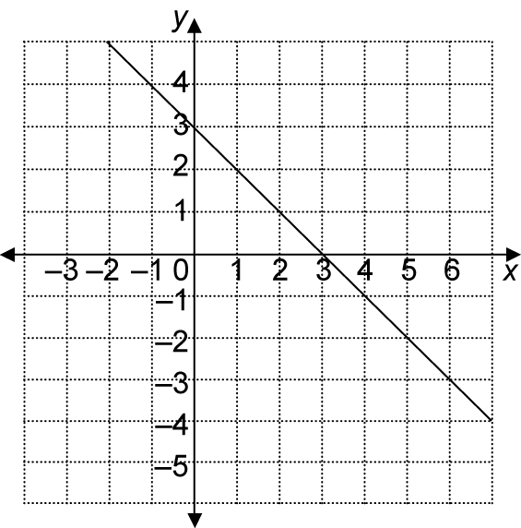
2. a)

b) −1
c) 3
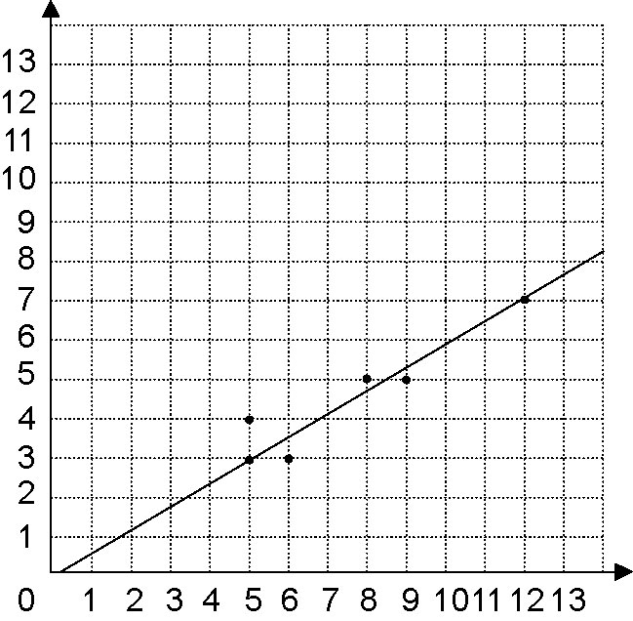
3. a)

b) about 6
4. a) b) 1 c)
BLM 6.1.1 Practice: The Equation of a Line in Slope y-Intercept Form: y = mx + b
1.
 | Equation | Slope | y-Intercept
a) | y = 4x + 1 | 4 | 1
b) | y = − 3 |  | −3
c) | y = −2x | −2 | 0
d) | y = −x + 2 | −1 | 2
2. a) −3; 6
b) ; 2
c) ; −2
d) ; 3
3. a) y = −3x + 6
b) y = x + 2
c) y =x − 2
d) y = x + 3
4. a) y = x − 3
b) y = −6x + 6
5. a) y = −2x + 1
b) y = x − 4
c) y = 5x
d) y = x + 3
6. a) slope ; y-intercept 3

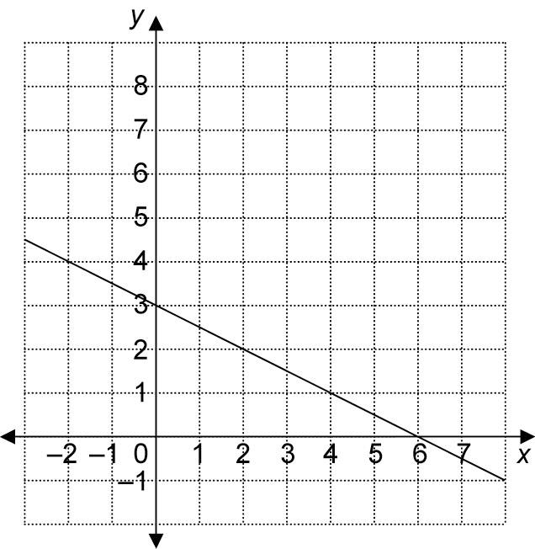

b) slope 1; y-intercept −4

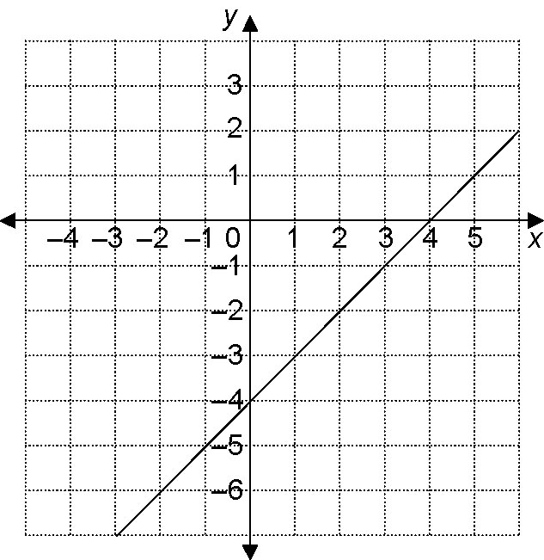
c) slope 0; y-intercept 5

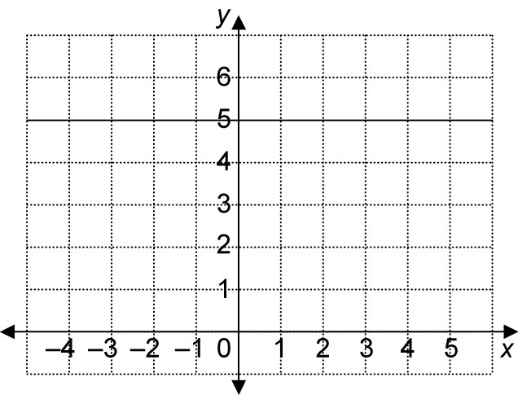

d) slope ; y-intercept 0

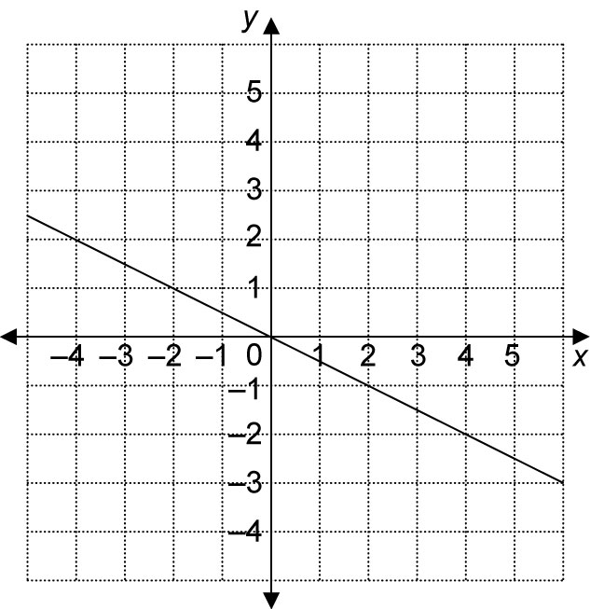
BLM 6.2.1 Practice: The Equation of a Line in Standard Form: Ax + By + C = 0
1. a) b)
c) P = A − I d) y = 4 − x
2. a) y = −x − 6
b) y = −2x
c) y = −5x + 3
d) y = −x + 1
3. a) 3y = −x − 1;
b) 2y = −4x − 3; y = −2x +
c) 3y = −x;
d) y = 5x − 1
e) 5y = 6x + 1;
f) 2y = −4x; y = −2x
4. a) y = −7x + 4
b)
c)
d)
5. a) ; 3
b) ;
c) ; −2
d) 1; 0

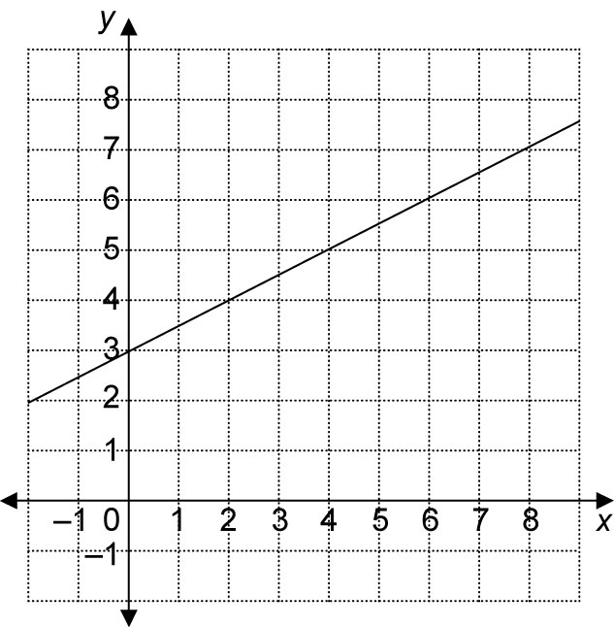
6. a)

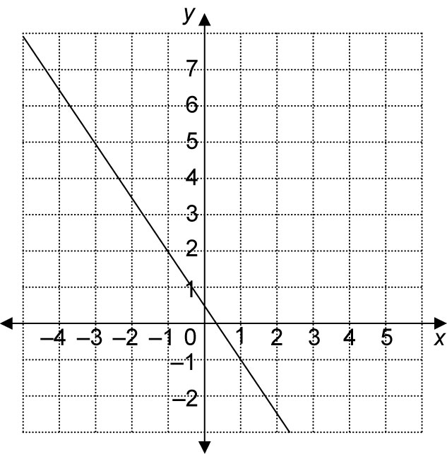
b)

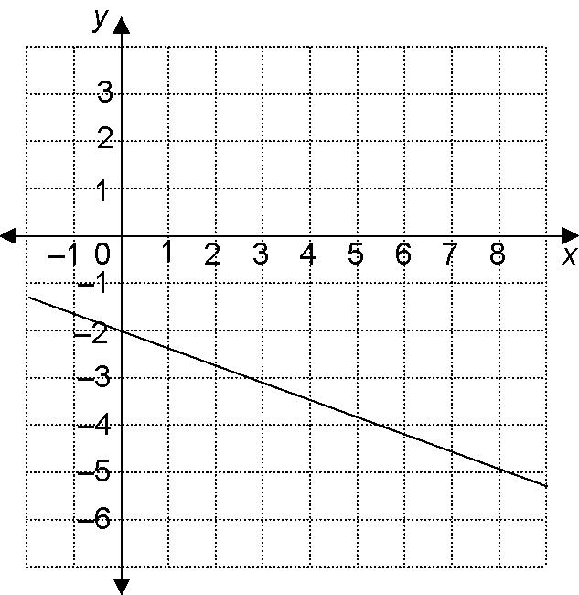
c)

d)
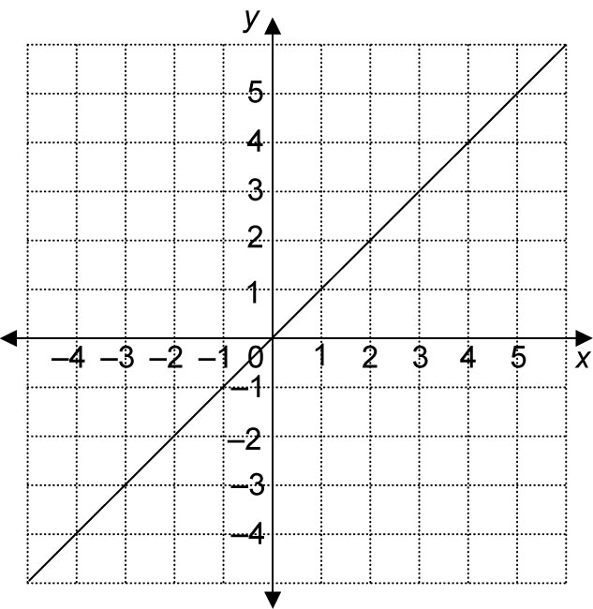

BLM 6.3.1 Practice: Graph a Line Using Intercepts
1. a) x-intercept: 3; y-intercept: −2
b) x-intercept: −3; y-intercept: −4
c) x-intercept: 2; y-intercept: 4
d) x-intercept: −6; y-intercept: −2
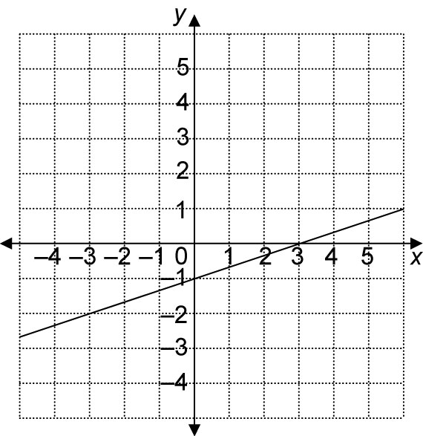
2. a)

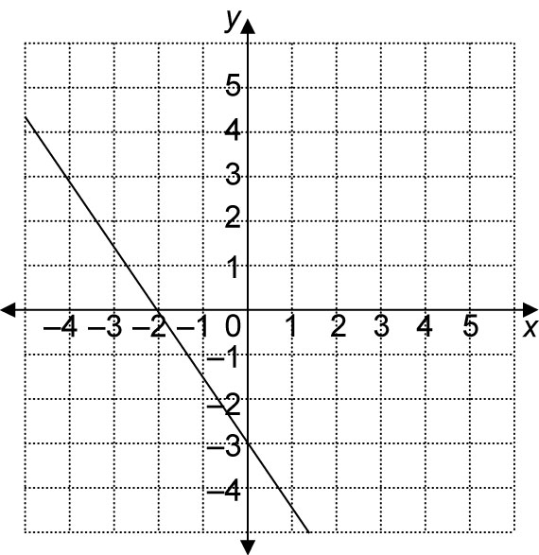
b)

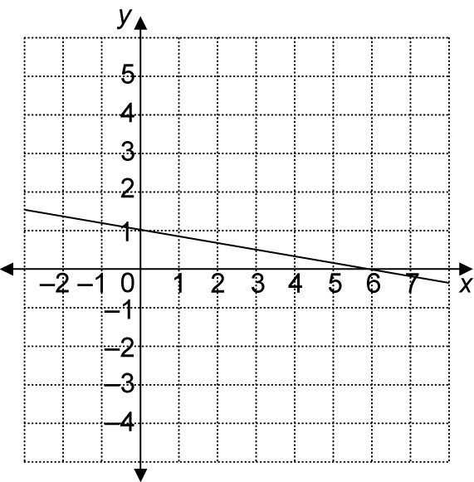
c)

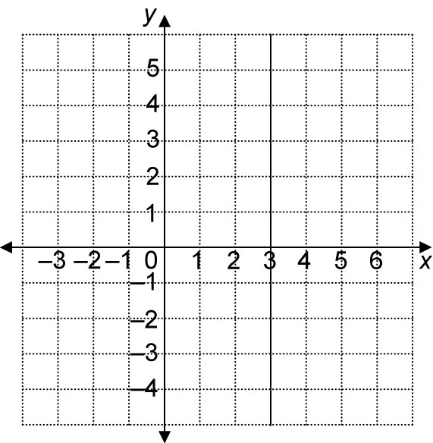
d)

3. a) b)
c) d) undefined
4. a) x-intercept: ; y-intercept: −4
b) x-intercept: ; y-intercept:
c) x-intercept: 6; y-intercept: 2
d) x-intercept: 3; y-intercept:
BLM 6.4.1 Practice: Parallel and Perpendicular Lines
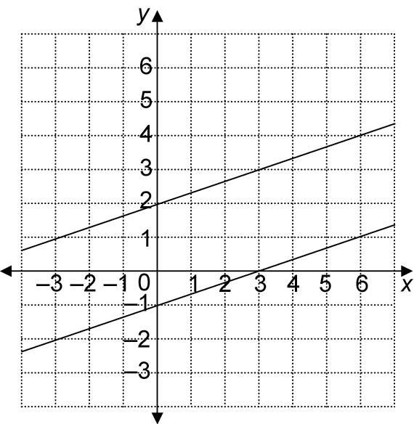
1. a)

parallel
b)
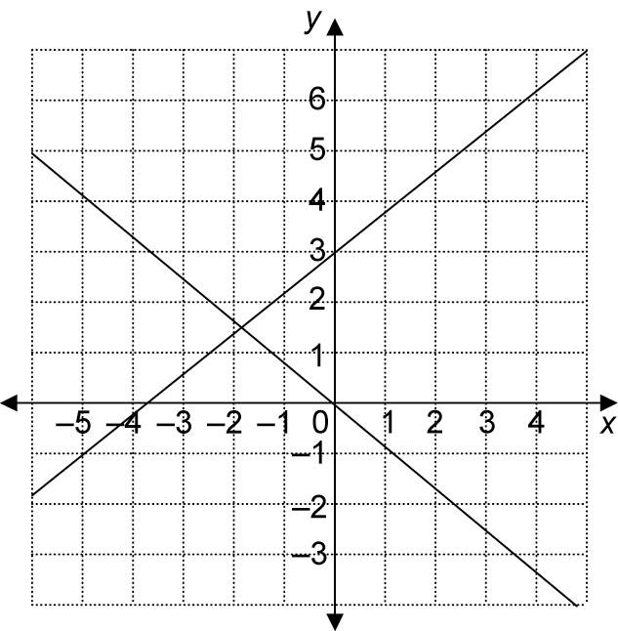

neither
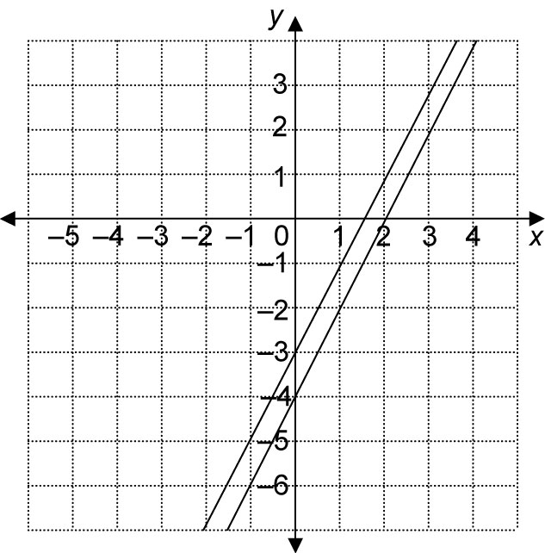
c)

parallel
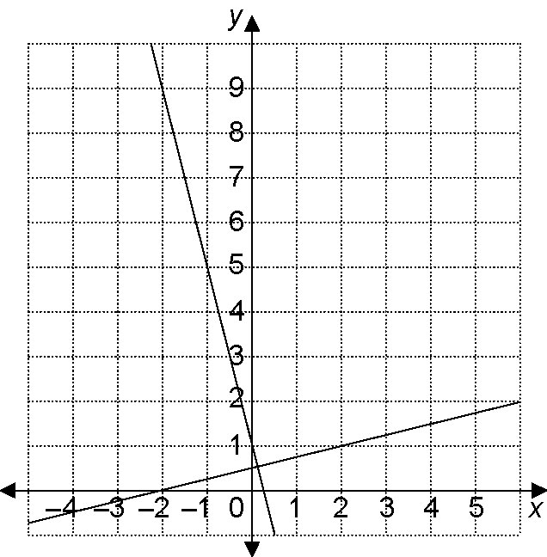
d)

perpendicular
2. a) neither b) perpendicular
c) parallel d) perpendicular
e) parallel f) neither
g) parallel h) perpendicular
3. a) ; parallel
b) ; neither
c) 3, −3; neither
d) ; perpendicular
e) 3, 3; parallel
f) 1, −1; perpendicular
4. a) 2 b) −5
c) d) 4
5. a) b) −2
c) d) −2
6. Possible answer:
7. Possible answer: y = −5x

BLM 6.5.1 Practice: Find an Equation for a Line Given the Slope and a Point
1. a) y = 5x + 2
b) y = 3x − 4
c) y = −2x
d) y = 4x + 8
e) y = −6x − 1
f) y = x + 12
g) y = x − 5
h) y = x − 2
2. a) y = x + 3
b) y = −x + 4
c) y = 2x − 1
d) y = −3x − 10
e) y = x + 2
f) y = x − 2
g) y = x + 7
h) y = x −
3. a) y = 4x − 3
b) y = −x + 5
c) y = x − 2
d) y = 5x + 11
e) y = x + 6
f) y = −5x
g) y = 2x + 7
h) y = −x + 6
4. a)
b) 10
c) y = x + 10
BLM 6.6.1 Practice: Find an Equation for a Line Given Two Points
1. a) 1 b) −3
c) d) 1
e) −4 f) 1
g) h) 1
2. a)
b) y = 3x + 1
c) y = −2x + 6
3. a) y = −4x + 21 b) y = x − 1
c) d) y = 6x + 19
e) y = x + 1 f)
g) h)
4. a) b)
5. a) b)

BLM 6.7.2 Practice: Linear Systems
1. a) (3, 2) b) (−1, 4)
2. a) (1, 3) b) (4, −1)
3. a) (2, 2) b) (2, 4)
c) (−1, 4) d) (1, 2)
4. B
5. C

BLM 6.CR.1 Chapter 6 Review
1. a) slope: −2; y-intercept: 6
b) slope: ; y-intercept: −3
2. a) slope: 4; y-intercept: −5
b) slope: ; y-intercept: 2
3. a) y = −x
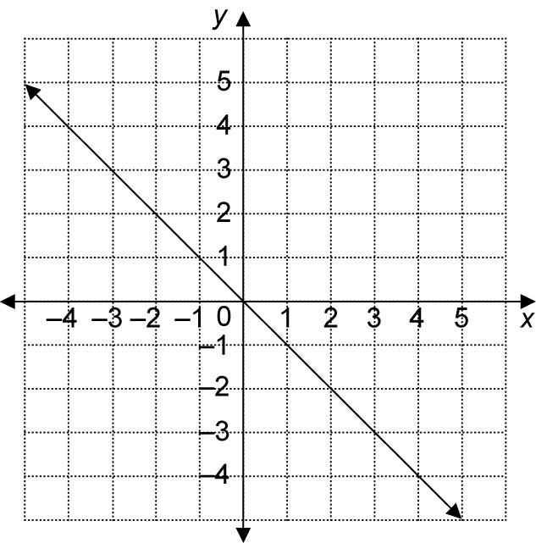

b) y = x + 5
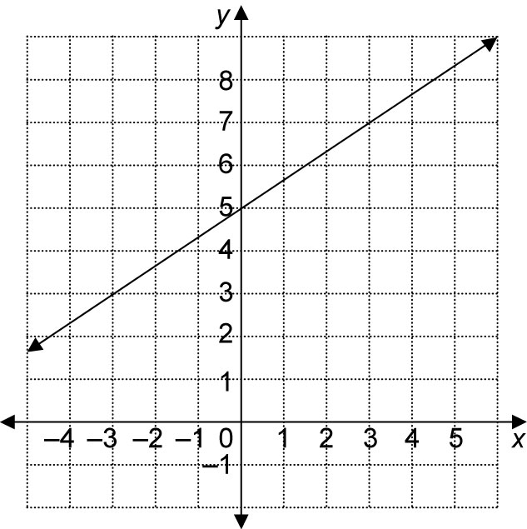

4. a) y = 6x − 4
b)
5. a) slope: −8; y-intercept: 4
b) slope: ; y-intercept: 4

6. a) x-intercept: 2; y-intercept: −4
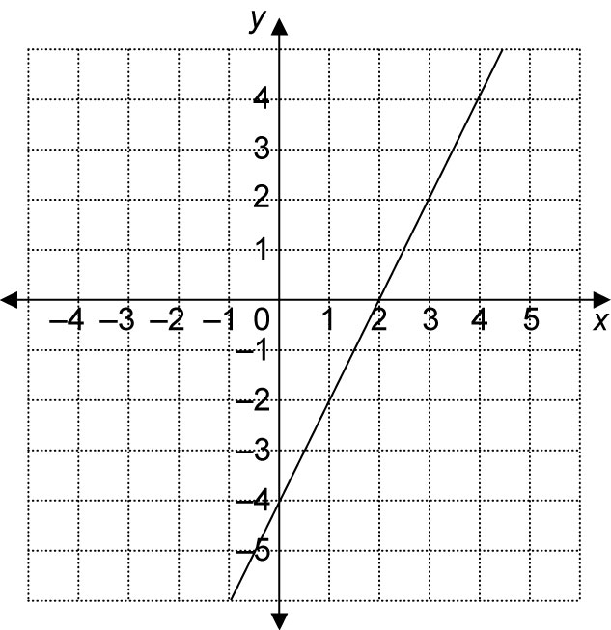
b) x-intercept: 6; y-intercept: 2
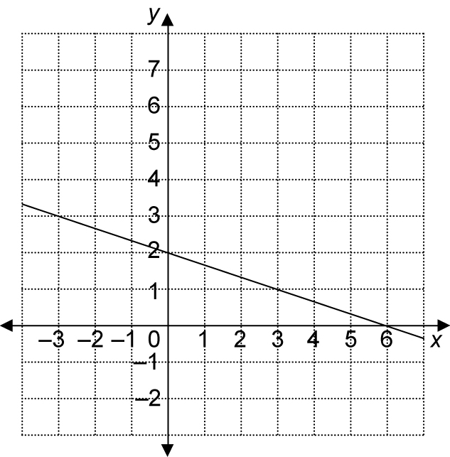

c) x-intercept: 2; y-intercept: −4
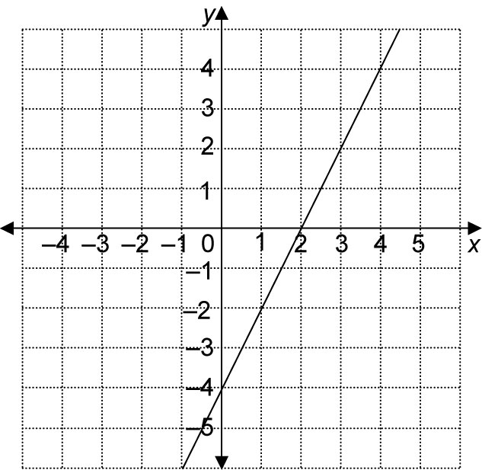

d) x-intercept: 3; y-intercept: 5
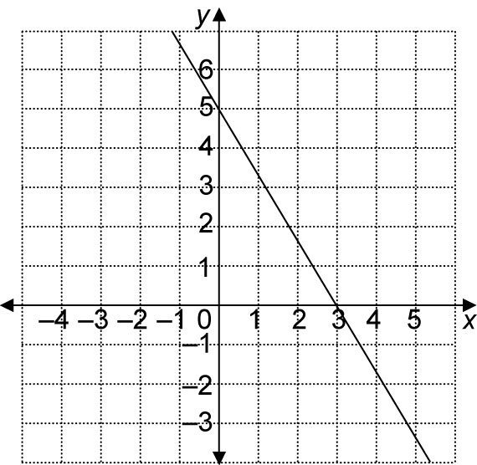

7. 2x − 3y + 12 = 0 and 3y = 2x + 6
8. 2x − 3y + 12 = 0 and 3x + 2y = −4; 3y = 2x + 6 and 3x + 2y = −4
9. −4
10. y = −3x + 1
11.
12. y = −9x + 23
13. a) −1.1
b) d = −1.1t + 5
c) About 4.5 s
14. (1, 1)
15. (2, 4)
BLM 6.PT.1 Chapter 6 Practice Test
1. D
2. A
3. D
4. A
5. B
6.
7. a) slope: −1.2; d-intercept: 12
b) d = −1.2t + 12
8. a)
b)
9.

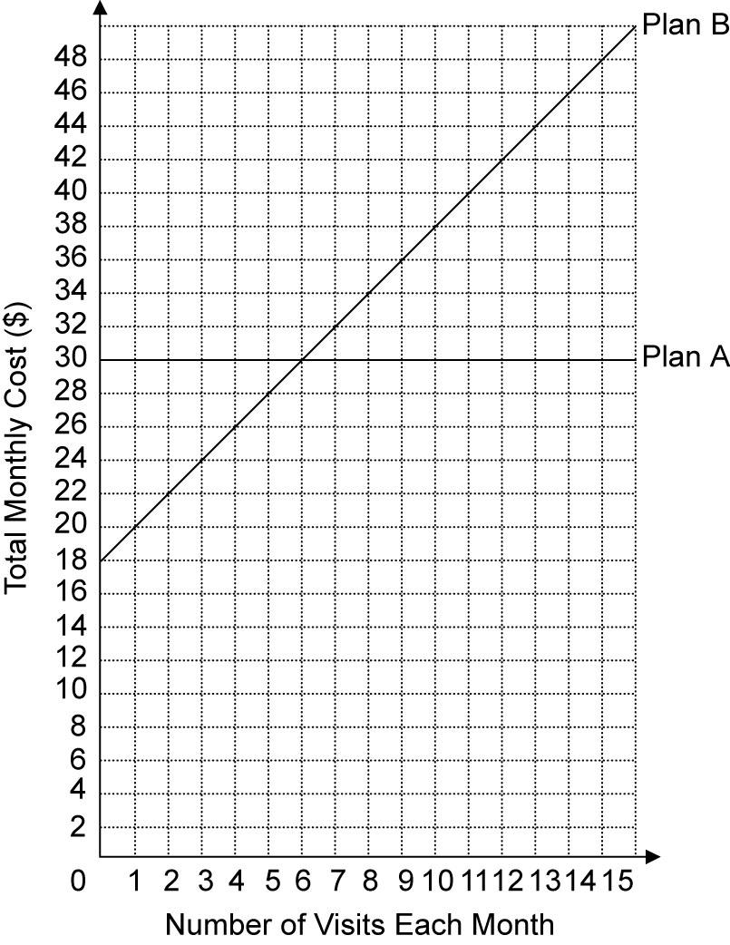
10. a)

When you make 6 visits per month, the cost
for both plans is $30.
b) I would choose Plan A if I go to the gym more
than 6 times each month. If I thought I would go fewer than 6 times per month, I would choose Plan B (or not get a membership!).
BLM 6.CT.1 Chapter 6 Test
1. D
2. D
3. B
4. D
5. C
6.
7. a) 3 m
b) Away; approximately 2.1 m/s
c) d = 2.1t + 3

8. a) y = 6x + 10
b)
9.
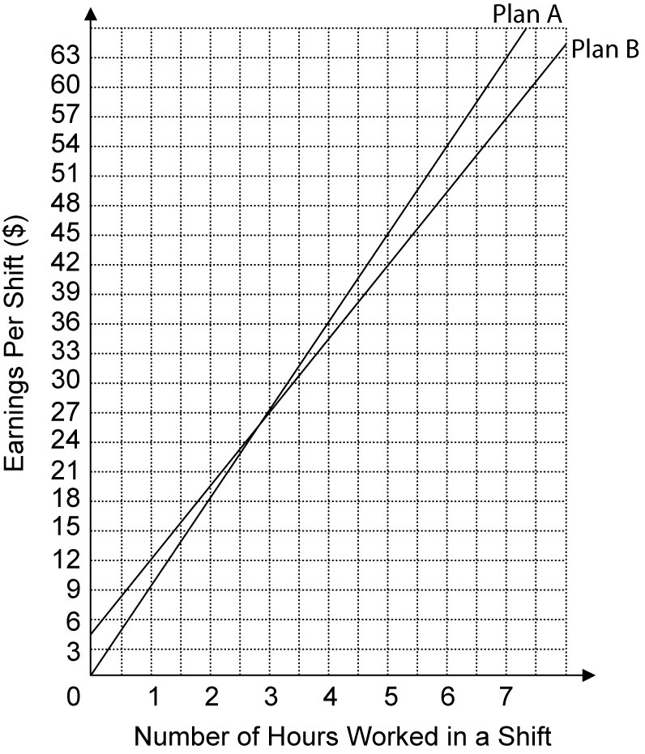
10. a)

The earnings per shift under both plans are
$27 when you work 3 h.
b) I would choose Plan A if I usually work more
than 3 h each shift. If I work fewer than 3 h per shift, I would choose Plan B.

