Bisectors, Medians, and Altitudes
In this worksheet, you will do two different constructions with the same triangle, looking for different patterns each time.

1. Construct the angle bisector of each angle of the triangle. What do you notice about the three line segments that you have created? Try this construction on either The Geometer’s Sketchpad® or Cabri™ Jr.

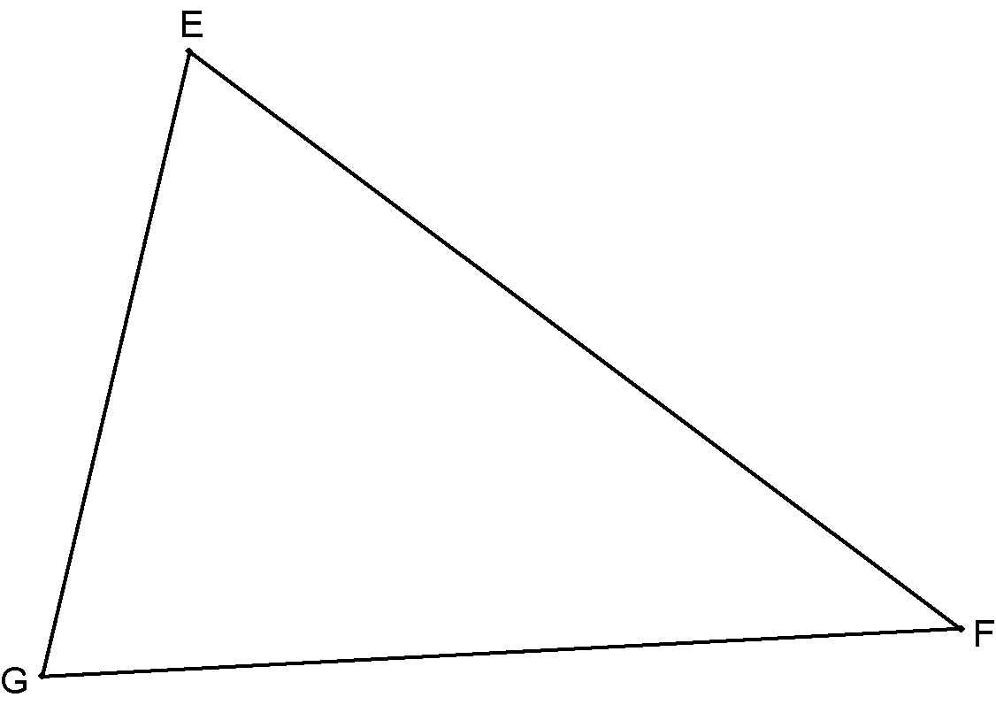

2. Can you construct a line segment from point E that intersects GF at 90°? Could you do this for all three vertices? What do you notice about the three line segments that you have constructed. Do you think that this will always happen? Could you do this construction using The Geometer’s Sketchpad® or Cabri™ Jr.?

