Practice: Angle Relationships in Polygons

1. Find the sum of the interior angles of each polygon.
  a) | 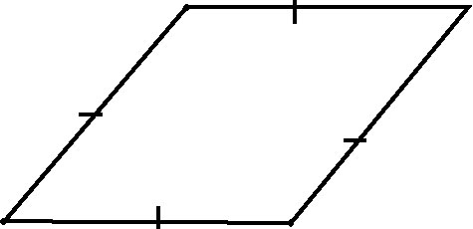  b)
  c) |   d)

2. Find the sum of the interior angles of each polygon.
  a) |   b)
  c) |   d)

3. Find the sum of the interior angles of a polygon with each number of sides.
a) 11 sides b) 14 sides c) 18 sides d) 24 sides

4. Find the measure of each interior angle of a regular polygon with each number of sides.
a) 3 sides b) 20 sides c) 9 sides d) 16 sides

5. Find the number of sides each polygon has given the sum of its interior angles.
a) 720° b) 1980° c) 2340° d) 4140°

