Constructing the Gazebo

The following sets of instructions will produce the type of figure shown in Section 7.3, question 13. In this diagram, a regular octagon will be created by connecting the end points of eight spokes radiating out from a centre point.

For each diagram, we know that there will be eight angles formed by adjacent spokes. Therefore, each angle will be 360° ÷ 8 = 45°.

Method 1
Using The Geometer’s Sketchpad®

Turn on automatic labelling of points. Start with a line segment, AB, in the centre of the screen.
Using the Point Tool, double-click point A. You should see a brief animation on the point. Click
line segment AB and point B.

On the Transform menu, click Rotate. Enter the angle as 45° and click OK.
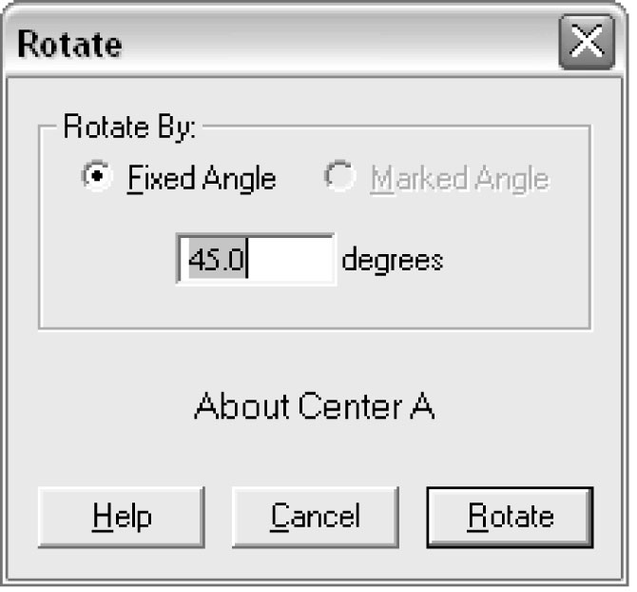
You should see an image of the original line segment. Notice that the new point is labelled B' rather than C.
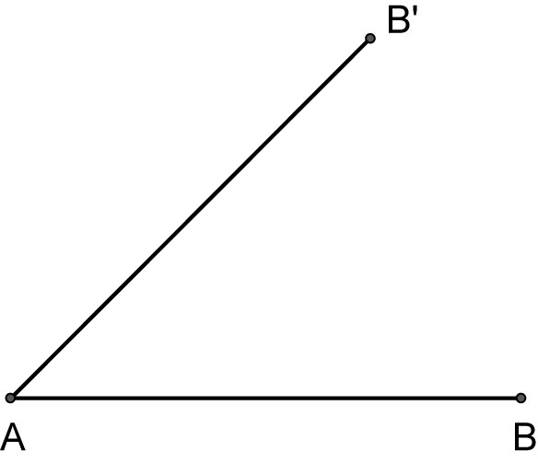
Repeat this process by highlighting each new point and line segment and rotating them through 45°.
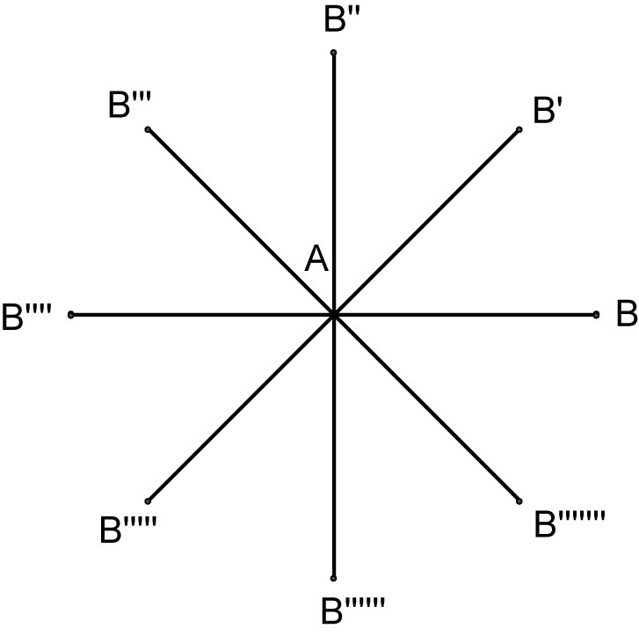
Finally, join all of the points at the ends of the spokes to form an octagon.
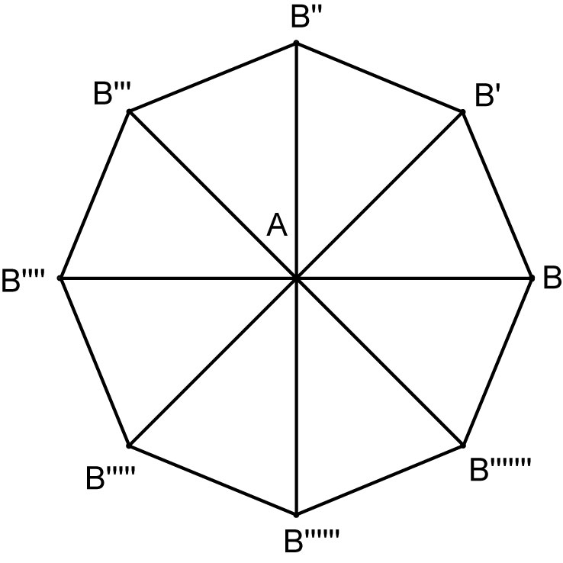
For any other shape, simply change the value that you divide into 360° to the number of sides in the polygon that you want to construct.

Method 2
Using Cabri™ Jr. on the TI-83 Plus or TI-84 Graphing Calculator

Press APPS, then Cabri™ Jr. When the title screen appears, press ENTER. If you need to clear a previous drawing from the screen, press Y= to display the F1 File menu, then select NEW.
From the F5 menu, choose Alpha-Num and press ENTER. This puts the keyboard in Alpha-Lock mode. Press the ALPHA key so that you can enter numbers. Move to a corner of the screen, press ENTER and type in the number 45. Press ENTER again to anchor the value in that position. You will refer to this value by moving to it during each rotation.
On the F2 menu, select Segment. Construct a line segment with one point near the centre of the screen. Cabri™ Jr. can rotate only one object at a time, so we will be rotating just the second end point of the line segment.
On the F4 menu, select the Rotation feature. Move your cursor to the centre point and press ENTER. Move to the number that you put on the screen for the angle of rotation and press ENTER. Finally, move to the second end point of the line segment and press ENTER. You should see a new point on the screen.
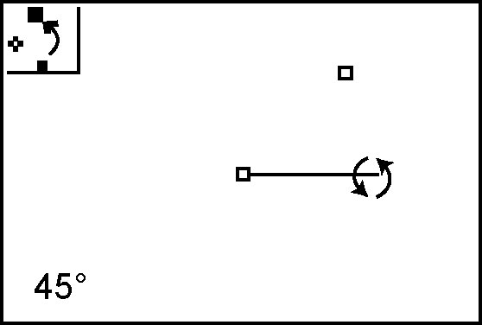
Repeat this operation by selecting the centre point, the angle of rotation, and the previous new point each time until you have all eight points on the screen.
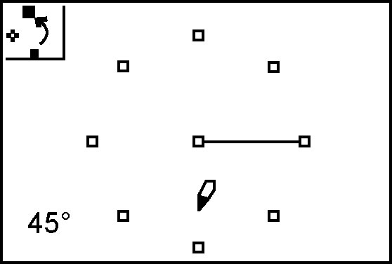
Complete the octagon by connecting adjacent points with line segments.
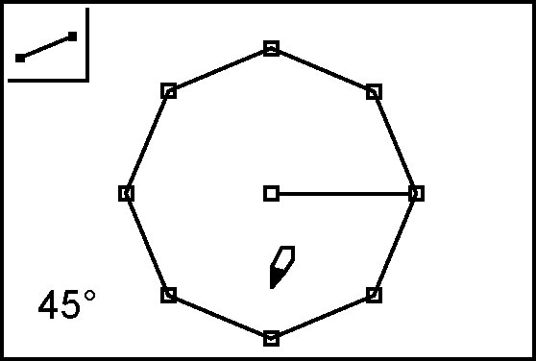
Finally, connect the centre point to the remaining seven points to form the spokes.
