Practice: Midpoints and Medians in Triangles

1. Find the length of line segment MN in each triangle.
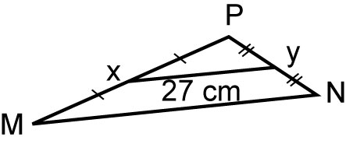
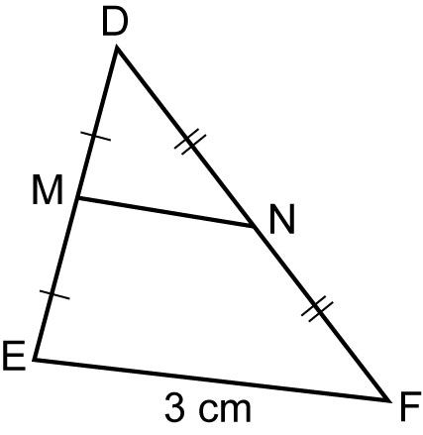
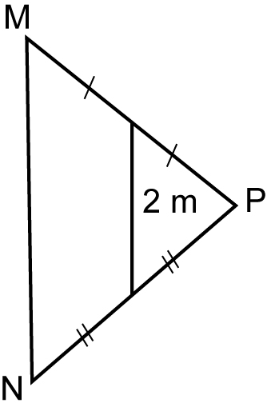
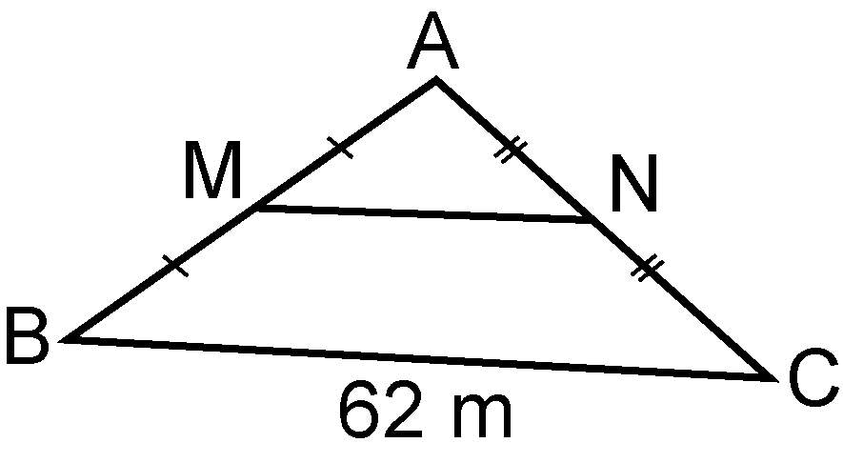
a) b) c) d)

2. Find the lengths of line segments AD and DE in each triangle.
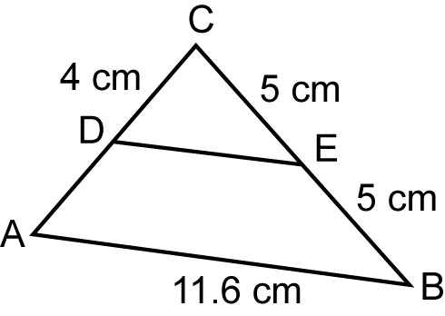
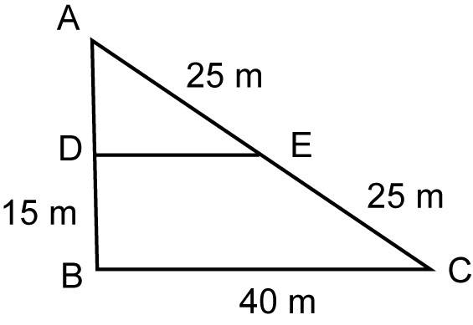
a) b)

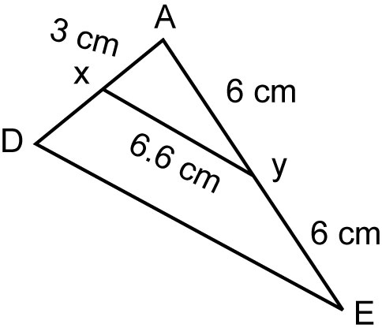
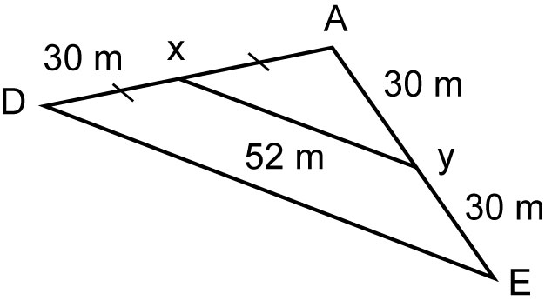
c) d)

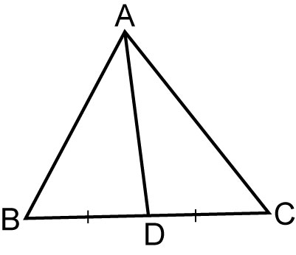
3. The area of ABC is 10 cm².
Calculate the area of each triangle.
a) ABD
b) ADC

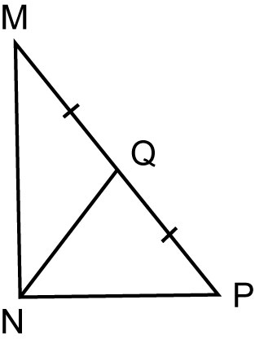

4. Calculate the area of each triangle given the area of MNQ is 12 cm².
a) MNP
b) NPQ

5. Here are two conjectures about a median in an isosceles triangle. For each conjecture, explain why the conjecture is true, or draw a counterexample to show it is false.
a) The median to the vertex opposite the unequal side bisects the angle.
b) The median to a vertex opposite one of the equal sides bisects the angle.

