Using a MIRA to Investigate Lines of
Symmetry
In each figure below, you are given either an isosceles triangle or an equilateral triangle. Use a MIRA to find the lines of symmetry.

For each line of symmetry, determine how the line bisects sides and angles in the triangle, and what other properties are present. Record your findings.
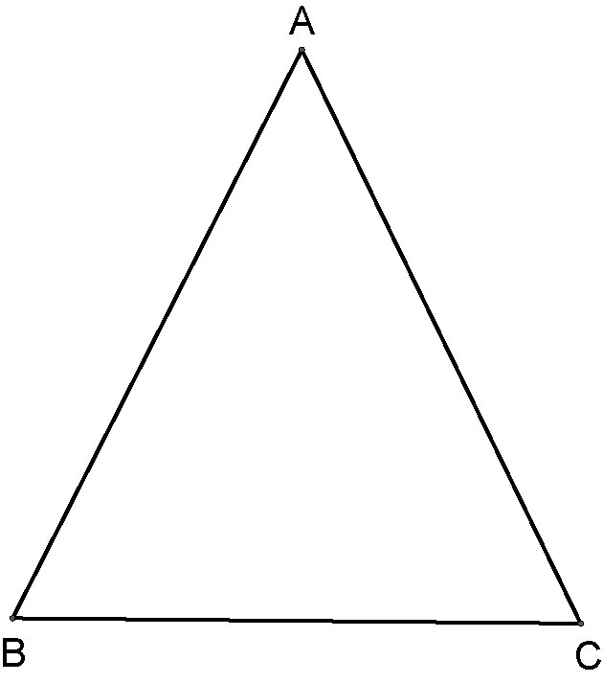  1. | 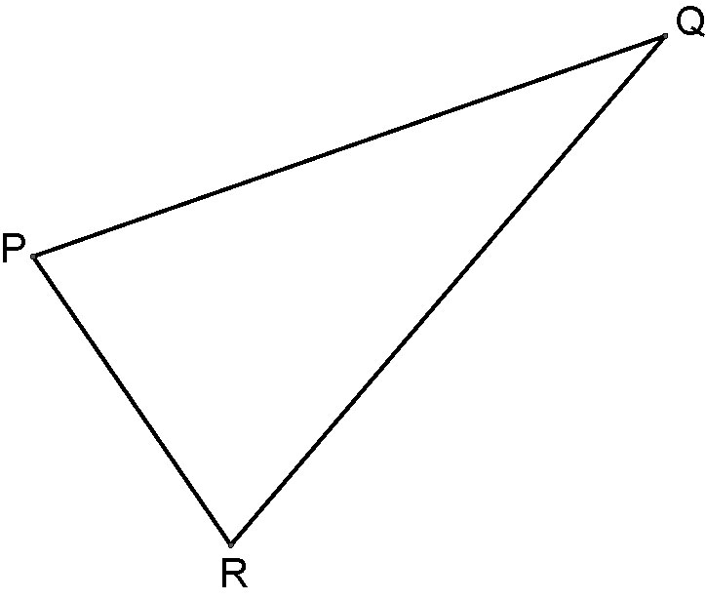  2.
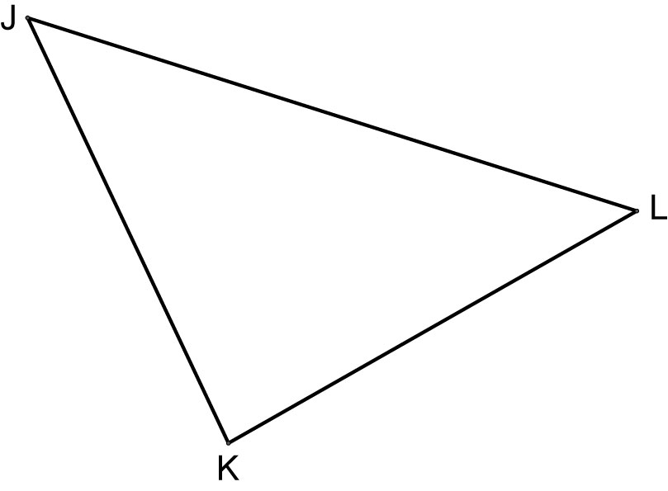  3. | 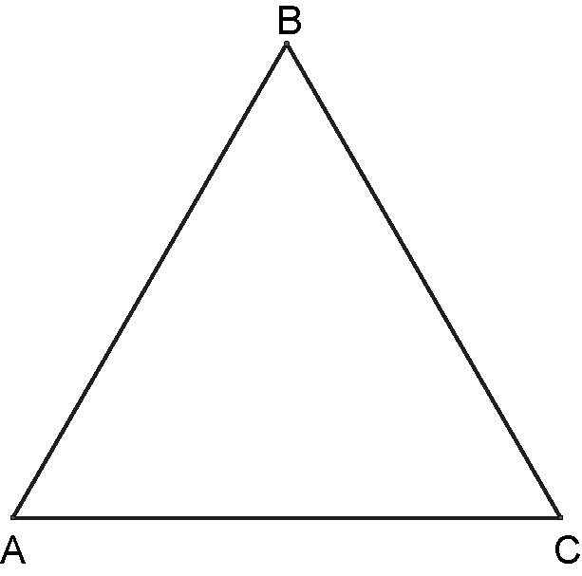  4.
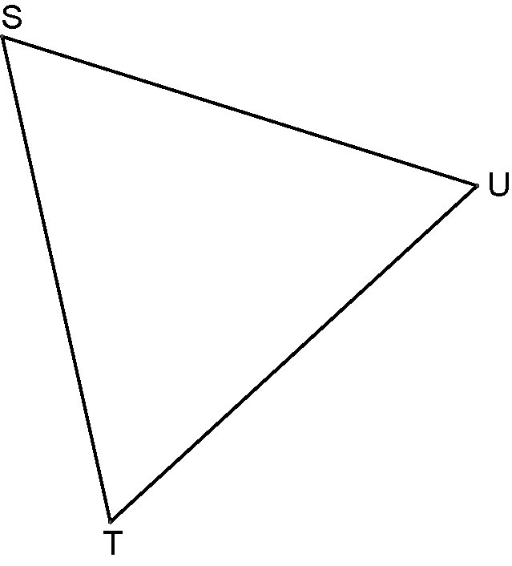
5.

