Sierpinski's Triangle

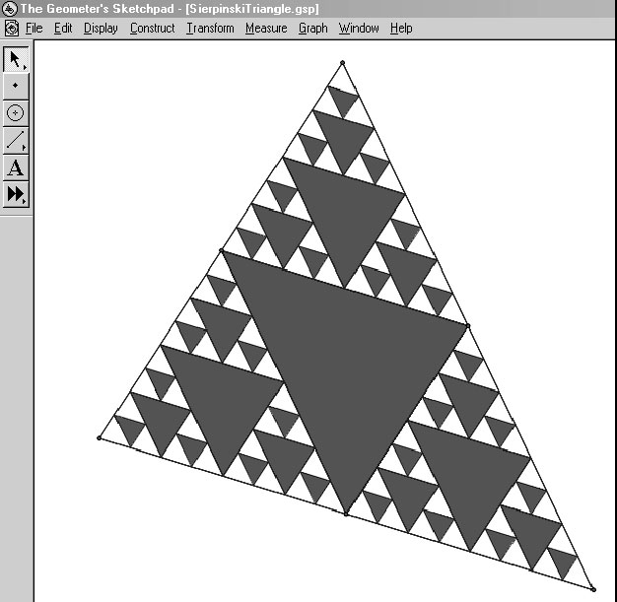
Sierpinski’s Triangle is a fractal created by connecting midpoints of a triangle. The resulting triangle is dark grey in the example, and the process is repeated. In theory, the process is infinite. However, memory limitations will only allow us to take the number of iterations to a certain point.

Method 1
Using a Custom Tool

For this method, we will create a new tool in The Geometer’s Sketchpad®. We will need to access the Custom Tool from the toolbox on the left side of the screen.

To create the fractal, start with any triangle. Construct the midpoints and connect them with line segments. Highlight the three midpoints. On the Construct menu, click Triangle Interior. Choose any colour that you would like to use.
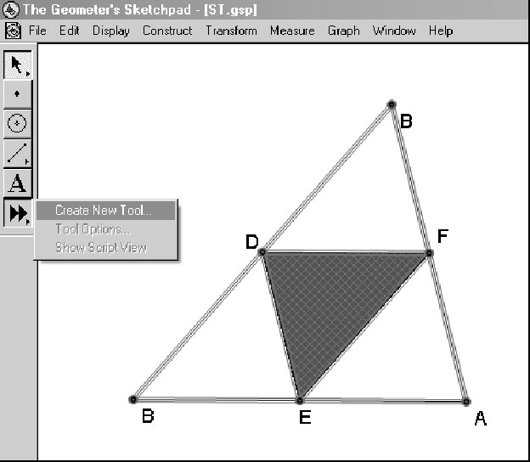
Highlight the three points of the original triangle, the three midpoints, the line segments connecting the midpoints, and the triangle interior. Click and hold the mouse button on the Custom Tool icon. Select the option labelled Create New Tool. Release the mouse button. A dialog box will open asking you to name the new tool. Type in something that you will remember.

The next time that you hold down the Custom Tool icon the name of your custom tool will be displayed.

Notes:
1. By clicking all of the points, segments and the triangle interior, you have created a set of objects that this tool will recognize in the future. If you click the Custom Tool, each time that you select three points, the entire set of actions in your Custom Tool will be applied to the triangle formed by those three points.
2. Before continuing, on the Edit menu click Preferences. Click the Text tab, and turn off automatic labelling of points.

As mentioned above, the tool is now active in your sketch. Select points B, D, and F. Describe what happens. Now, select points D, B, and E. The action should have been repeated. Finally, select points F, E, and A. This is the second iteration of the fractal. A number of new triangular regions have been created and you could apply this routine to these regions, ad infinitum.

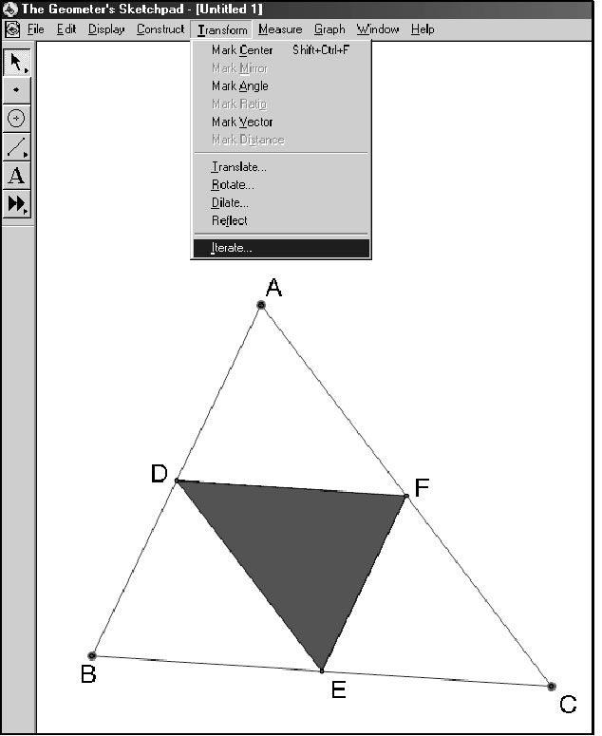
Method 2

Using the Iteration Feature

Start a new sketch. Use the Preferences command on the
Edit menu to have the names of points displayed automatically as they appear. Construct a triangle ABC, the midpoints
D, E, and F, the line segments DE, EF, and DF and the triangle interior DEF. Now, shut off the automatic display of the labels on points.

Highlight points A, B, and C. On the Transform menu, click Iterate.

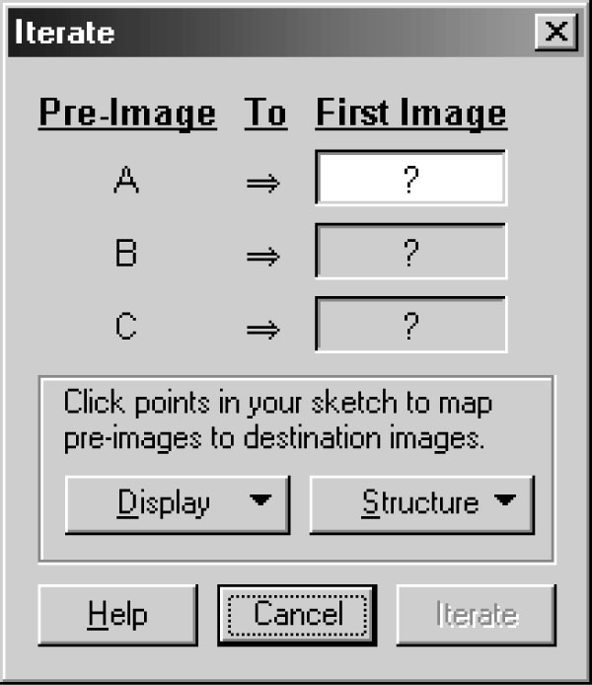
A dialog box will open on the screen. This will ask you to map the object points A, B, and C onto the image points. Do this three times, once for each of the triangles ADF, DBE, and FEC. Note the order in which the triangles were named. Since these triangles are all similar to the original triangle, match up corresponding points. When the dialog box first opens, highlight the point corresponding to A in the first triangle. To complete the window the first time, highlight points A, D, and F in that order. Images of the triangle will appear as you highlight each image point. Click the Structure button.

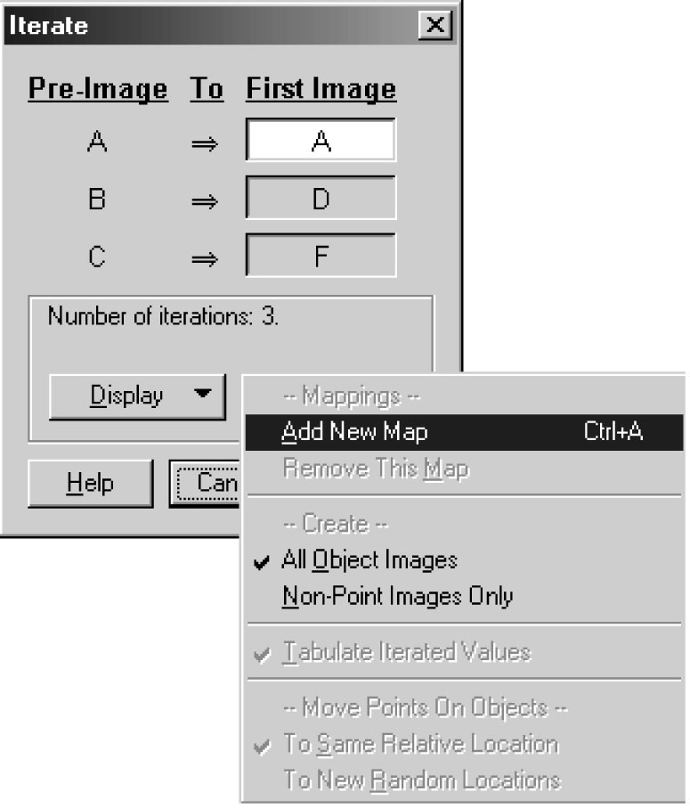

Click Add New Map. This will allow you to set up a second mapping.

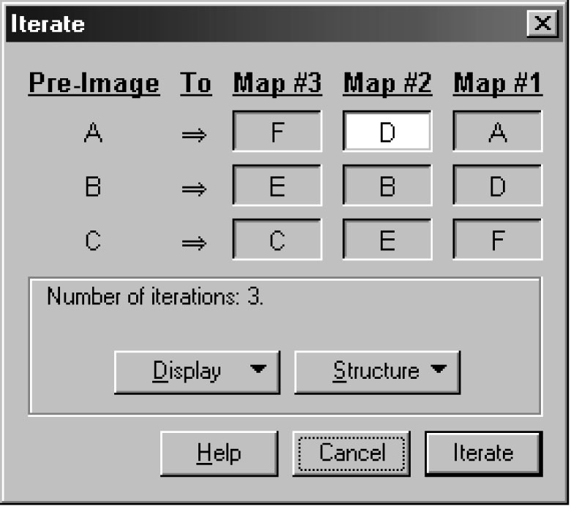

Repeat this a third time for the final image, completing the table as shown. When you are finished, click the Iterate button.

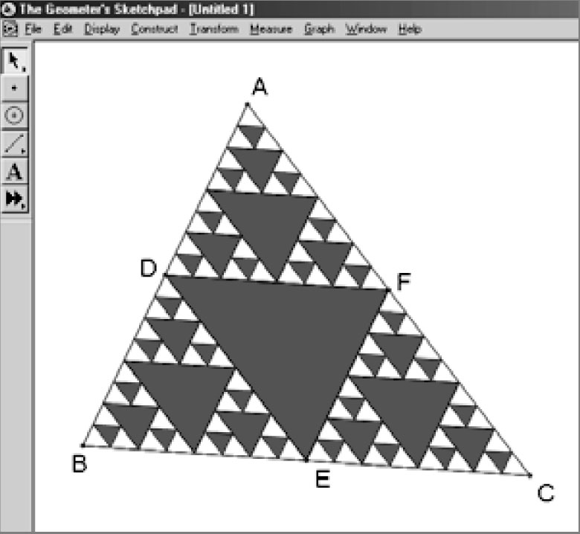

Due to the settings in the dialog box above, three iterations of the process have been applied and all of the triangles produced by the iterative process are highlighted. Press the + key. What happens?
How would you reduce the number of iterations?
If the new triangles are not all highlighted, clicking any of the smallest triangles will highlight them.

