Constructing Parallelograms

The process of creating a parallelogram can be very difficult. Follow the steps outlined below. Refer to BLM T4 The Geometer’s Sketchpad® 3 or BLM T5 The Geometer’s Sketchpad® 4 for basic operations.

Method 1
Using The Geometer’s Sketchpad®

Turn on automatic labelling of points. Start with a line segment, AB, in the centre of the screen. Construct line segment BC. Highlight point C and then line segment AB. On the Construct menu, click Labelled Parallel Line.
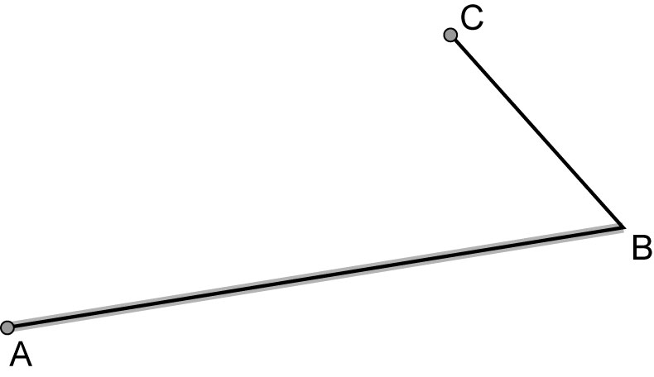
Repeat this step by highlighting point A and then line segment BC. Highlight the two parallel lines that were constructed. On the Construct menu, click Intersection. Point D should be the fourth point of the parallelogram.

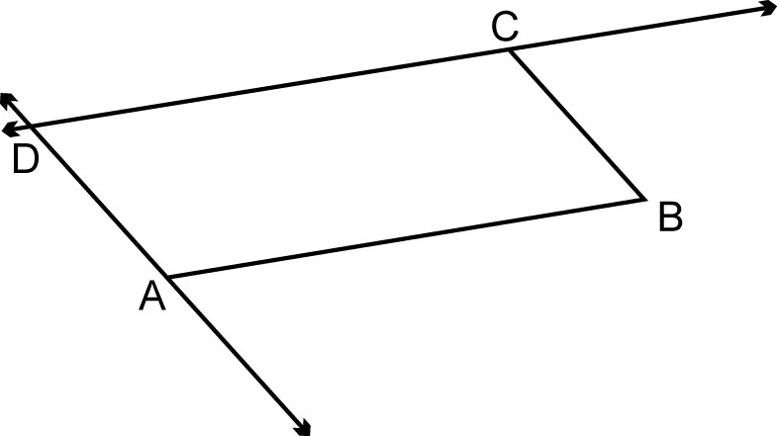
Highlight the two parallel lines that were created and select the Hide Parallel Lines feature from the Display menu, or press CTRL and H together. Construct line segments AD and CD. Drag points A, B, or C around the screen to test your construction.
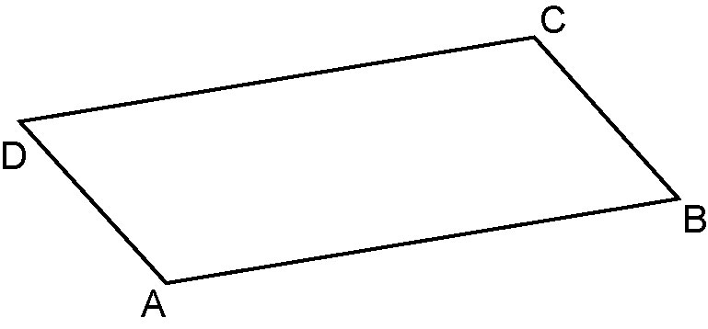

Method 2
Using Cabri™ Jr.

Press APPS, then Cabri™ Jr. Press ENTER when the title screen appears. If you need to clear a previous drawing from the screen, press Y= to display the F1 File menu, then select NEW.

Construct line segments on the screen with a common vertex. Label the points as shown.
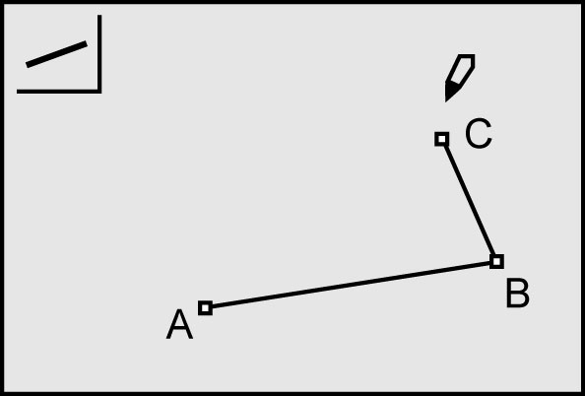
Press F3 and select the option Parallel. Press ENTER on vertex C and then on line segment AB.
A line will be drawn through C that is parallel to AB.
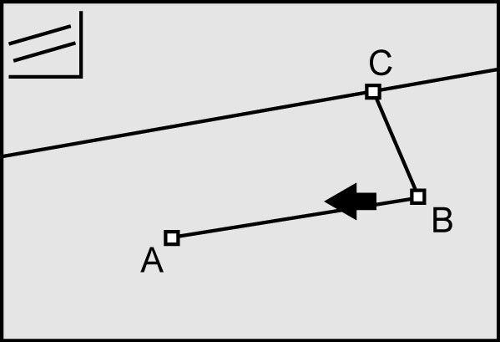
Repeat this for point A and line segment BC. Press F2 and the option Point. Press the right arrow and select Intersection. Press ENTER on each of the parallel lines that you created.
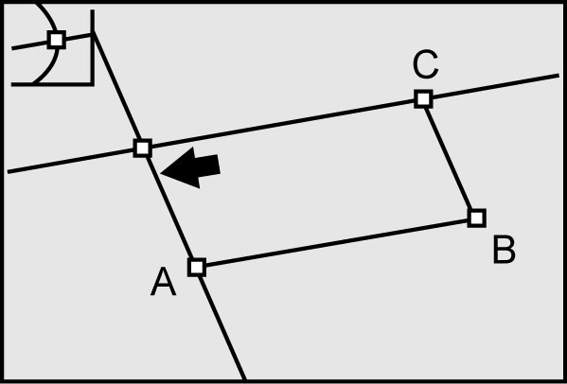
Hide the parallel lines leaving the point of intersection. Label this point D. Connect A to D, and C to D. Test your construction by dragging any of points A, B, or C.
