Practice: Midpoints and Diagonals in Quadrilaterals

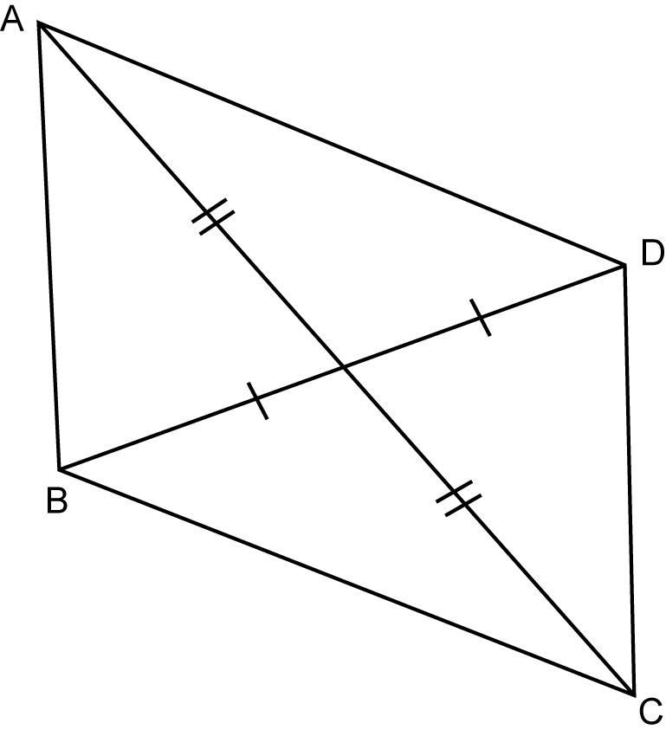
1. Which line segments in each diagram are parallel?
a)

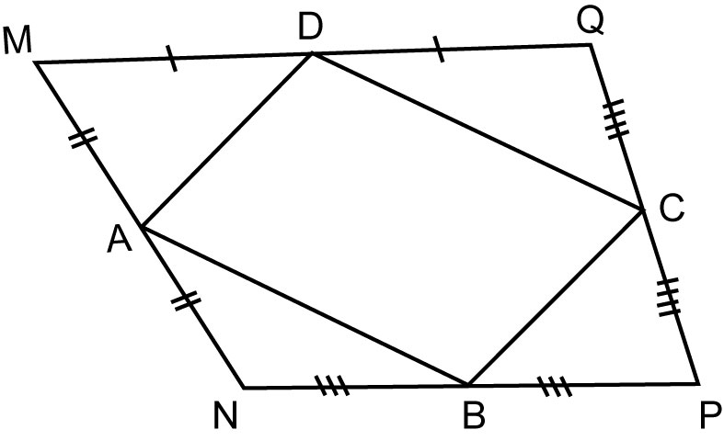
b)

2. Find the measures of the indicated angles.
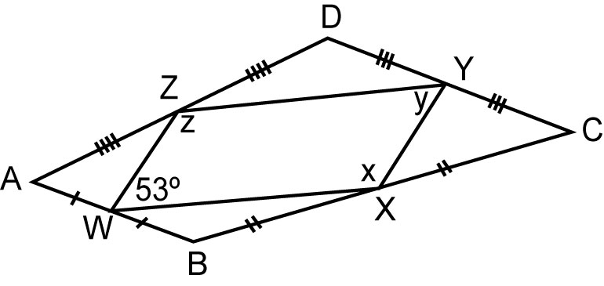
a)

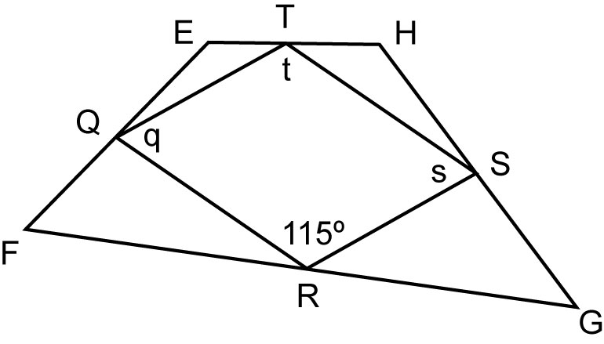
b)
3. Calculate the length of each line segment given that RU = 3.6 cm and RT = 6 cm.
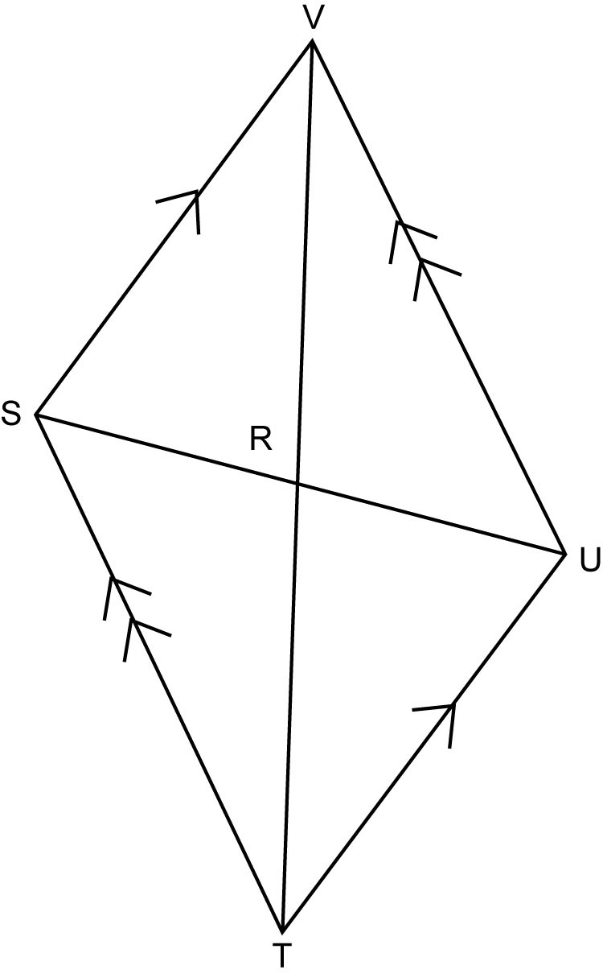
a) SR b) SU
c) VR d) VT

4. Calculate the length of each line segment given that AC = 13.2 m and XD = 6.6 m.
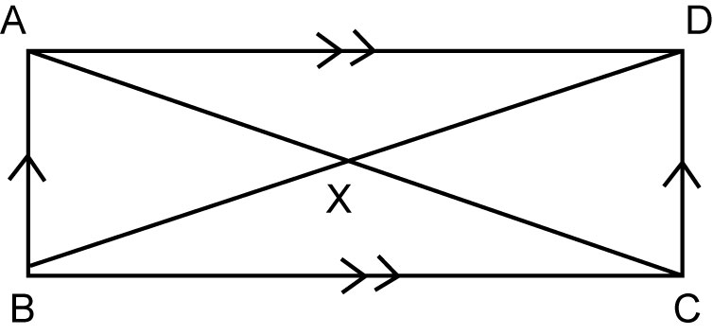
a) AX b) XC
c) BX d) BD

5. Explain why each statement is true or draw a counterexample to show it is false.
a) The diagonals of a rectangle are perpendicular to one another.
b) The diagonals of a square are perpendicular to one another.

