Chapter 7 Review

7.1 Angle Relationships in Triangles,
pages 364–373

1. Find the measure of each indicated angle.
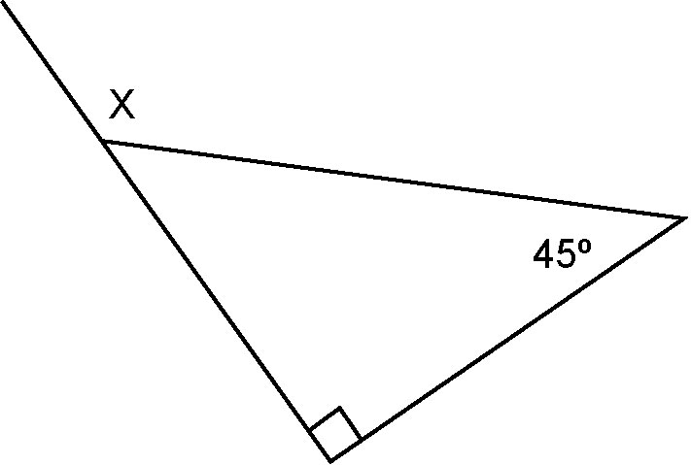
a)

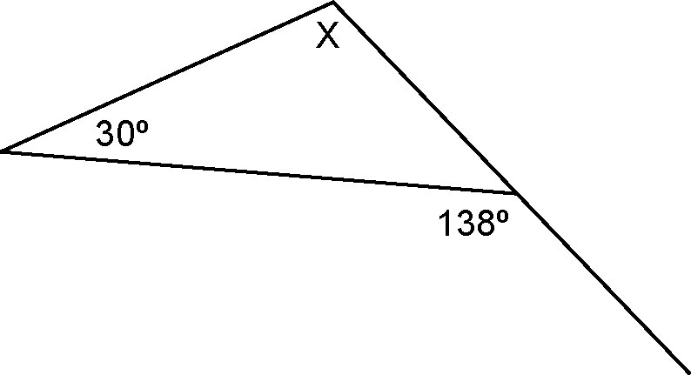
b)

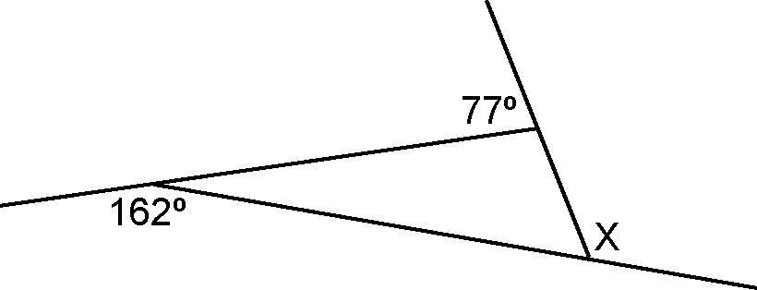

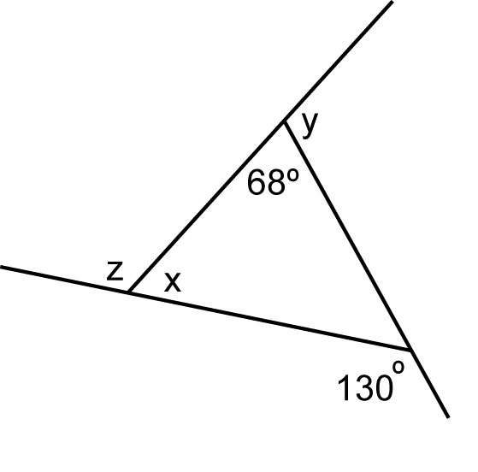

2. The measures of two interior angles in a triangle are 108° and 24°. Find the measure of the third interior angle and the measures of the exterior angles.
7.2 Angle Relationships in Quadrilaterals,
pages 374–383

3. Find the measure of each indicated angle.
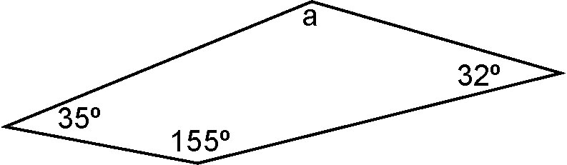
a)

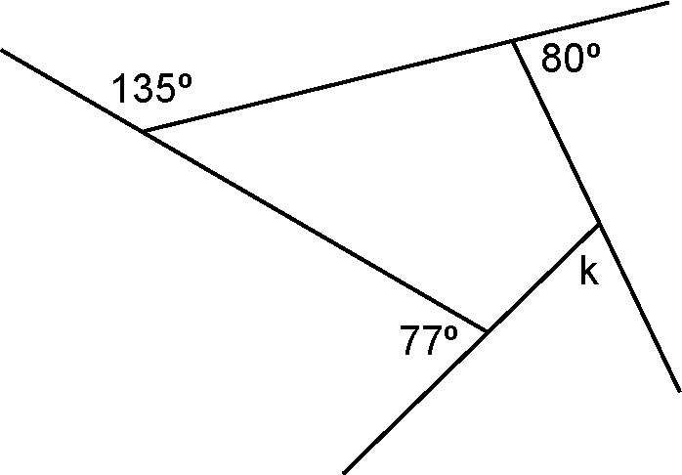
b)

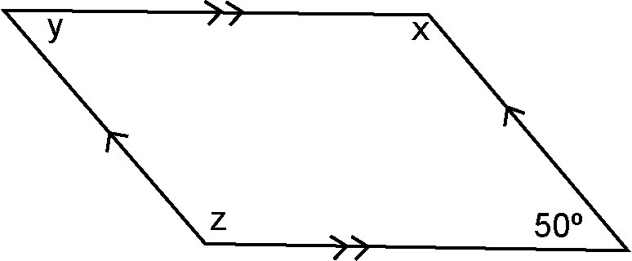
c)

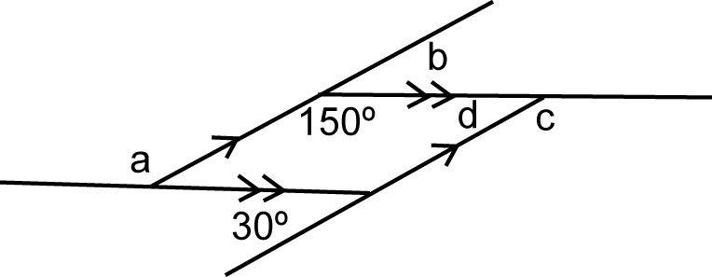
d)

4. The measures of three interior angles of a quadrilateral are 21°, 94°, and 88°.
a) Find the measure of the fourth interior angle.
b) Find the measures of the exterior angles.

7.3 Angle Relationships in Polygons,
pages 384–393

5. Find the sum of the interior angles of a polygon with each number of sides.
a) 5 b) 10 c) 4 d) 7

6. Find the measures of the interior angles for each regular polygon.
a) triangle b) hexagon
c) octagon d) decagon

7. The sum of the interior angles of a polygon is 3240°. How many sides does the polygon have?

7.4 Midpoints and Medians in Triangles,
pages 394–400

8. Find the area of each triangle given the area of EFG is 16 cm².
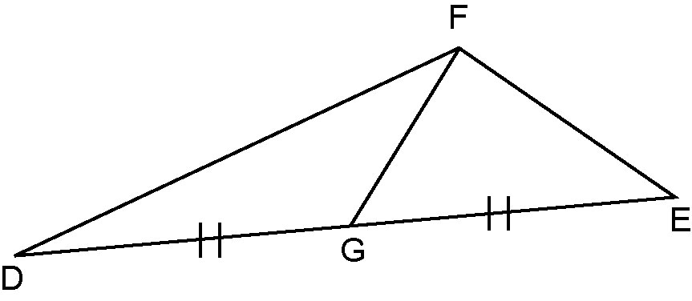
a) DEF b) DGF

9. Explain why each conjecture is true or draw a counterexample to show it is false.
a) The area of a triangle is 4 times the area of the smaller triangle formed by joining the midpoints of two sides.
b) A scalene triangle cannot contain a right angle.

7.5 Midpoints and Diagonals in
Quadrilaterals, pages 401–407

10. For each diagram, state which line segments are parallel.

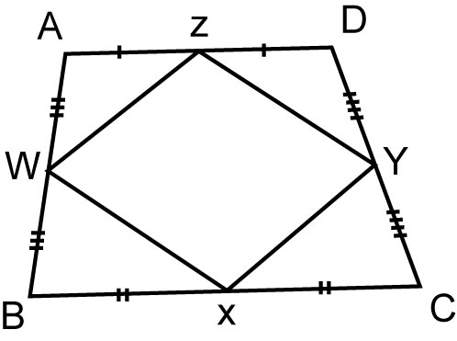
a)

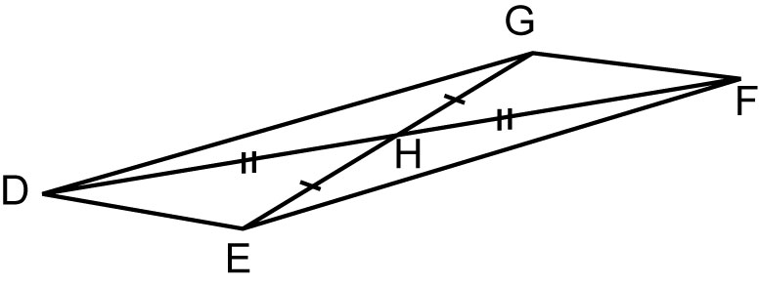
b)

11. Show that each conjecture is true, or use a counterexample to show it is false.
a) A diagonal of a parallelogram divides the parallelogram into two congruent triangles.
b) The diagonals of a rhombus have equal length.

