Chapter 7 Test

Multiple Choice
For questions 1 to 5, select the best answer.

1. The exterior angle at the vertex formed by the equal sides of an isosceles triangle is 140°. Which are the measures of the exterior angles at the other vertices?
A 140°, 80° B 110°, 110°
C 40°, 40° D 40°, 80°
2. In MNP, the interior angle at N is 24° and the exterior angle at P is 55°. Which is the measure of the interior angle at M?
A 101° B 79° C 31° D 281°
3. The sum of the interior angles of a convex pentagon
A is always 360°
B is always 540°
C is always 180°
D depends on the shape of the pentagon
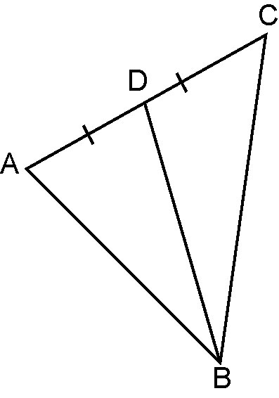
4. The area of ABC is

A equal to the area of BCD
B half the area of ABD
C half the area of BCD
D double the area of ABD

5. The diagonals of a parallelogram
A are always perpendicular to each other
B always bisect the interior angles
C always bisect each other
D always bisect each other at right angles
Short Response
Show all steps to your solution.

6. Find the measure of each indicated angle.
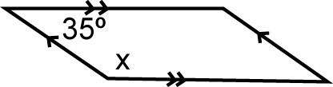
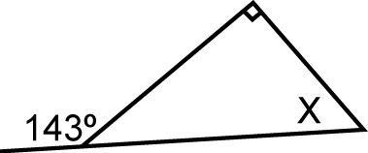
a) b)

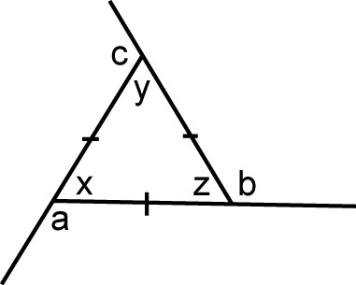
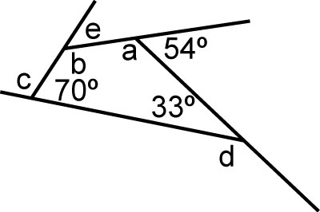
c) d)

7. What is the sum of the interior angles of a convex polygon with 9 sides?

8. Explain why each conjecture is true, or use a counterexample to show it is false.
a) A triangle can have more than one obtuse angle.
b) A quadrilateral can have more than one obtuse angle.

Extend
Provide complete solutions.

9. The sum of the interior angles of a regular convex polygon is 2520°.
a) What is the measure of each interior angle?
b) What is the measure of each exterior angle?

10. One exterior angle of an isosceles triangle is 80°.
a) Find the possible measures of the other two exterior angles.
b) How many answers can you find? Explain.

