Using a MIRA With Isosceles Triangles
In each of the following, triangle ABC is an isosceles triangle. Use a MIRA to find the line of symmetry for the triangle. Label point D where the line of symmetry intersects with side BC.
Using a ruler and a protractor, test the following properties:
• does AD bisect angle BAC?
• does point D bisect AC?
• does line segment AD create two congruent triangles? If so, name the corresponding parts.

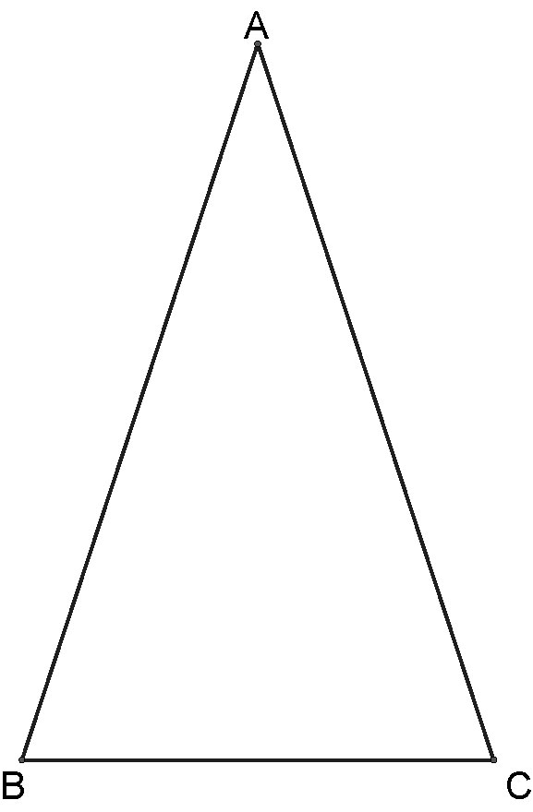  1. | 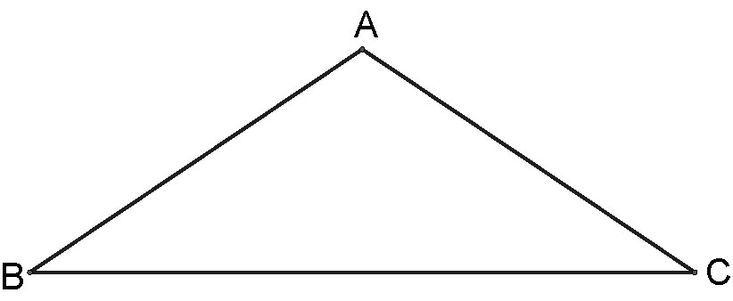  2.
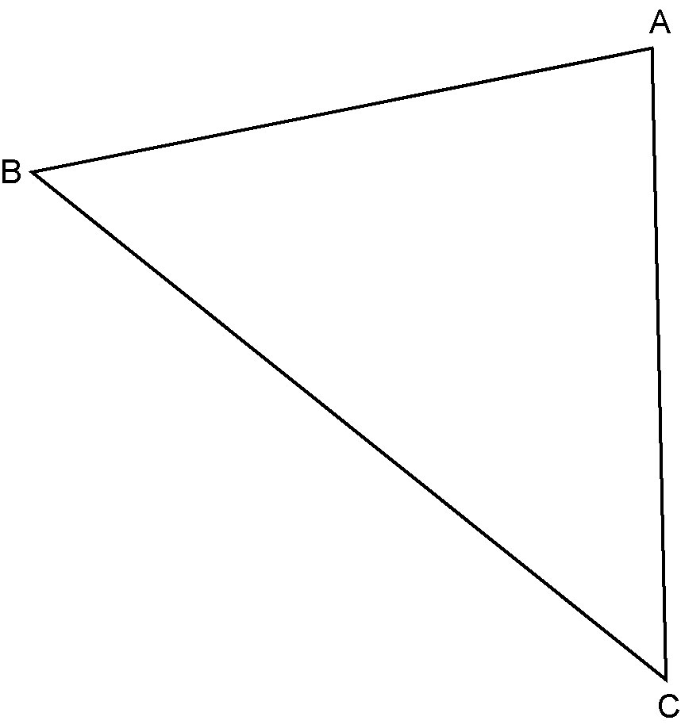  3. | 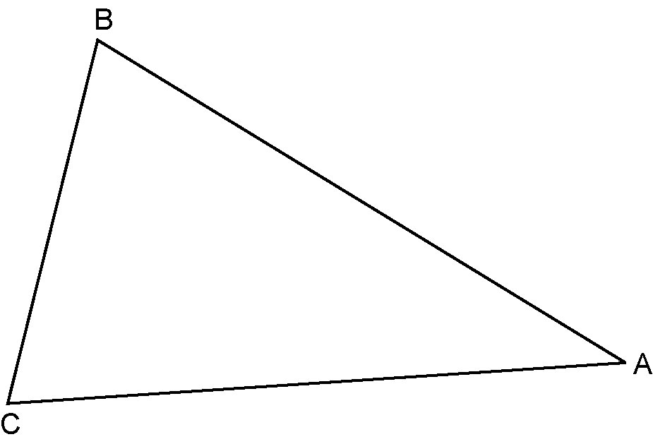  4.

