Opposite, Supplementary, and
Complementary Angles
In each diagram, identify pairs of opposite angles and pairs of supplementary angles.
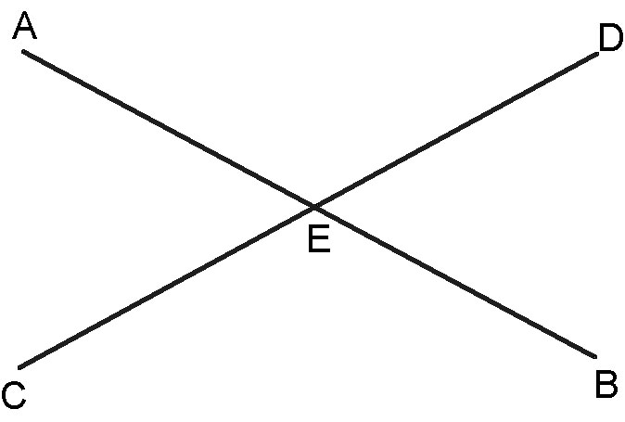
1.

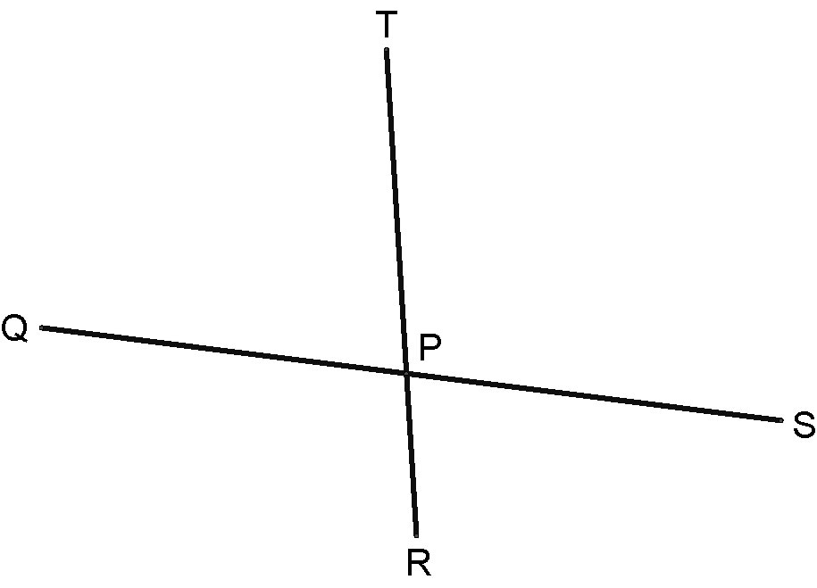
2.

3. In the diagram below, angle AEC = 90°. Identify all pairs of opposite angles, pairs of
supplementary angles, and pairs of complementary angles.

