Practice: Get Ready

Classify Triangles

1. Classify each triangle according to its side lengths.
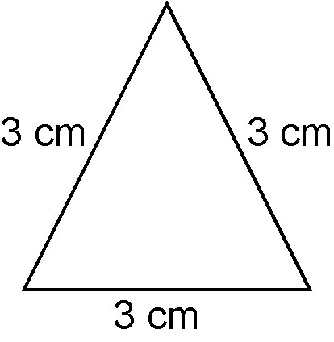  a) | 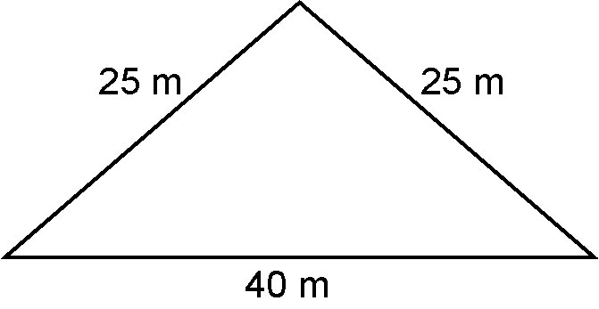  b)
2. Classify each triangle according to its side lengths and angle measures.
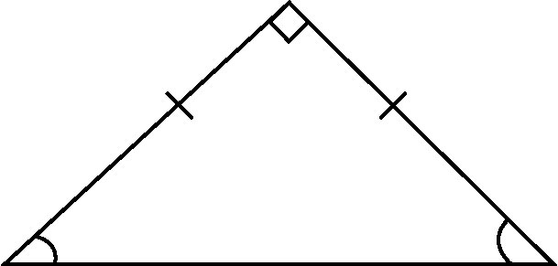  a) | 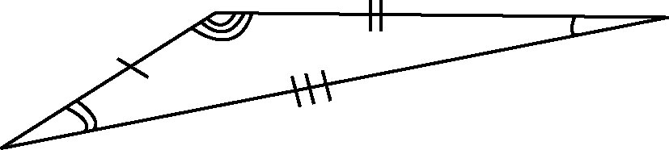  b)
Classify Polygons
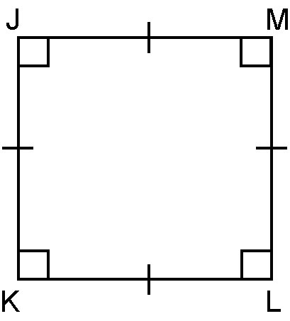
3. Is each quadrilateral regular or irregular? Name each quadrilateral.
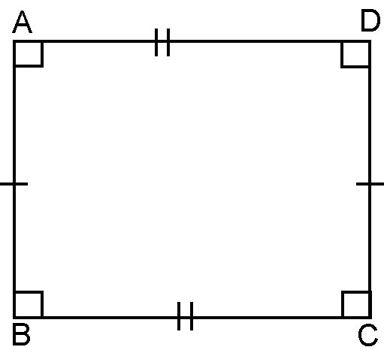  a) | 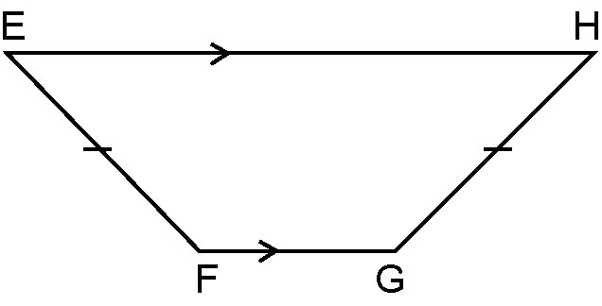  b) | c)

4. Is each polygon regular or irregular? Classify each polygon according to its number of sides.

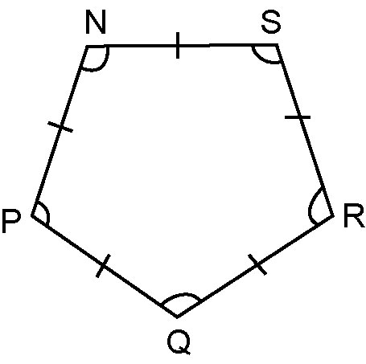  a) | 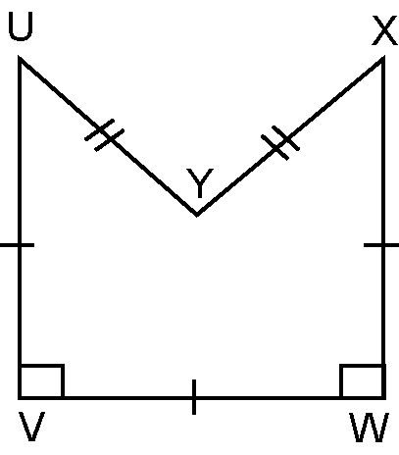  b) | 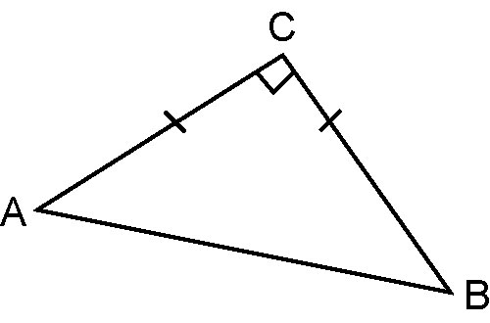  c)

Angle Properties

5. Find the measures of the indicated angles.

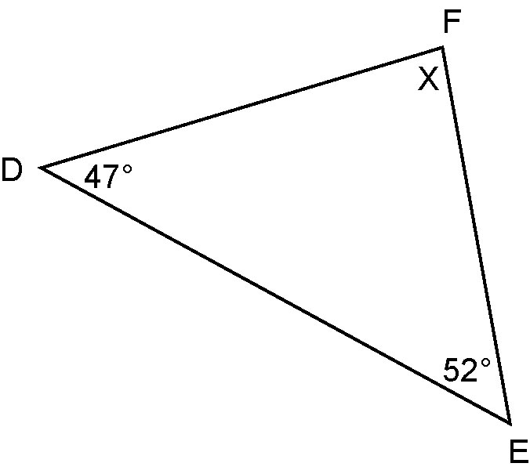  a) | 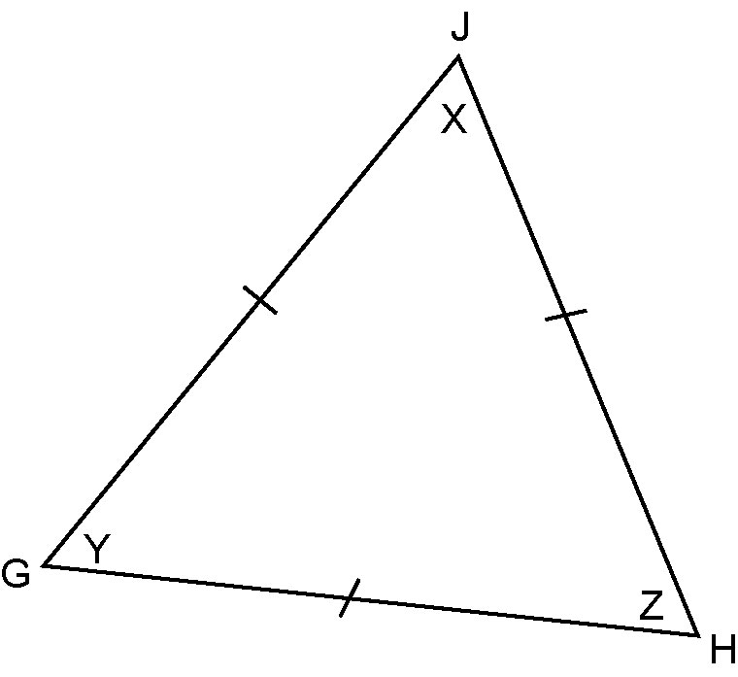  b)

6. Find the measures of the indicated angles. Give reasons for your answers.

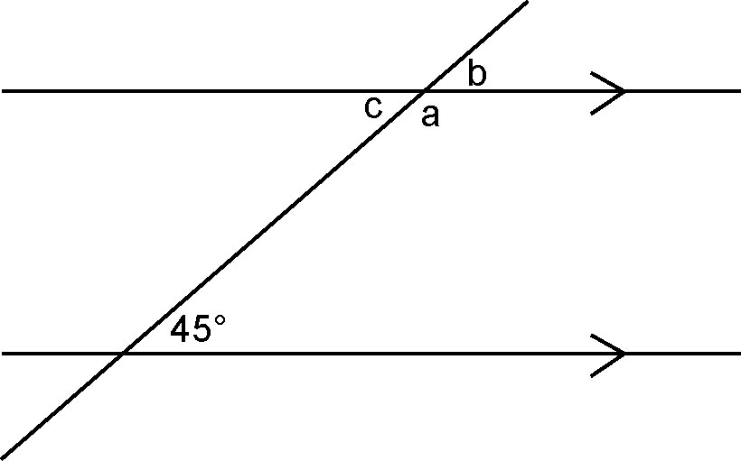  a) | 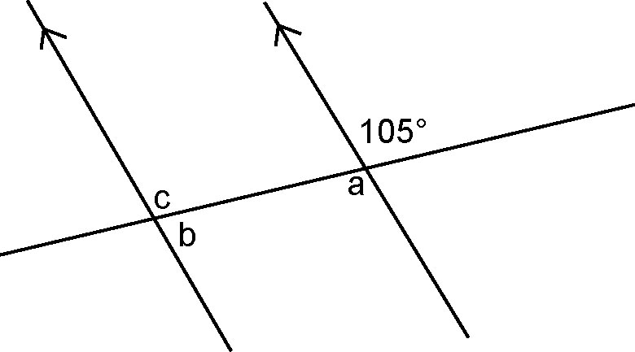  b)

