Chapter 7 Practice Test

Multiple Choice
For questions 1 to 5, select the best answer.

1. Each exterior angle of an equilateral triangle has which measure?
A 60° B 180° C 360° D 120°

2. Triangle DEF has interior angles at D and E, which measure 100° and 25°. Which is the measure of the exterior angle at F?
A 55° B 125° C 180° D 75°

3. The sum of the interior angles of a convex polygon
A is always 180°
B is always 720°
C is always 360°
D depends on the number of sides

4. The length of segment BC is
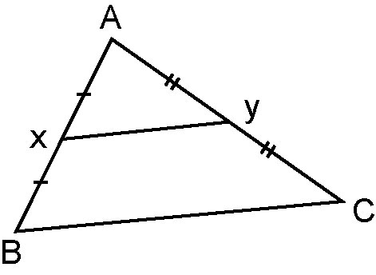
A half the length of XY
B half the length of AB
C double the length of XY
D triple the length of XY

5. The segments joining the midpoints of a quadrilateral.
A form a parallelogram
B bisect each other
C are always perpendicular to each other
D always bisect each other at right angles

Short Response
Show all steps to your solution.

6. Find the measure of each indicated angle.
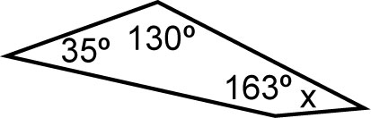
a) b)

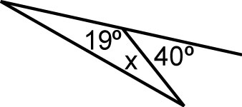
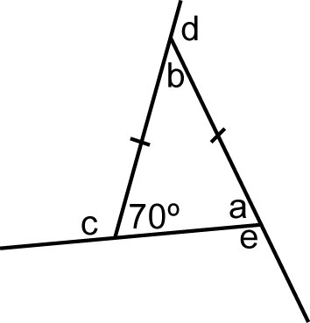
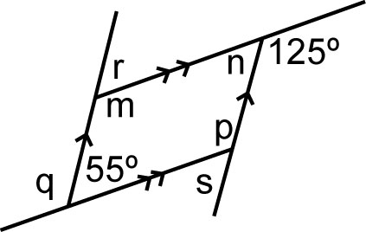
c) d)

7. A convex polygon has 20 sides. Find the sum of the interior angles.

8. Explain why each conjecture is true, or use a counterexample to show it is false.
a) The sum of the interior angles of any convex hexagon is always 720°.
b) The sum of the exterior angles of any convex polygon depends on the number of sides.

Extend
Provide complete solutions.

9. The sum of the interior angles of a convex polygon is 1080°.
a) How many sides does the polygon have?
b) Suppose the polygon is regular. What is the measure of each interior angle?
10. Show that the area of trapezoid BCED is 3 times the area of ADE.
