BLM 7.GR.3 Practice: Get Ready
1. a) equilateral triangle
b) isosceles triangle
2. a) right isosceles triangle
b) obtuse scalene triangle
3. a) irregular; rectangle
b) irregular; trapezoid
c) regular; square
4. a) regular; pentagon
b) irregular; hexagon
c) irregular; triangle
5. a) x = 81° b) x = y = z = 60°
6. a) a = 135°; b = 45°; c = 45°
b) a = 105°; b = 75°; c = 105°
BLM 7.1.1 Practice: Angle Relationships in Triangles
1. a) 115° b) 116° c) 111°
d) 120° e) 55° f) 85°
2. a) 138° b) 130° c) 61°
d) 123° e) 143° f) 90°
3. a) 105° b) 145° c) 124° d) 110°
4. a) x = 95°
b) x = y = 55°; z = 70°
c) x = 50°; y = 115°; z = 130°
d) x = 45°; y = 15°; z = 30°
5. 138°, 138°, 84° or 138°, 111°, 111°
BLM 7.1.3 Word Origins and Plurals
Word | Origin | Plural
1. Appendix | Latin | appendices
2. Minimum | Latin | minima
3. Matrix | Latin | matrices
4. Radius | Latin | radii
5. Polyhedron | Greek | polyhedra
6. Focus | Latin | foci
7. Index | Latin | indices
8. Formula | Latin | formulae
9. Datum | Latin | data
10. Basis | Latin and Greek | bases
11. Hypothesis | Latin and Greek | hypotheses
12. Analysis | Latin and Greek | analyses
BLM 7.2.1 Angle Relationships in Quadrilaterals
1. a) 110° b) 86° c) 120° d) 125°
2. a) 146° b) 73° c) 93° d) 65°
3. a) 95° b) 20° c) 160° d) 113°
4. a) 125° b) 80° c) 72° d) 63°
5. a) x = y = 85° b) x = 130°; y = 50°
c) x = y = 145°; z = 35° d) x = z = 105°; y = 75°
6. a) x = 90°; y = 53°
b) a = 140°; b = 52°
c) m = 25°; n = 155°; p = 25°
d) s = 85°; t = 50°; v = 108°; x = 63°; y = 72°
BLM 7.3.1 Practice: Angle Relationships
in Polygons
1. a) 540° b) 360° c) 900° d) 1260°
2. a) 1440° b) 720° c) 360° d) 1080°
3. a) 1620° b) 2160° c) 2880° d) 3960°
4. a) 60° b) 162° c) 140° d) 157.5°
5. a) 6 sides b) 13 sides
c) 15 sides d) 25 sides
BLM 7.4.1 Practice: Midpoints and Medians in Triangles
1. a) 31 m b) 1.5 cm c) 54 cm d) 4 m
2. a) AD = 15 m; DE = 20 m
b) AD = 4 cm; DE = 5.8 cm
c) AD = 60 m; DE = 104 m
d) AD = 6 cm; DE = 13.2 cm
3. a) 5 cm² b) 5 cm²
4. a) 24 cm² b) 12 cm²
5. a) The median divides the isosceles triangle into
two smaller triangles. It bisects the unequal side, and is a common side in each of the smaller triangles. The original triangle is isosceles, so the third sides in the smaller triangles are equal. The angles opposite the new common side were equal and still are, and both new triangles have a right angle where the common side meets the original unequal side. Therefore, the two triangles have all sides equal and two angles equal, so the third angle in each must be equal. So, the median to the vertex opposite the unequal side of an isosceles triangle bisects the angle at that vertex.
b) False
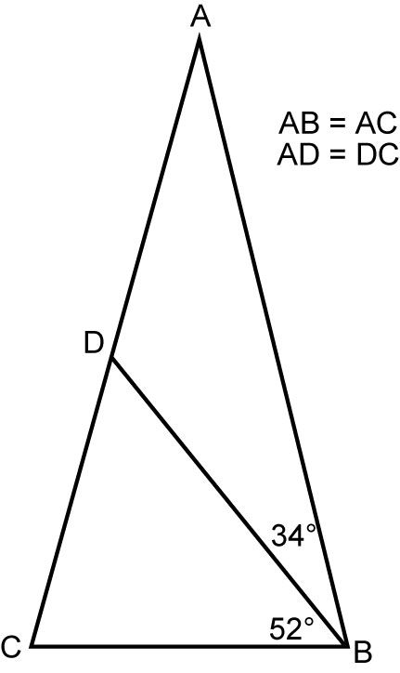

BLM 7.4.3 Sierpinski’s Triangle
1. equidistant from the endpoints of the original line segment.
2. a) Call the school at (1, 9) school A, the school at
(3, 2) school B, and the school at (9, 5) school C.
Using the method of finding the equation of a line using two points, the equation of the line AB is . Similarly the equation for line BC is , and the equation of line AC is .
We know that the slope of the perpendicular bisector of a line is the inverse reciprocal of the slope of the original line. Using this, we can find the slopes of the perpendicular bisectors of lines AB, BC, and AC.
The midpoints of lines AB, BC, and AC are , and (5, 7) respectively.
Using the slope and one point method of finding the equation of a line, we can find the equations of the perpendicular bisectors.
Perpendicular bisector of line AB is
Perpendicular bisector of line BC is
Perpendicular bisector of line AC is y = 2x − 3.
These are the equations of the boundaries between schools A and B, B and C, and A and C respectively, since the points on these lines are equidistant from each pair of schools.
b) Graphing these lines, we see that they all intersect at a point roughly (4.5, 6.25), the point equidistant from all three schools. Solving any two of the equations as a system, we find the actual intersection point
or (4.6, 6.25).
3. The boundaries between the original three schools still apply. We just need boundaries between new school D and each of the original three.
By the same methods as above, the equation for CD is , the equation for AD is
, and the equation for BD is
y = 2x − 4.
The perpendicular bisectors are , , and .
The boundaries between each pair of schools is
y = 2x − 3
BLM 7.5.2 Practice: Midpoints and Diagonals in Quadrilaterals
1. a) AB and DC; AD and BC
b) AD and BC; AB and DC
2. a) x = z = 127°; y = 53°
b) q = s = 65°; t = 115°
3. a) 3.6 cm b) 7.2 cm c) 6 cm d) 12 cm
4. a) 6.6 cm b) 6.6 cm c) 6.6 cm d) 13.2 cm
5. a) False
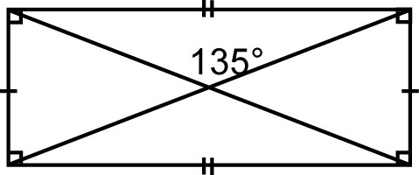
b) True
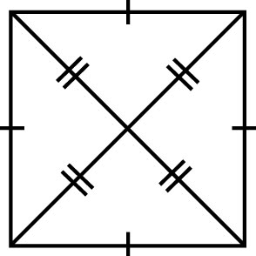
The diagonals and the sides of the square form
four congruent isosceles triangles. The angles formed by the equal sides of the triangles are all equal, so the four angles in the middle must be equal. The sum of the measures of these angles is 360°. The measure of each angle is 360 ÷ 4, or 90°.
BLM 7.CR.1 Chapter 7 Review
1. a) x = 135° b) x = 108°
c) x = 121° d) x = 62°; y = 112°; z = 118°
2. 48°; 72°, 156°, 132°
3. a) a = 138° b) k = 68°
c) x = z = 130°; y = 50°
d) a = c = 150°; b = d = 30°
4. a) 157° b) 159°, 86°, 92°, 23°
5. a) 540° b) 1440° c) 360° d) 900°
6. a) 60° b) 120° c) 135° d) 144°
7. 20
8. a) 32 cm² b) 16 cm²
9. a) True
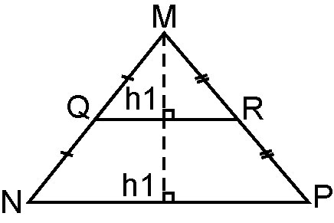
The area of MQR is QR × h.
The area of MNP is NP × 2h or NP × h.
But NP = 2 × QR.
So, the area of MNP is 2 × QR × h.
b) False
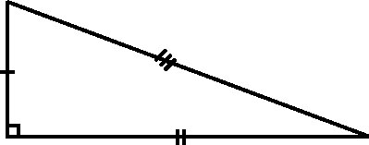
10. a) WZ and XY; WX and ZY
b) DE and GF; DG and EF
11. a) True
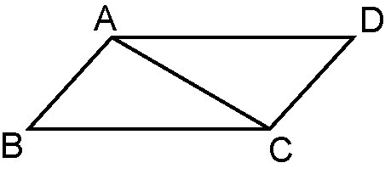
AB = DC
BC = AD
AC = AC
So, ABC is congruent to CDA.
b) False
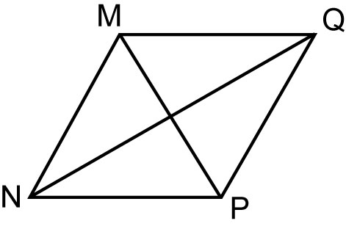
NQ = 5.2 cm
MP = 3 cm

BLM 7.PT.1 Chapter 7 Practice Test
1. D
2. B
3. D
4. C
5. A
6. a) x = 21°
b) x = 32°
c) a = 70°; b = 40°; c = e = 110°; d = 140°
d) m = p = q = 125°; n = r = s = 55°
7. 3240°
8. a) True; three diagonals can be drawn from one vertex of a hexagon. These diagonals divide the hexagon into four triangles. The sum of the interior angles of a triangle is 180°. Since there are four triangles in a hexagon, the sum of the interior angles is 4 × 180, or 720°.
b) False; the sum of the exterior angles of any convex polygon is always 360°.
9. a) 8 b) 135°
10. The area of BCED is .
But BC = 2DE.
So, the area becomes
or .
The area of ADE is .
But AD = BD.
So, the area becomes .
BLM 7.CT.1 Chapter 7 Test
1. B
2. C
3. B
4. D
5. C
6. a) x = 53° b) x = 145°
c) x = y = z = 60°; a = b = c = 120°
d) a = 126°; b = 131°; c = 110°; d = 147°; e = 49°
7. 1260°
8. a) False; the sum of the interior angles of a triangle is 180°. If two angles are obtuse, the sum of the angles will be greater than 180°.
b) True; the sum of the interior angles of a quadrilateral is 360°. A quadrilateral can have one or two obtuse angles.
9. a) 157.5° b) 22.5°
10. a) 140°, 140°
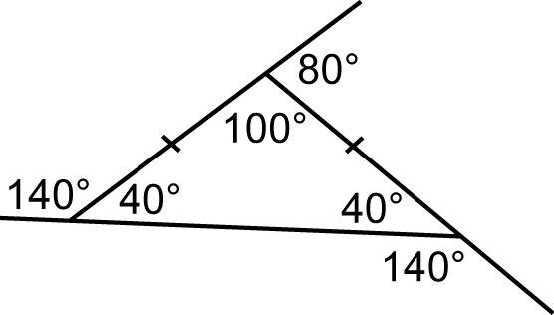
b) One; if the 80° exterior angle is at one of the vertices with equal interior angles, the equal interior angles would be 100°. The sum of
the interior angles of a triangle is 180°.
2 × 100° = 200°, so this triangle is not possible.

