Practice: Perimeter and Area of
Composite Figures

For all questions, round your answer to the nearest tenth of a unit when necessary.

1. Find the length of each indicated side.
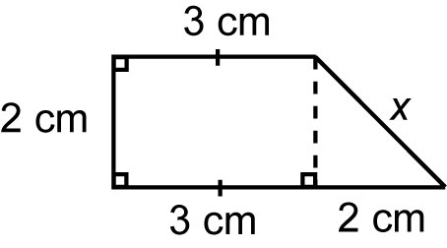
a)

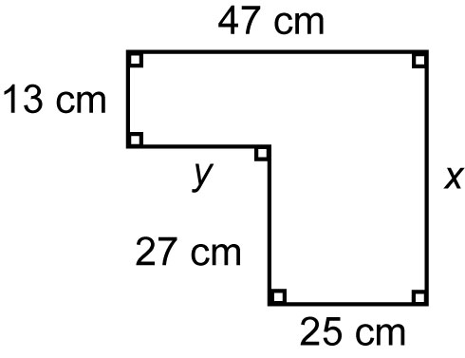
b)

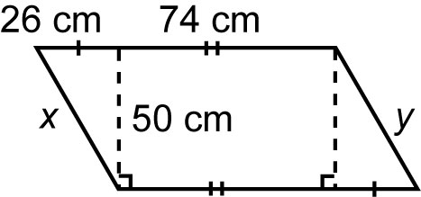
c)

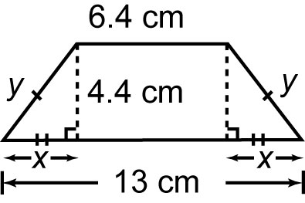
d)

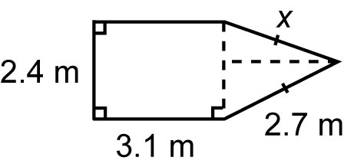
e)

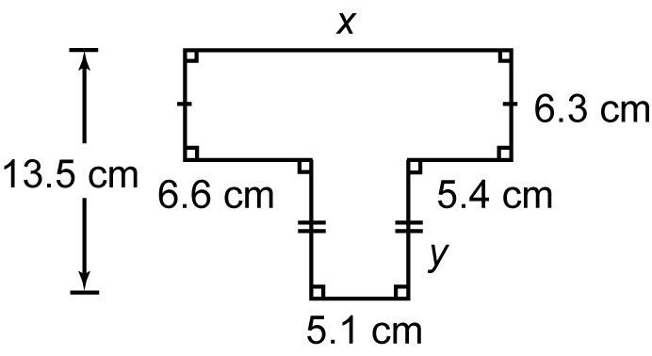
f)

2. Find the perimeter of each composite figure in question 1.
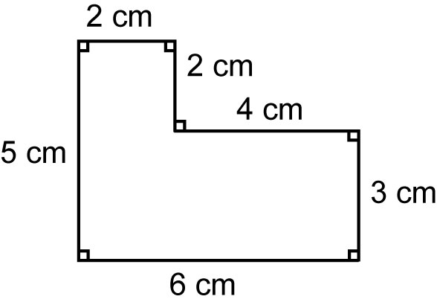
3. Trace this composite figure.

a) Draw broken lines to divide the figure into simpler figures.
b) Find the area of each simple figure.
c) Find the area of the composite figure.

4. Follow the steps in question 3 to find the area of this composite figure.
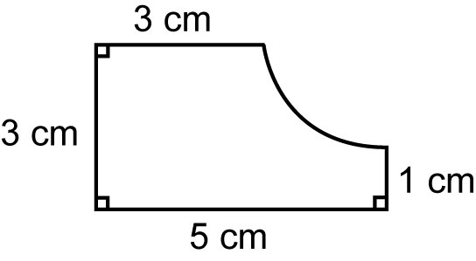

5. Find the area of each composite figure.
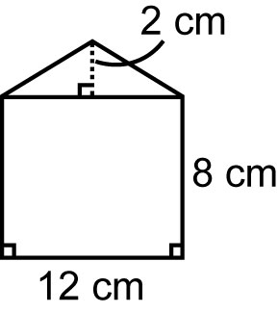
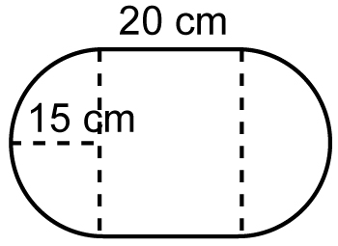
a) b)

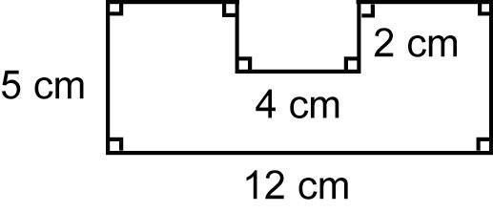
c)

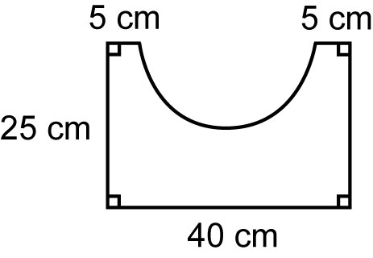
d)

