Practice: Surface Area and Volume of
Prisms and Pyramids

For all questions, round your answer to the nearest tenth of a unit when necessary.

1. Draw a net for each object. Find the area of each face, then find the surface area of
the object.
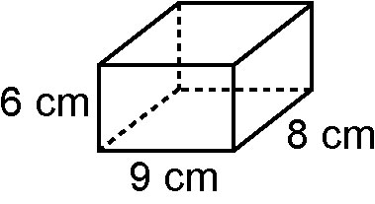
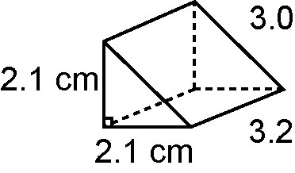
a) b)

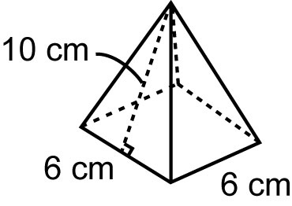
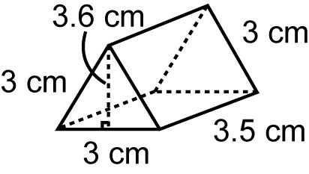
c) d)

2. Find the surface area of each object.`
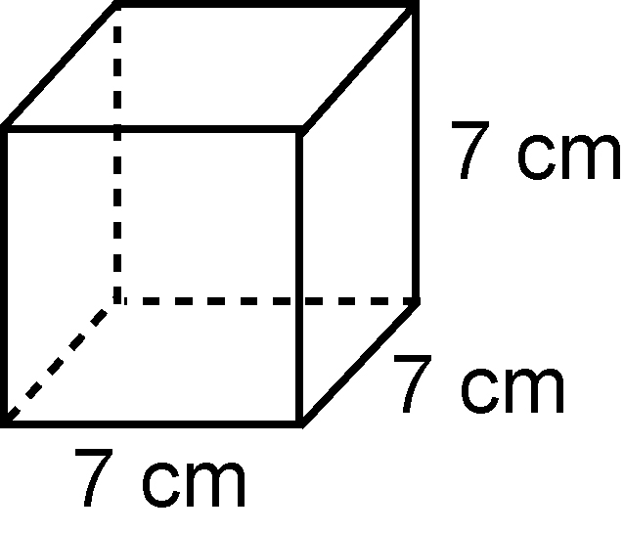
a)

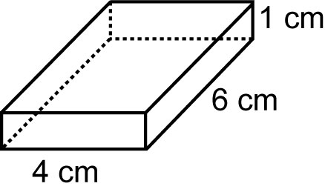
b)

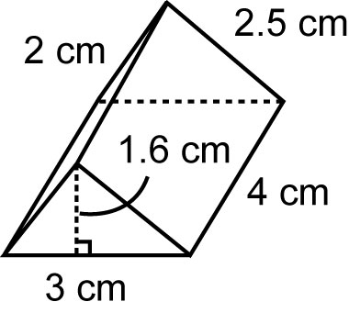
c)

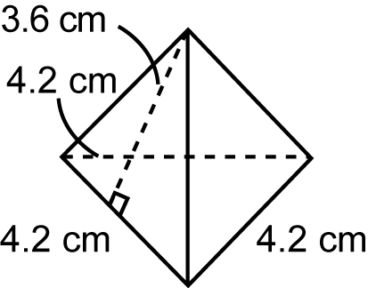
d)

3. Find the volume of each object.
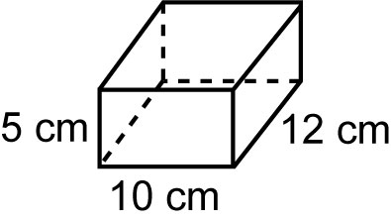
a)

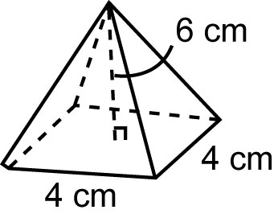
b)

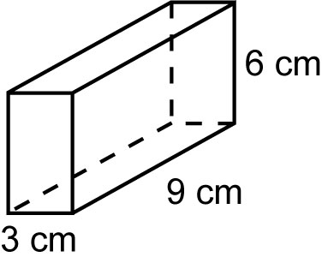
c)

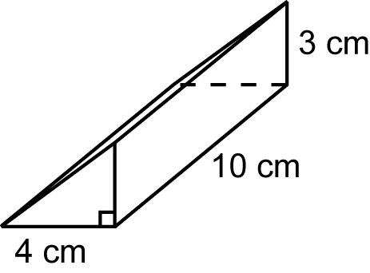
d)

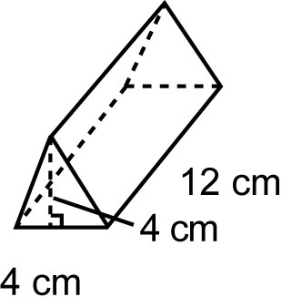
e)

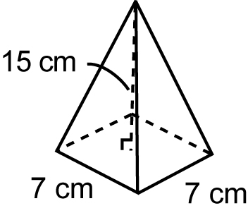
f)

4. A rectangular prism has length 8 cm, width 9 cm, and volume 504 cm³. What is the height of the prism?
5. Find the dimensions of each cube.
a) a cube with volume 1728 cm³
b) a cube with surface area 726 cm²

