Practice: Surface Area of a Cone

For all questions, round your answer to the nearest tenth of a unit when necessary.

1. Find the surface area of each cone.
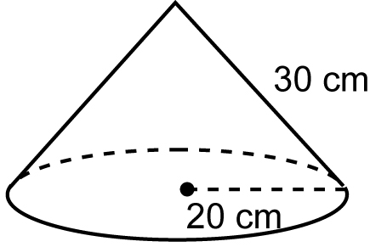
a)

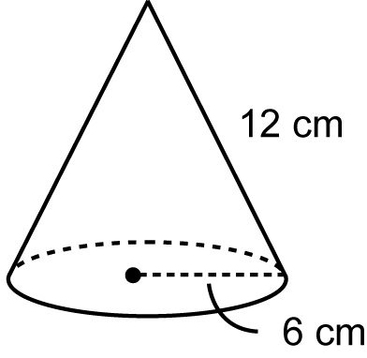
b)

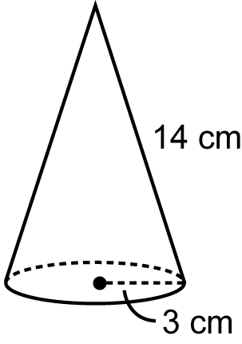
c)

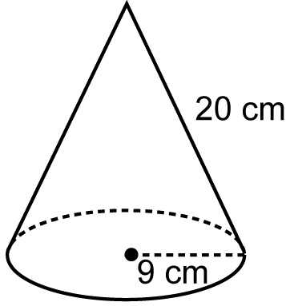
d)

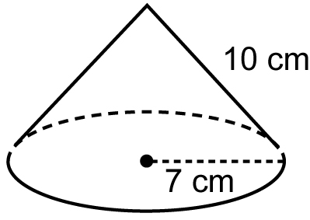
e)

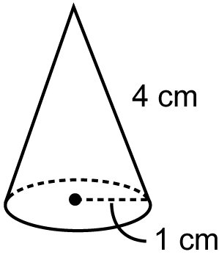
f)

2. Find the slant height of each cone, then find the surface area of the cone.
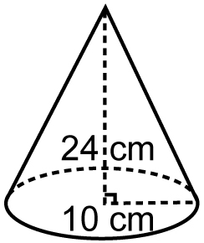
a)

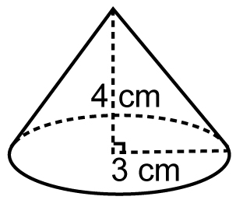
b)

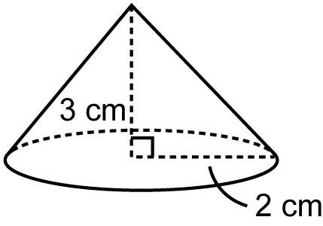
c)

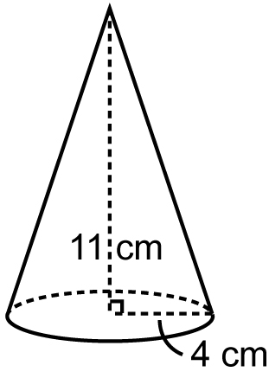
d)

3. Cone A has base radius 5 cm and height
7 cm. Cone B has base radius 7 cm and height 5 cm.
a) Find the slant height of each cone.
b) Find the surface area of each cone.
c) Explain why the surface areas in part b are not equal.

4. Cone A has base radius 4 cm and slant height 5 cm. Cone B has base radius 4 cm and slant height 10 cm. Is the surface area of cone B double the surface area of
cone A? How do you know?

5. Find the surface area of a cone with base diameter 12 cm and height 8 cm.

